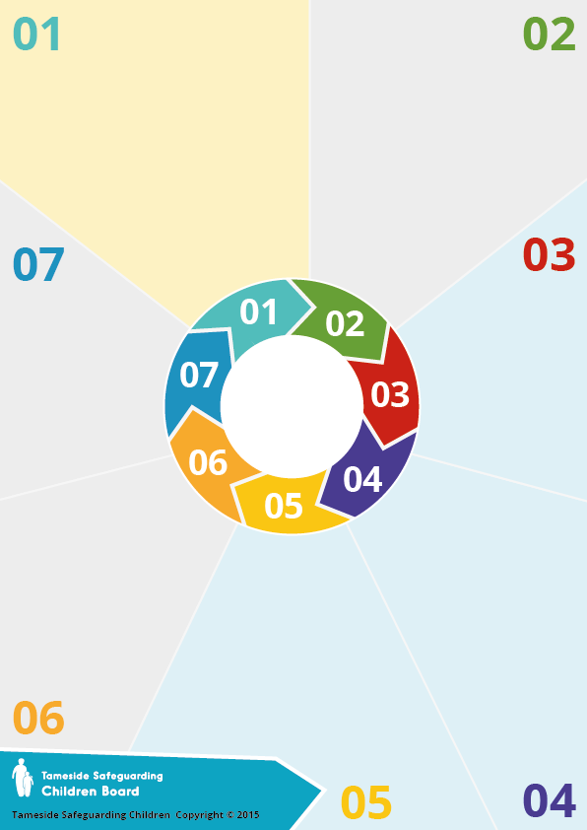

**Prevent and Channel**

**Making a referral**

**Channel works in the same way as other safeguarding processes. Referrals are made through the online referral form available on the Channel and Prevent page on the Council’s website.**

**It is recommended that advice be sought from the Multi Agency Safeguarding Hub or GMP Channel lead for Oldham (see below) prior to submitting a referral.**

**The Prevent Duty**

**Introduced by the Counter-Terrorism and Security Act 2015.**

**Requires specified authorities “in the exercise of their functions, to have due regard to the need to prevent people from being drawn into terrorism”.**

**Local authorities, schools, NHS Trusts FE/HE and childcare providers are among the specified authorities.**

**Delivering the Duty includes: working in partnership; risk assessment; staff training; preventing misuse of public resources by extremists e.g. use of venues, protocols around use of IT**

**Prevent**

**Prevent aims to stop people becoming terrorists or supporting terrorism by:**

* **tackling the ideological causes of terrorism;**
* **intervening early to support people susceptible to radicalisation;**
* **enabling people who have already engaged in terrorism to disengage and rehabilitate**

**For further information:**

Oldham Multi-Agency Safeguarding Hub (MASH) – 0161 770 7777

GMP Channel lead for Oldham – PC David Bull

0161 856 6345 [david.bull1@gmp.police.uk](mailto:david.bull1@gmp.police.uk)

**Terrorism risk**

**The threat to the UK (England, Wales, Scotland and Northern Ireland) is SUBSTANTIAL (an attack is likely)**

**In the UK, the primary domestic terrorist threat comes from Islamist terrorism. The remainder of the domestic terrorist threat is driven almost exclusively by Extreme Right-Wing Terrorism (ERWT). Left Wing, Anarchist and Single Issue Terrorism (LASIT) represents a significantly smaller terrorist threat to the UK.**



Prevent lead – Bruce Penhale 0161 770 4196

Channel and Prevent Co-ordinator – Mike Walker 0161 770 3675

GMP Prevent Officer for Oldham – DC Dave Bull 0161 856 8912

Oldham MASH – 0161 770 7777

**Myth busting**

**Prevent deals with all forms of extremism.**

**It is not about preventing peaceful protest or discouraging debate**

**Channel is about safeguarding. It aims to prevent people committing criminal offences. Referrals do not result in a criminal record.**

**Participation in interventions is voluntary.**

**Channel**

**Channel is the safeguarding process for children, young people and adults at risk of being drawn into terrorism or extremism leading to terrorism**

**Practitioners are encouraged to:**

* + **NOTICE concerns**
  + **CHECK them out**
  + **SHARE them through a referral, if appropriate**

**Channel is pre-criminal. Support is tailored to individual needs based on a vulnerability assessment.**

**CONTEST (UK Counter-**

**terrorism Strategy)**

**Aims to reduce the risk to the UK and its interests overseas from international terrorism, so that people can go about their lives freely and with confidence**

* **Pursue – to stop terrorist attacks**
* **Protect – to strengthen protection against terrorist attacks**
* **Prepare – where an attack cannot be stopped, to mitigate its impact**
* **Prevent– to stop people becoming terrorists or supporting extremism leading to terrorism**