fIMPORTANT-THIS COMMUNICATION AFFECTS YOUR PROPERTY

TOWN AND COUNTRY PLANNING ACT 1990

(as amended by the Planning and Compensation Act 1991) ENFORCEMENT NOTICE

ISSUED BY: Oldham Metropolitan Borough Council ("the Council")

- THIS NOTICE is issued by the Council because it appears to them that there has been a breach of planning control, under Section 171A(1) of the above Act, at the land described below. They consider that it is expedient to issue this Notice, having regard to the provisions of the Development Plan and to other material planning considerations. The Annex at the end of the Notice and the enclosures to which it refers contain additional information.

THE LAND TO WHICH THE NOTICE RELATES

Land at 292-294 Roundthorn Road, Oldham, OL4 SJL as shown edged red on the accompanying plan ("the Land").

THE MATTERS WHICH APPEAR TO CONSTITUTE THE BREACH OF PLANNING CONTROL

Without planning permIss1on, the continued siting on the Land of boundary fencing, the height of which exceeds 1 metre above ground level adjacent to a highway used by vehicular traffic, namely Roundthorn Road, Oldham. The height of the fencing is higher than that permitted by the Town and Country Planning (General Permitted Development) (England) Order 2015 (as amended).

REASONS FOR ISSUING THIS NOTICE

The boundary fencing represents a highly prominent and stark feature on the street scene and is harmful to the character and appearance of the Land to the detriment of the character and appearance of the area. The boundary fencing is contrary to Policy 9 (Local Environment) and Policy 20 (Design) of the Council's Development Plan Document - Joint Core Strategy and Development Management Policies.
It appears to the Council that the breach of planning control stated at paragraph 3 above has occurred within the last four years.

WHAT YOU ARE REQUIRED TO DO

Permanently reduce the height of the boundary fencing on the Land fronting Roundthorn Road, including all fencing and gates forward of the front elevation of the building on the Land, so that it does not exceed 1 metre in height above ground level.

TIME FOR COMPLIANCE

The actions specified in paragraph 5 above must be carried out within two months of this Notice taking effect.

WHEN THIS NOTICE TAKES EFFECT

The Notice takes effect on 4 December 2023, unless an appeal is made against it beforehand.

Dated: 31 October 2023

CVAM
Signed:

For Paul Entwistle Director of Legal Services
Council's Authorised Officer

On behalf of: Oldham Metropolitan Borough Council Civic Centre
West Street Oldham OL1 1UL

ANNEX

YOUR RIGHT OF APPEAL

You can appeal against this Notice, but any appeal must be received, or posted in time to be received, by the Planning Inspectorate acting on behalf of the Secretary of State before the date specified in paragraph 7 of the Notice.

WHAT HAPPENS IF YOU DO NOT APPEAL

If you do not appeal against this Enforcement Notice, it will take effect on the date specified in paragraph 7 of the Notice and you must then ensure that the required steps for complying with it, for which you may be held responsible, are taken within the period specified in paragraph 6 of this Notice. Failure to comply with an Enforcement Notice which has taken effect can result in prosecution and/or remedial action by the Council. The fee for any planning application submitted would be £234.

IMPORTANT ADDITIONAL INFORMATION

A copy of this Enforcement Notice has been served on the following person: -

Mr Michael Nicholas Thomas Camey of Bunkers Hill Cottage, 495 Medlock Road, Failsworth, Manchester M35 9WR.

t11111

II

Plan referred to in an Enforcement Notice
€l,AllJIJ& 1"0 1.,ANV A 2ci2- zCJ ,:;:o\)Nl)THORN
1
R.oAP OLf)\-IAJ\.1 0L4- 5:IL. PH
Dated:....J.'j.I.9..). ..;$ ......:
II
S.igned:..................................................

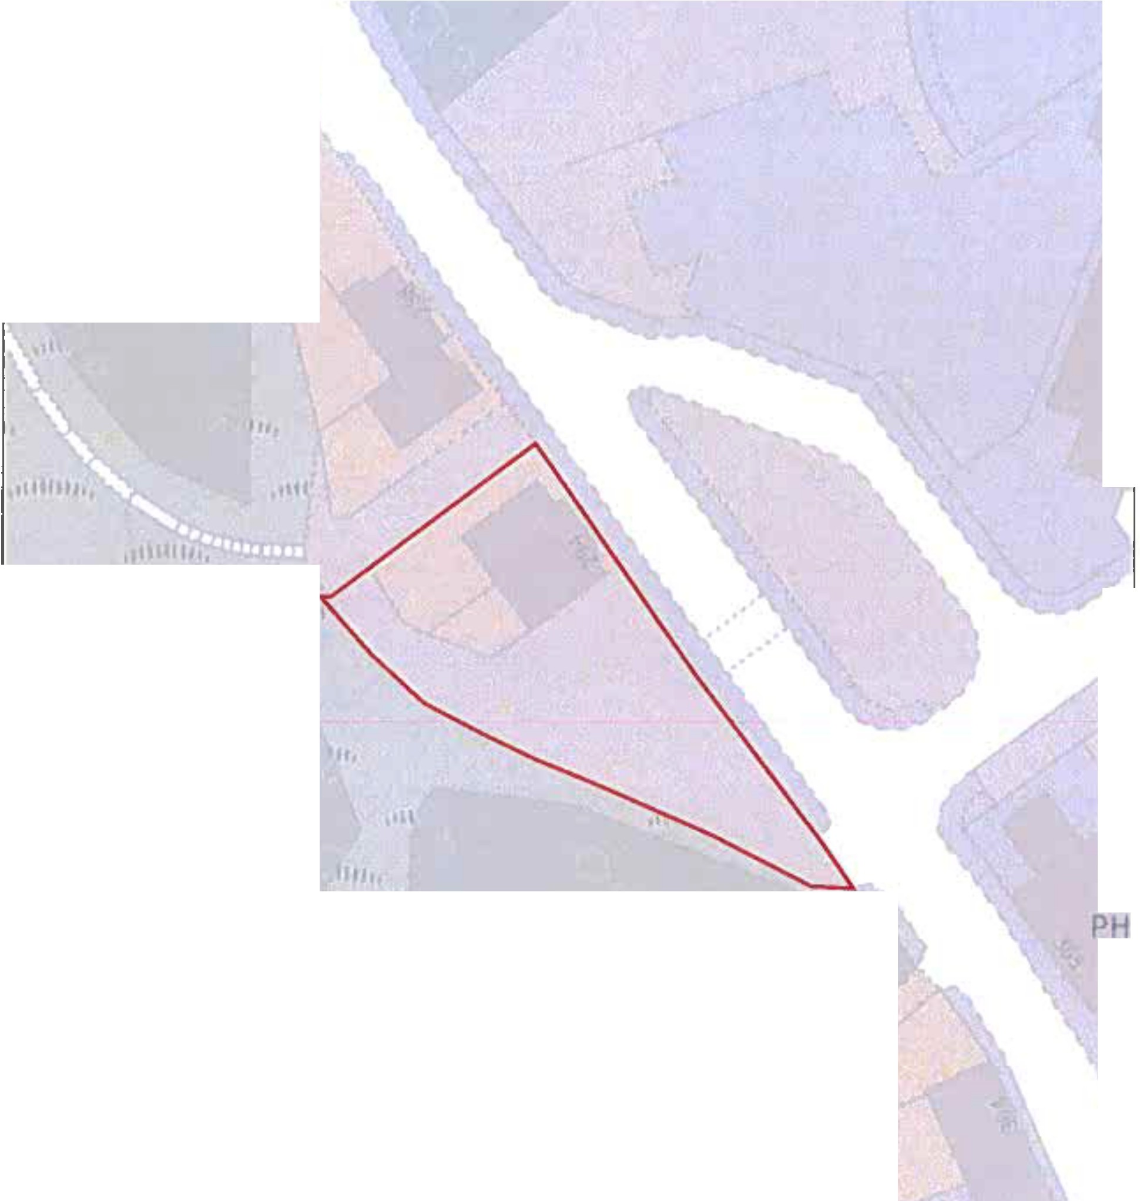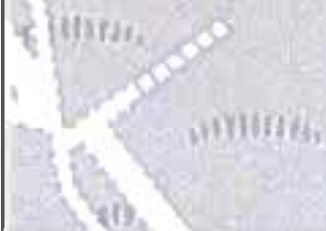

OCrQIIIIIR -...._,.,_pt21J Sww,-...c.0Itan11M
Oldham Council Civic Centre West Street Oldham OL11UT

Oldham
t
Drawn by:
Division:
Drawing No:
Date: 18:09:23 | Scale: 1:625

Council

IMPORTANT ADDITIONAL INFORMATION

Under section 174 of the Town and Country Planning Act 1990 (as amended) you may appeal on one or more of the following grounds:-
- that, in respect of any breach of planning control which may be constituted by the matters stated in the notice, planning permission ought to be granted or, as the case may be, the condition or limitation concerned ought to be discharged;
- that those matters have not occurred;

- that those matters (if they occurred) do not constitute a breach of planning control;
- that, at the date when the notice was issued, no enforcement action could be taken in respect of any breach of planning control which may be constituted by those matters;
- that copies of the enforcement notice were not served as required by section 172;

- that the steps required by the notice to be taken, or the activities required by the notice to cease, exceed what is necessary to remedy any breach of planning control which may be constituted by those matters or, as the case may be, to remedy any injury to amenity which has been caused by any such breach;
- that any period specified in the notice in accordance with section 173(9) falls short of what should reasonably be allowed.
Not all of these grounds may be relevant to you.

If you appeal under Ground (a) of Section 174(2) of the Town and Country Planning Act 1990 this is the equivalent of applying for planning permission for the development alleged in the notice and you will have to pay a fee of £234 which is payable to the Council. There is no fee for the appeal itself.
If you decide to appeal, when you submit it, you should state in writing the ground(s) on which you are appealing against the enforcement notice and you should state briefly the facts on which you intend to rely in support of each of those grounds. If you do not do this when you make your appeal the Secretary of State will send you a notice requiring you to do so within 14 days.

