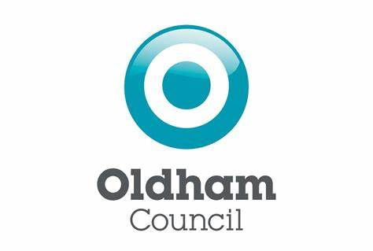

Notice of Publication of Revised Register of Electors
Notice is hereby given, in accordance with the Representation of the People Act 1983, section 13 (3) and the Representation of the People Regulations 2001, section 36, that a revised version of the Register of Electors for the Oldham Council area will be published on 1 February 2023.
The revised register will incorporate changes to polling districts, as a result of the statutory review of parliamentary wards and local polling district and polling places which commenced in November 2021.
The revised register will be made available to those persons or organisations entitled to receive the documents. Electors registered in the area need take no action as a result of this notice, but prospective candidates and their agents and political parties should take note that the electoral numbers of registered electors will change as a consequence of the re-publication.
The revised register will be available for inspection under supervision by prior appointment.

Harry Catherall
Electoral Registration Officer
Oldham Council
Civic Centre, West Street
Oldham
OL1 1NL

Helpline: 0161 770 4718 Email: elections@oldham.gov.uk
Dated: 11th February 2023

