St Pauls Vicarage

175.9m

174.3m

© Crown copyright (and database rights) 2018 OS license 0100019668

Production Date:
27th October 2020

Scale 1100
when printed at A4

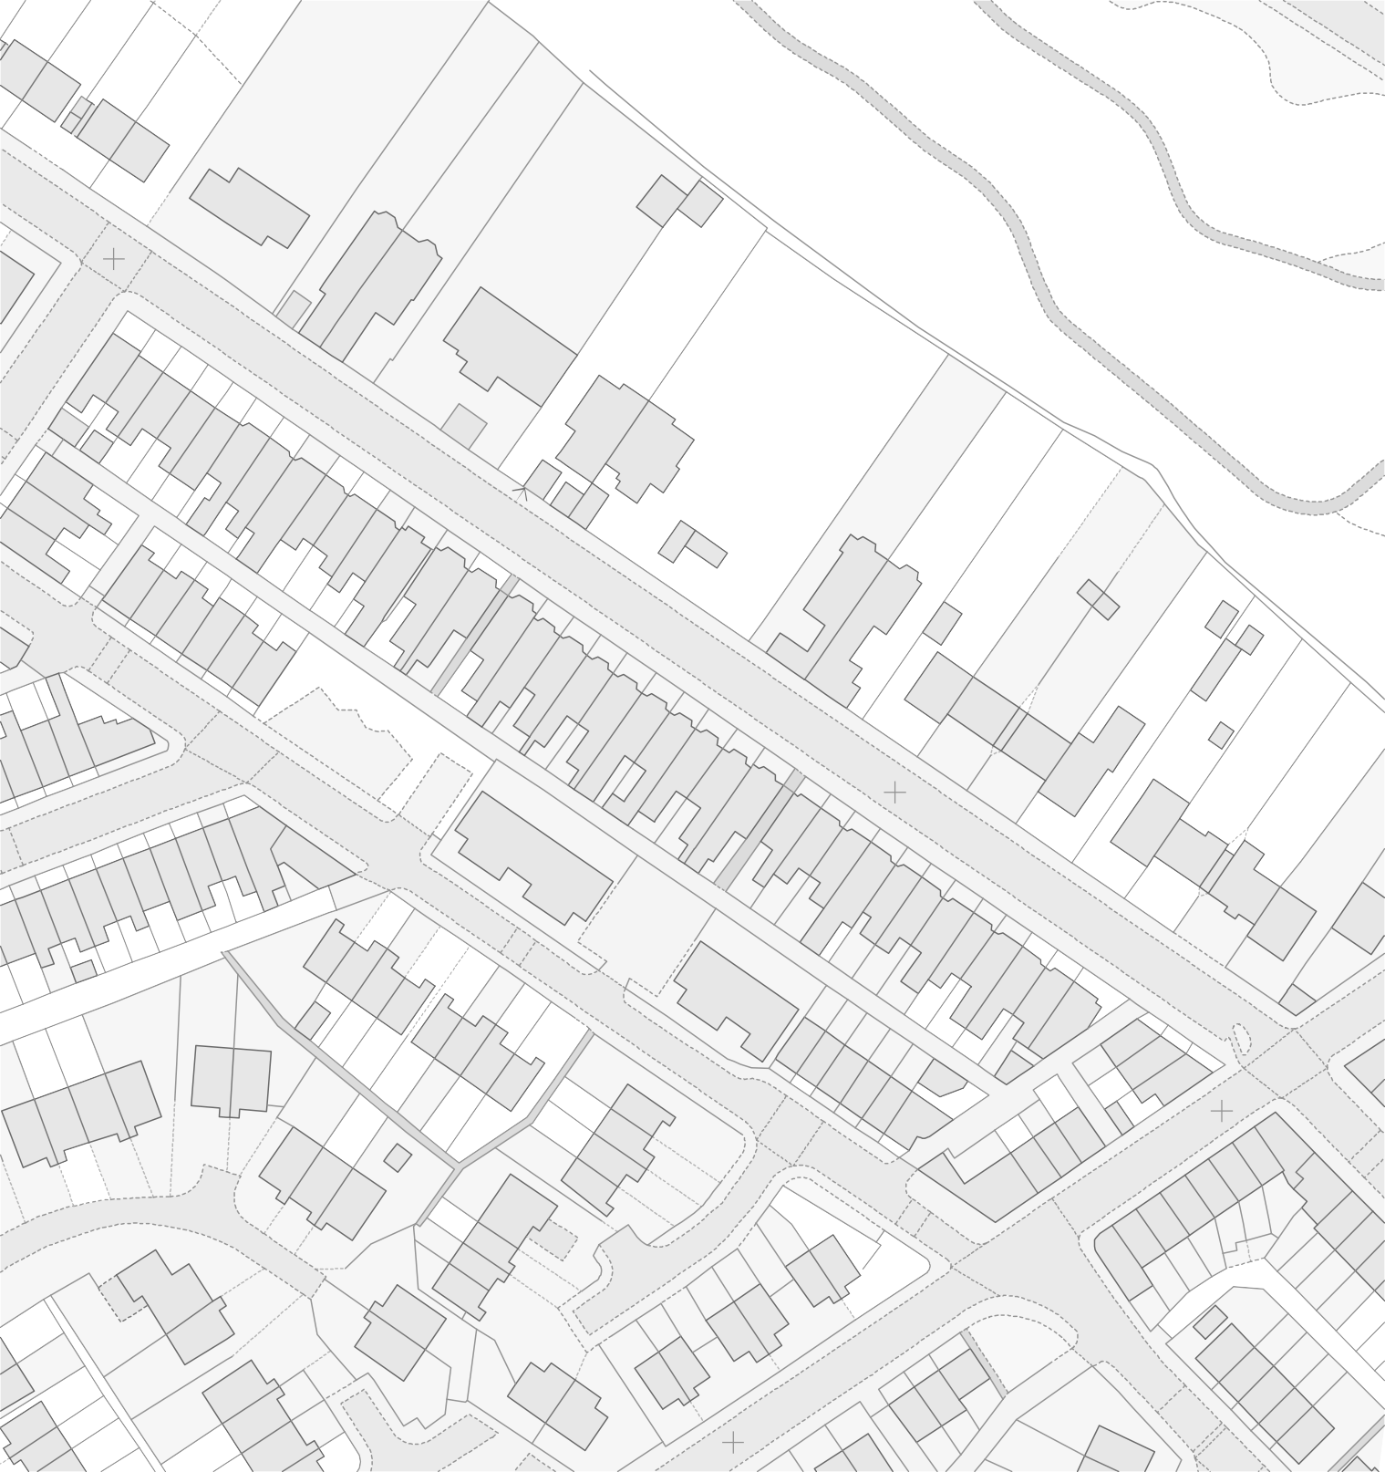
PSPO 082/20
DOMAINOMBC

Notes

