Shelte

© Crown copyright (and database rights) 2018 OS license 0100019668

Production Date:
27th October 2020

Scale 500
when printed at A4

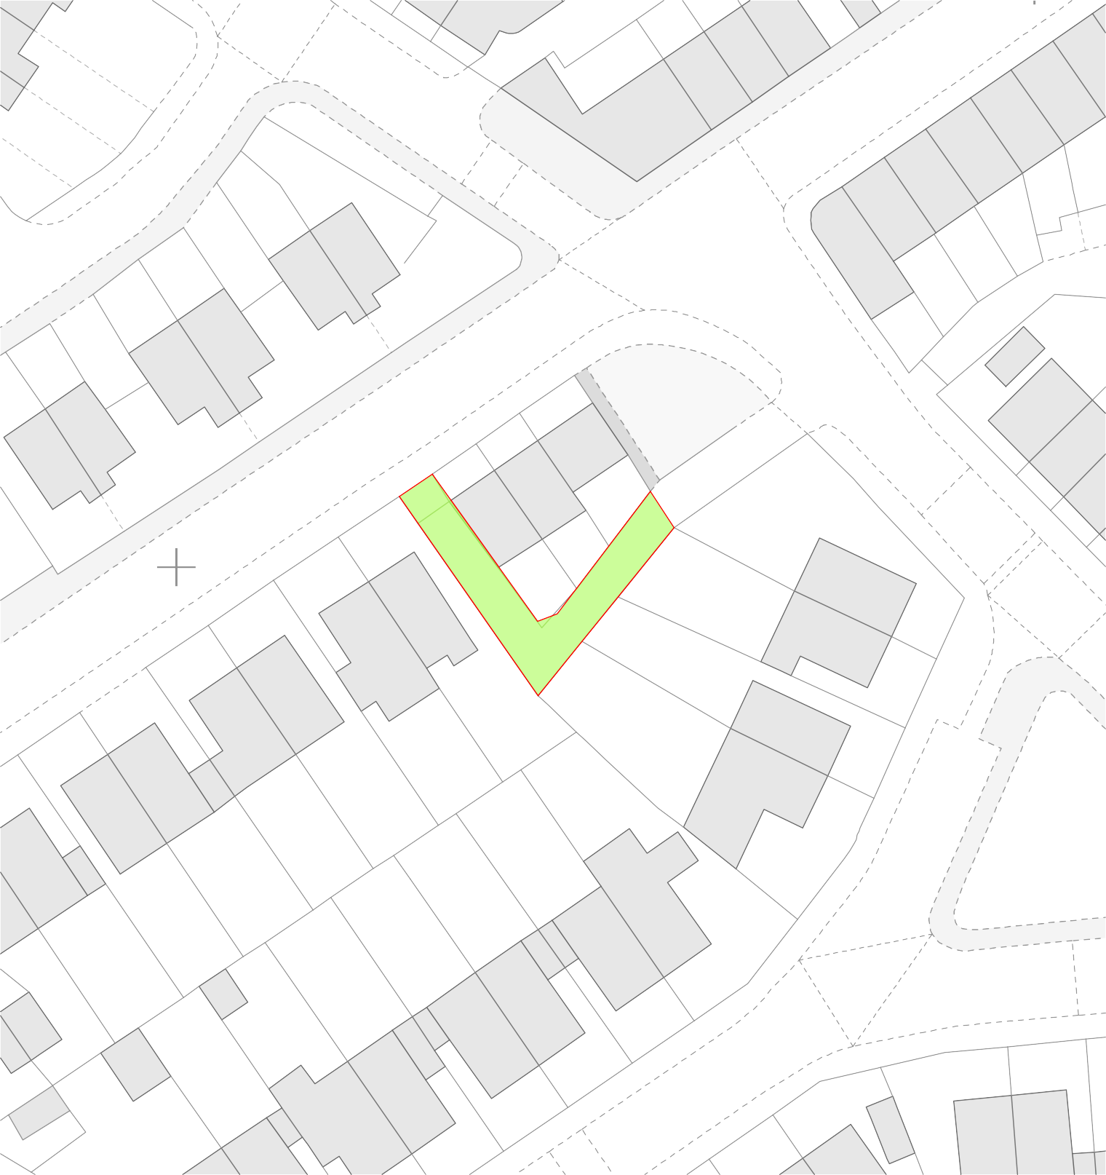
PSPO 081/20
DOMAINOMBC

Notes

