El Sub Sta
40
125.6m

125.3m
PO

TCBs

LB Community
Centre

124.4m

The Sett
(PH)

121.3m

18.9m

125.0m

2

© Crown copyright (and database rights) 2018 OS license 0100019668

Production Date:
16th October 2020

Scale 1250
when printed at A4

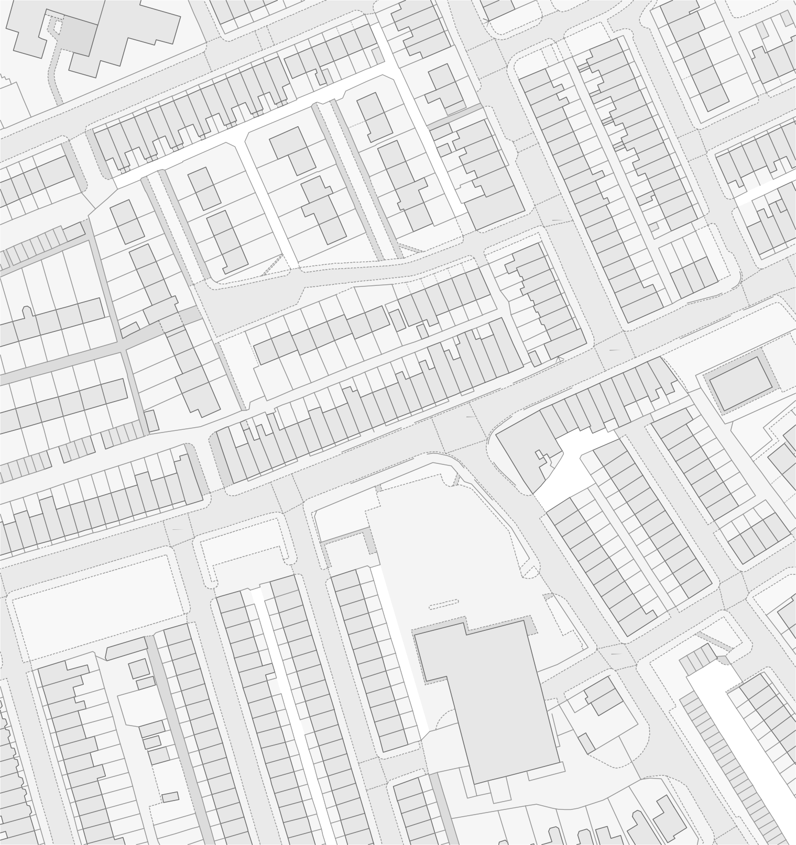
PSPO 074/20A
User Name

Notes

