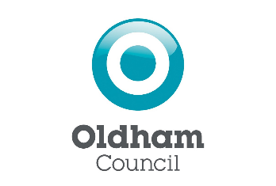

Notice of Review of Polling Districts and Polling Places Section 18C (4) of the Representation of the People Act 1983 (as amended) The Electoral Registration and Administration Act 2013

NOTICE IS HEREBY GIVEN to the formal commencement of a review into polling districts and polling places for the new ward arrangements that come into force for the Local Council Elections to be held on Thursday 4 May 2023.
The Local Government Boundary Commission for England (LGBCE) has concluded its electoral review of Oldham Council. This means that some ward boundaries will change for next year’s local elections to be held on Thursday 4 May 2023. You can see the new ward boundaries here: Oldham | LGBCE Site
Between Thursday 28 July and Thursday 25 August 2022 (the consultation period) Oldham Council would welcome the views of all residents’ views on the proposed polling district and polling station changes, and is asking for you to make your voice heard. We want to hear what you think of the proposals, how they will impact you and the people you live with and to make a representation about any aspect of the polling districts or polling places to be used at future elections.
Representations may be made:
- by email to election@oldham.gov.uk
- by post to Elections Team, Room 222 Civic Centre, West Street, Oldham, OL1 1UL

The ward boundary review may mean that the ward you vote in has changed. It also means that your polling station may change, so you may be voting in a different place in the 2023 Local Elections.
Once Stage 1 of the Consultation is finished, the Council will publish their final recommendations which will show the new polling districts and polling stations for future elections on Thursday 1 September August 2022 for the Stage 2 of the Consultation which will conclude on Monday 3 October 2022.
Please note that all proposals and comments received will be published and available to view on the Council’s website at the conclusion of the review.
Final proposals will be considered by the Council on 2 November 2022. These revised arrangements, if approved, will come into effect when the revised version of the Electoral Register is published on the new ward boundaries on 1 December 2022.

Harry Catherall
(Acting) Returning Officer
28 July 2022

