Notice of Designation – Selective Licensing

Oldham Council hereby gives notice of the designation of areas subject to Selective Licensing in accordance with section 80 of the Housing Act 2004 for the areas depicted in the maps below known as Area 1, Area 2, Area 3, Area 4 and Area 5. This affects specific areas within the following Oldham Council wards: Alexandra, St Mary’s, St James, Waterhead, Coldhurst, Werneth, Chadderton South, Hollinwood and Medlock Vale.

This designation was made under The Housing Act 2004: Licensing of Houses in Multiple Occupation and Selective Licensing of Other Residential Accommodation (England) General Approval 2015, pursuant to section 82, of the Housing Act 2004 and was designated on 1 April 2022.

The areas shown on the maps overleaf will be subject to selective licensing under section 80 of the Housing Act 2004 with effect from 4 July 2022

Under the scheme, private landlords who rent out a property which falls within any of these areas will be required to apply for a licence. The designation may be inspected at Chadderton Town Hall, Middleton Road, Oldham OL9 6PP and on Oldham Council’s website www.oldham.gov.uk/selectivelicensing

After the 4 July 2022 the consequences of failing to licence a property that is required to be licensed include the criminal sanction of an unlimited fine, having a rent repayment order, interim management order, final management order or civil penalty issued to a maximum of £30,000.

All landlords, managing agents and tenants should check if their property is affected. For a full street list, please refer to the Oldham Council website address: www.oldham.gov.uk/selectivelicensing

Details of how to apply for a licence will be available on the website shortly.

If you require any further information, please contact us.
Landlord Licensing Team, Oldham Council, Chadderton Town Hall, Middleton Road, Chadderton, Oldham, OL9 6PP

T: 0161 770 2244 E: landlordlicensing@oldham.gov.uk

Maps of Designated Areas

AREA 1

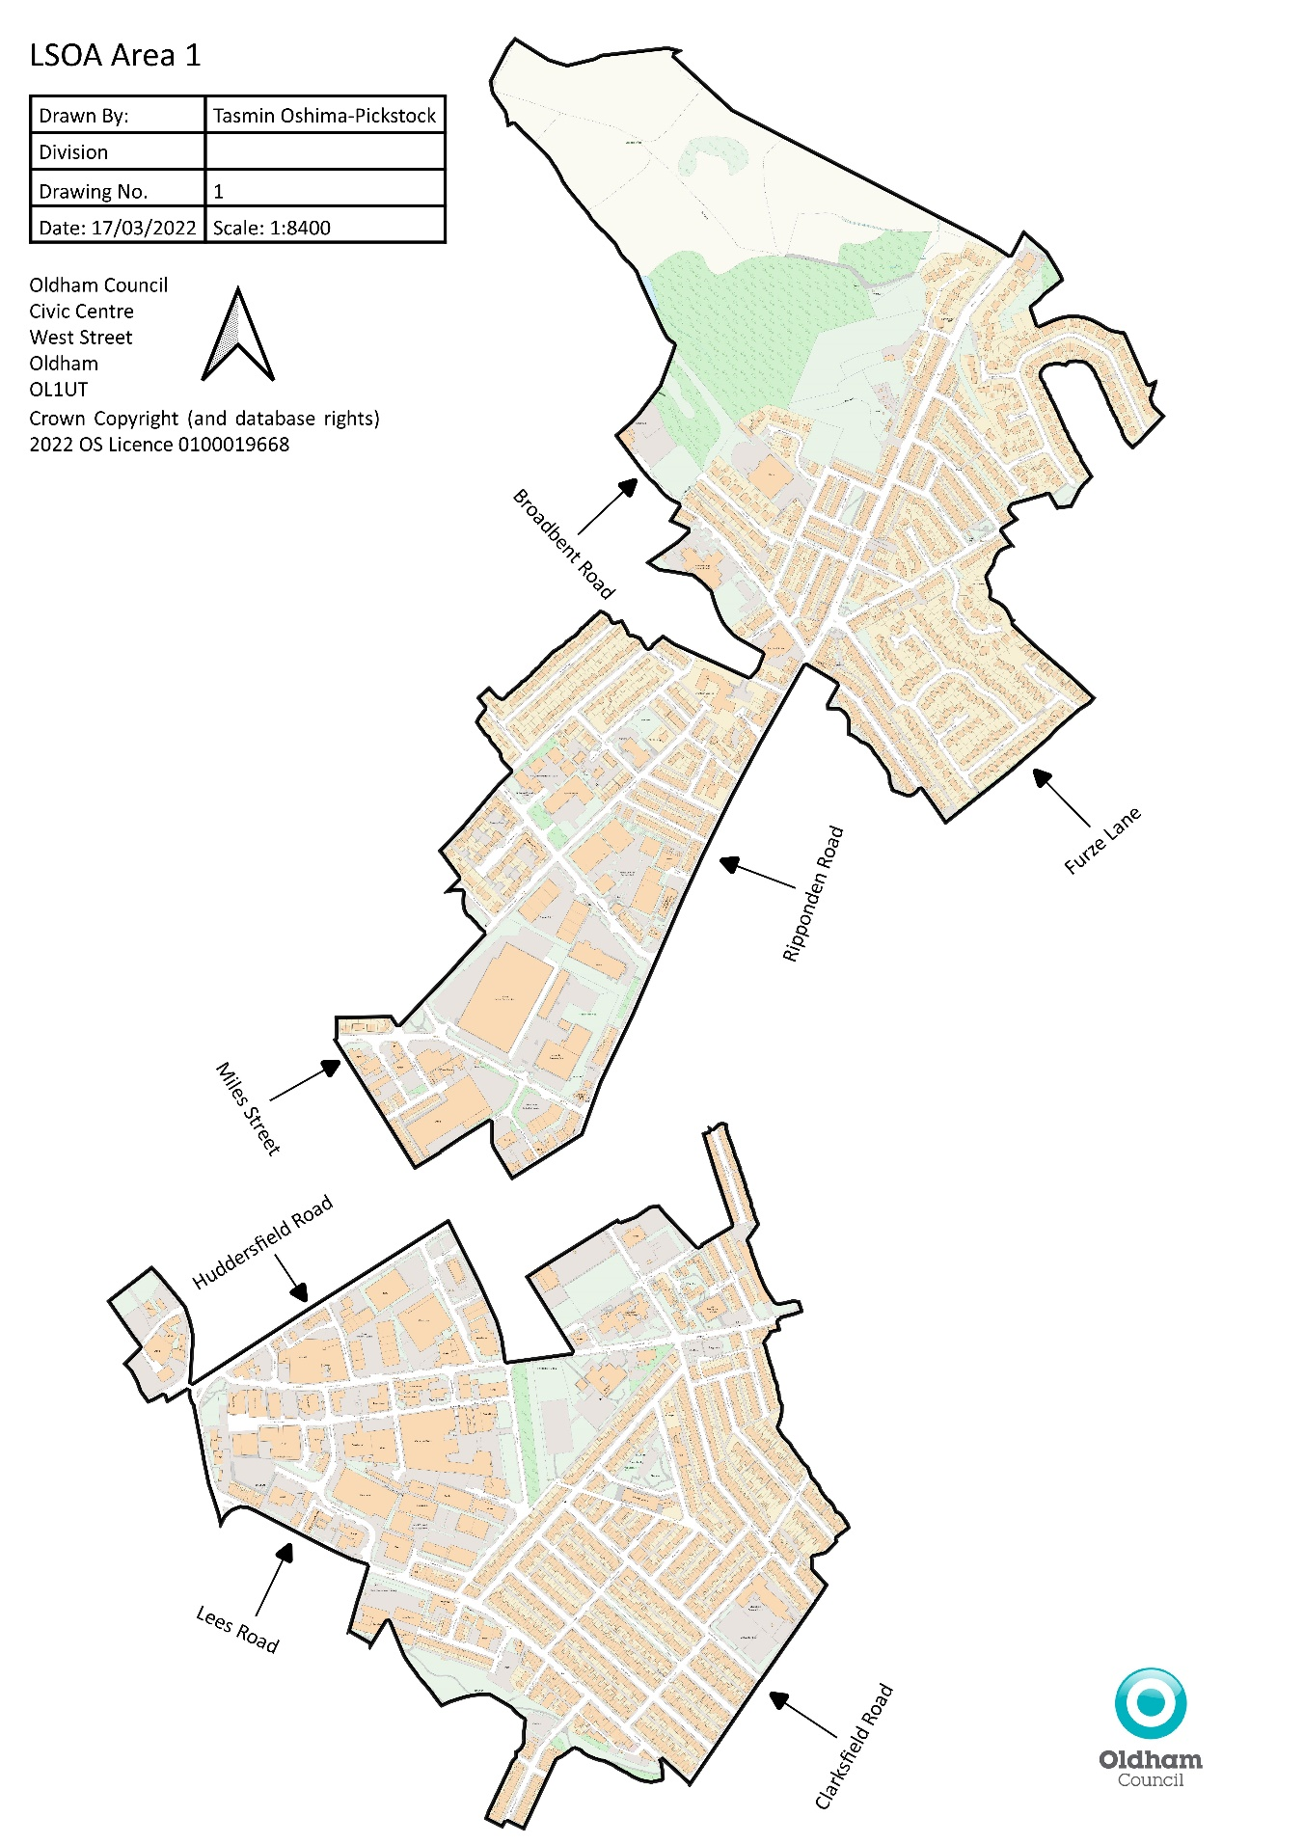

AREA 2

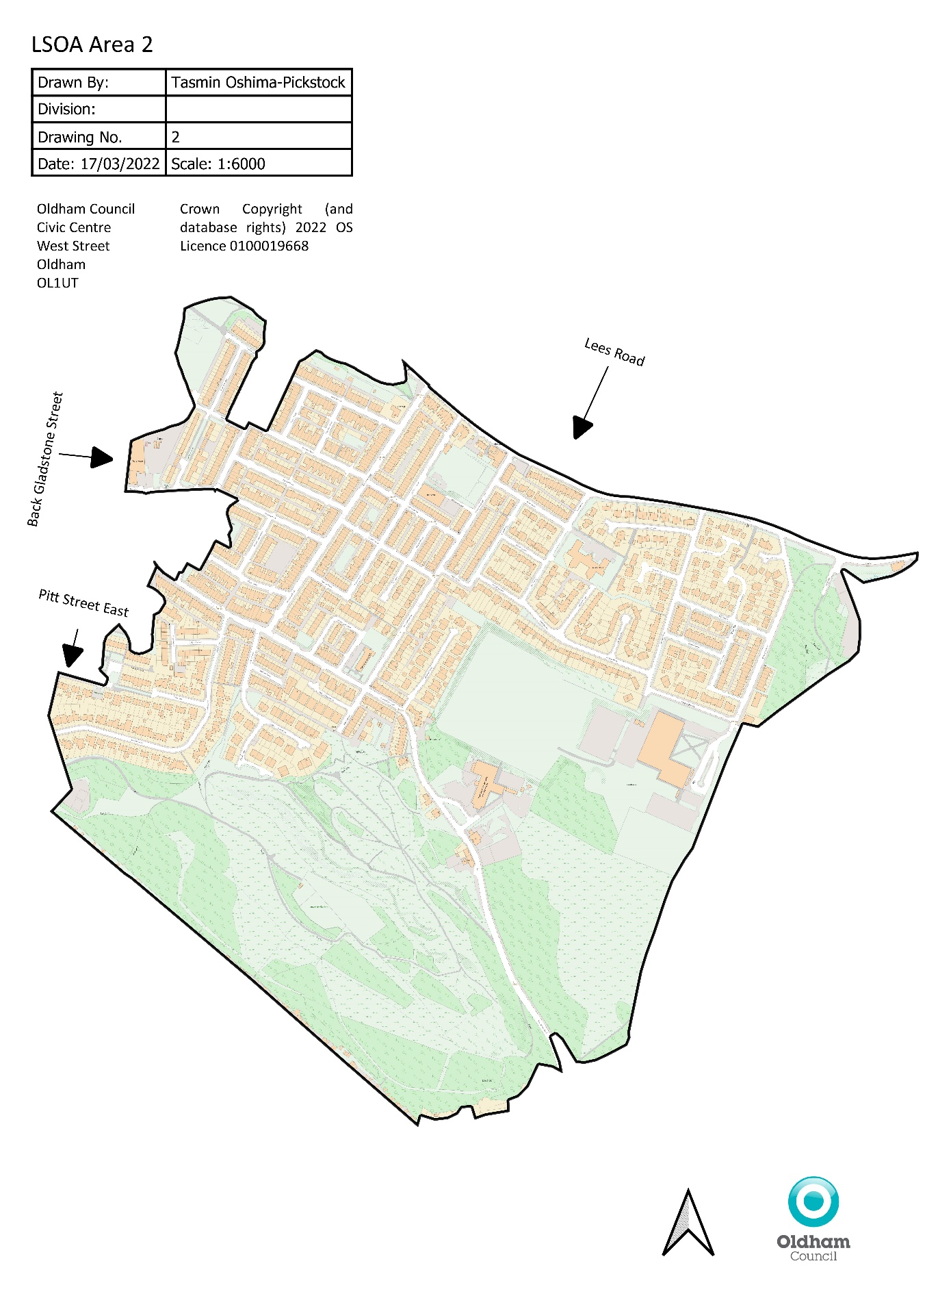

AREA 3

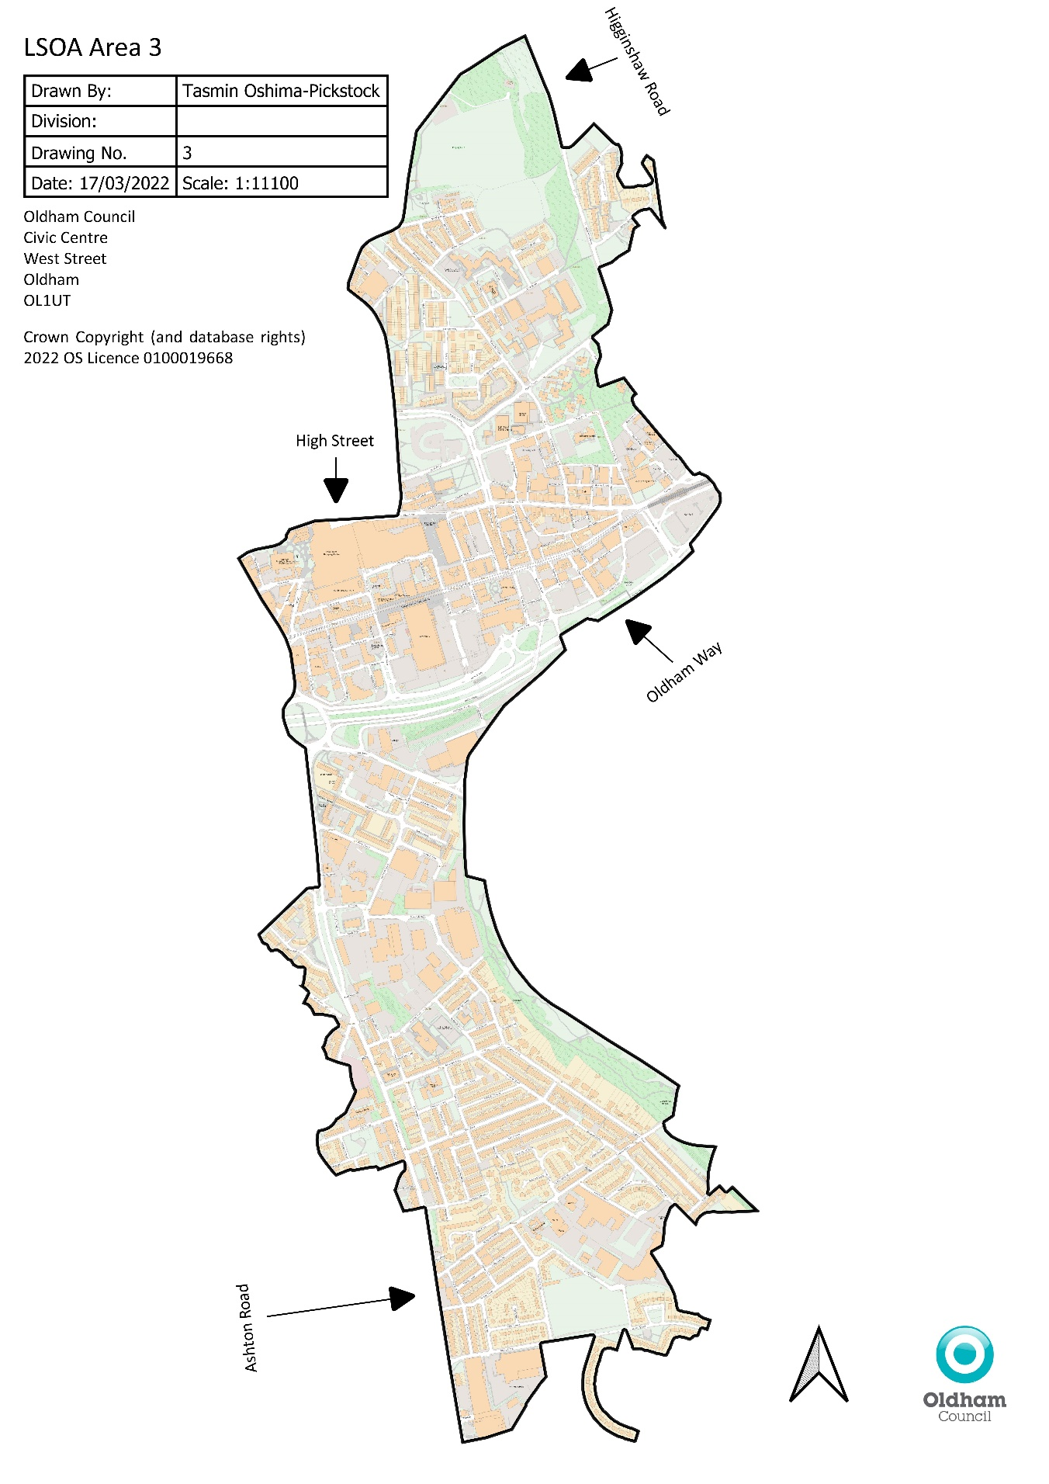

AREA 4

Map 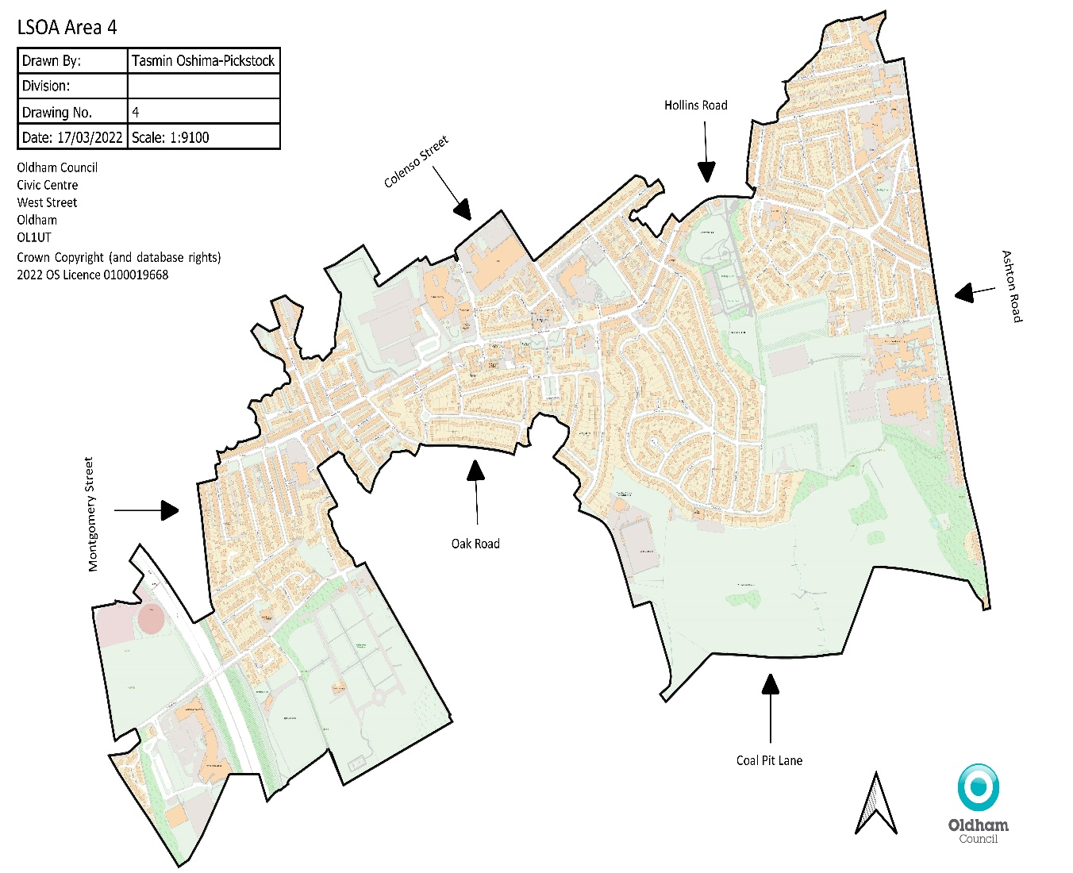

AREA 5

Map o