Oldham Metropolitan Borough Council

Selective Licensing review report

December 2020

Main Contact: Helen Brzozowski
Email: helen.brzozowski@arc4.co.uk
Telephone: 07721011276
Website: www.arc4.co.uk
© 2020 arc⁴ Limited (Company No. 06205180)

Table of Contents
1. Introduction 3
Overview 3
2. The indicators that have been reviewed 4
3. Comparison of data 8

List of Tables
Table 2.1 Sources of Data Used to Identify Areas of Low Housing Demand 4

List of Maps
Map 3.1 Ward based ranking of 14 indicators 9
Map 3.2 Wards falling in quartile one in total of 14 indicators 10
Map 3.3 LSOA based ranking of 14 indicators 11
Map 3.4 LSOAs falling in quartile one in total of 14 indicators 12

This report takes into account the particular instructions and requirements of our client. It is not intended for and should not be relied upon by any third party and no responsibility is undertaken to any third party.
arc⁴ Limited accepts no responsibility or liability for, and makes no representation or warranty with respect to, the accuracy or completeness of any third party information (including data) that is contained in this document.

Registered Address: arc4, 41 Clarendon Road, Sale Manchester M33 2DY
Email: contact@arc4.co.uk www.arc4.co.uk
arc4 Limited Registered in England & Wales 6205180 VAT Registration No: 909 9814 77
Directors - Helen Brzozowski – Michael Bullock

Introduction

Overview
- A selective licensing designation may be made if the area to which it relates satisfies one or more of the following conditions. The area is experiencing:
- low housing demand (or is likely to become such an area);
- a significant and persistent problem caused by antisocial behaviour;
- poor property conditions;
- high levels of migration;
- high level of deprivation; and
- high levels of crime.
- In Oldham MBC, the council is planning to consult on the potential locations that may be included in a selective licensing designation under the low demand criteria.
- In May 2019, arc4 published a report that compared the findings of the 2014/15 report produced by Oldham Metropolitan Borough Council (OMBC) in respect of key statistical data and indicators pertaining to the selective licencing of landlords. The report provided an update on parts of Section 7 of that report, the Low Demand Evidence Base (including tables 4 -16). https://www.oldham.gov.uk/downloads/file/3488/statistical_report. The report also included some supplementary or alternative indicators to the council’s original evidence base to support the identification of specific locations that may be designated within selective licensing.
- Since then, the council has developed its consultation documents to engage with local landlords and stakeholders about the potential locations. However, Covid-19 has delayed the consultation process which the council now plans to undertake in 2021. However, the council must ensure that the consultation and proposed locations for selective licensing are underpinned with the most robust and up to date information and arc4 has been appointed to review the indicators that were originally used in 2019 and ensure that the current performance of those indicators would still support a selective licensing designation.
- In the original report published in May 2019, individual indicators were considered at LSOA geographical boundary. Locations were allocated a quartile depending on their performance against each indicator. Those with the worst score were allocated into quartile 1 and those with the best performance quartile 4. In determining those locations for selective licensing, those LSOAs with the highest number of indicators in quartile 1 were identified and mapped.
- This report compares the LSOAs that were identified as having the highest number of indicators with quartile 1 scores in 2019 compared to their current performance.

The indicators that have been reviewed
Table 2.1 Sources of Data Used to Identify Areas of Low Housing Demand
Factor | Data Source | Measure | Weighting | Quartile Rent | Output Areas
Total Households* | ONS 2011  Census Table KS402 | Number of Households | N/A | N/A | LSOA
Tenure: Private Sector Households* | ONS 2011  Census Table KS402 | % Households Privately renting | 100% | 1 = lowest quartile (highest %), to  4 = highest quartile (lowest %) | LSOA
Vacant Stock | Council Tax extracts in Early 2020 | % Vacant Dwellings | 100% | 1 = lowest quartile (highest %), to  4 = highest quartile (lowest %) | LSOA
Property Prices | ONS HPSSA dataset 11 and  Land Registry  Sale prices to 2020 | Ranked low to high values:-  - lower quartile  - median | 100% | 1 = lowest quartile (lowest value) to  4 = highest quartile (highest value) | LSOA
Rental Values | LLPG and Academy extracts in March 2020 | Per calendar month.  Ranked low to high values | 100% | 1 = lowest quartile (lowest value) to  4 = highest quartile (highest value) | LSOA
Rental Yields | Land Registry and Zoopla data to 2020 | Mean and Median** rents as percentage of average values | 100% | 1 = lowest quartile (lowest yield) to  4 = highest quartile (highest yield) | LSOA
Property prices | HM Land Registry data | Change in lower quartile property price pre- and post-introduction of PRS licensing. The lower quartile prices for the four years 2011-2014 (pre-licensing) and 2020 (post-licensing) have been averaged and the change in averages between the two periods calculated | 100% | 1 = lowest change (%) to  4 = highest change (highest %) | LSOA
House prices | HM Land Registry data | Change in lower quartile house price pre- and post-introduction of PRS licensing. The lower quartile prices for the four years 2011-2014 (pre-licensing) and 2020 (post-licensing) have been averaged and the change in averages between the two periods calculated | 100% | 1 = lowest change (%) to  4 = highest change (highest %) | LSOA
2 bed house prices | Zoopla 2020 | Median Quartile property prices (2 bed houses) 2019 | 100% | 1 = lowest quartile (lowest value) to  4 = highest quartile (highest value) | LSOA
2 bed house prices | Zoopla 2020 | Change in median quartile 2 bed house price pre- and post-introduction of PRS licensing. The median quartile prices for the four years 2011-2014 (pre-licensing) and 2020 (post-licensing) have been averaged and the change in averages between the two periods calculated | 100% | 1 = lowest change (%) to  4 = highest change (highest %) | LSOA
2 bed houses rent levels | Zoopla 2020 | Lower quartile rent levels by property type (2 bed houses) | 100% | 1 = lowest quartile (lowest value) to  4 = highest quartile (highest value) | LSOA
Rent levels | Zoopla 2020 | Change in lower quartile rents 2 bed house price pre- and post-introduction of PRS licensing. The lower quartile rent for the four years 2011-2014 (pre-licensing) and 2020 (post-licensing) have been averaged and the change in averages between the two periods calculated | 100% | 1 = lowest change (%) to  4 = highest change (highest %) | LSOA
Time to let | Zoopla 2020 | Change in the time to let property pre- and post-introduction of PRS licensing. The time to let property for the four years 2011-2014 (pre-licensing) and 2020 (post-licensing) have been averaged and the change in averages between the two periods calculated | 100% | 1 = highest change (%) to  4 = lowest change (highest %) | LSOA
Voids | Oldham MBC | Change in the long-term void levels pre- and post-licensing. The percentage of long term voids for the four years 2011-2014 (pre-licensing) and 2020 (post-licensing) have been identified and the change in percentages between the two periods calculated | 100% | 1 = highest change (%) to  4 = lowest change (highest %) | LSOA

Note: * The OMBC 2014/15 report stated ‘Dwellings’ here. 2011 Census table KS402 counts households. ‘Dwellings’ are counted in other census tables but are not reported on by tenure. See para 2.1
** The OMBC report stated ‘average’ – unless otherwise stated this update uses Median values (rather than arithmetic mean) but for the purposes of alignment, we have used ‘mean’ in part 2 of the report for this indicator.

Comparison of data
- In the final analysis we have considered two types of scoring at both Ward and LSOA level.
- The first scores each of the 14 indicators into a quartile and adds overall scores together to give an overall final score which itself is then quartiled. Those locations in Quartile one are the worst performing locations.
- The second considers each of the 14 indicators and the quartile score for each location. It then identifies the total number of times that the location fell within a quartile one score.
- Map 3.1 shows the current wards in the first and second quartiles based on the updated information and illustrates whether each ward was in the first or second quartile in the May 2019 report using either a ‘diagonal’ line or a ‘crossed’ line. For example, in the current updated report Coldhurst is in the first quartile identifying it as one of the worst performing locations for all indicators and as it has diagonal lines running across it also indicates that in the May 2019 report it was in quartile one too. Overall, Map 3.1 illustrates that the focus for quartile one and quartile two wards is much more closely aligned to adjacent wards within more urban locations than in May 2019. It removes Saddleworth South, Saddleworth West and Lees, Hollinwood, Chadderton North and Royton North from second quartile locations in May 2019. In the updated report Royton South and Shaw now become second quartile wards and St. James becomes a quartile one ward. None of these wards were previously in quartile one or two. However, seven of the 10 wards that feature in quartile one and two in the updated report were previously in quartile one and two in the May 2019 report.
- Map 3.2 shows the previously identified LSOAs, in the May 2019 report, that were designated as potential areas for selective licensing. All of these locations still remain in locations where there are significant numbers of quartile one scores for indicators.
- Map 3.3 considers the LSOAs that are scored as first quartile or second quartile over all locations. It is clear to see that in all cases those LSOAs that were proposed for licensing in the May 2019 report still score as first or second quartile scored locations and therefore remain appropriate for consideration for licensing.
- Map 3.4 shows the previously identified LSOAs, in the May 2019 report, that were designated as potential areas for selective licensing and shows the number of times that the LSOA scored in quartile 1 for each of the 14 indicators. In all cases the LSOAs still retain some of the highest scores for quartile one indicators.
- This updated report has demonstrated that the proposed locations for selective licensing designation, whilst have some changing scores are still those locations that feature as some of the worst performing locations in the borough. It is therefore appropriate that the council consider this updated report and the May 2019 report as a joint evidence base to underpin their decision for selective licensing locations.

Map 3.1 Ward based ranking of 14 indicators
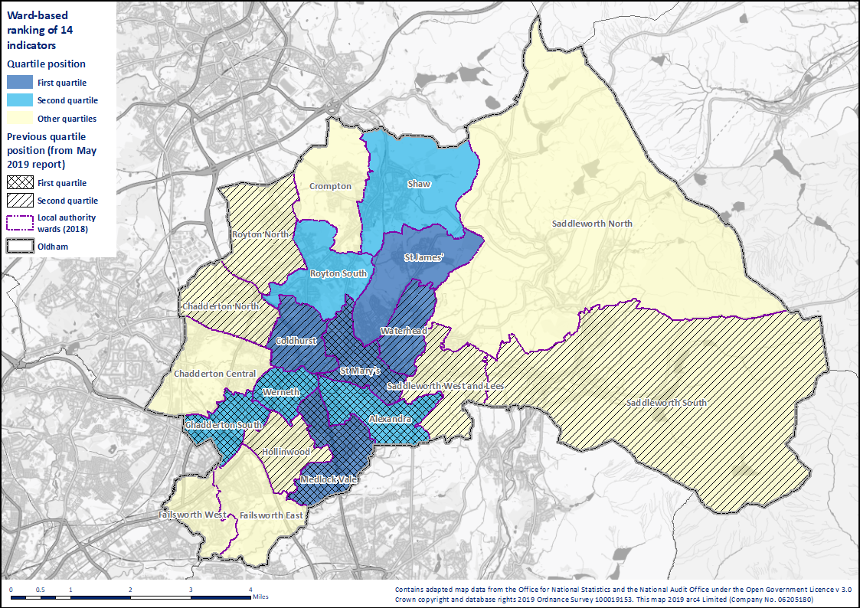
Map 3.2 Wards falling in quartile one in total of 14 indicators
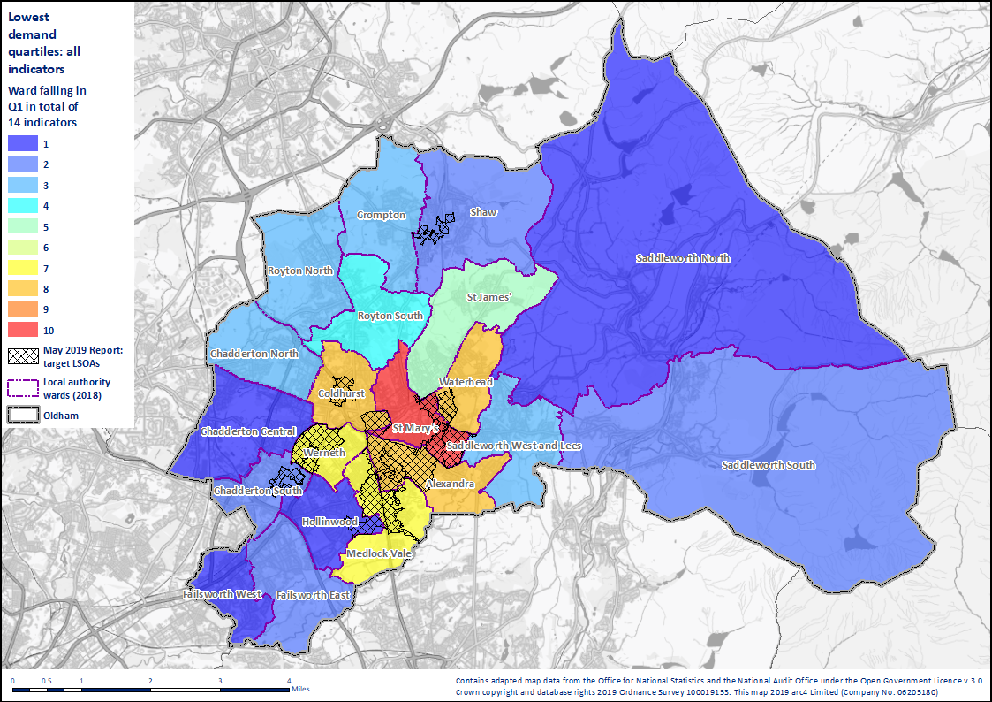
Map 3.3 LSOA based ranking of 14 indicators
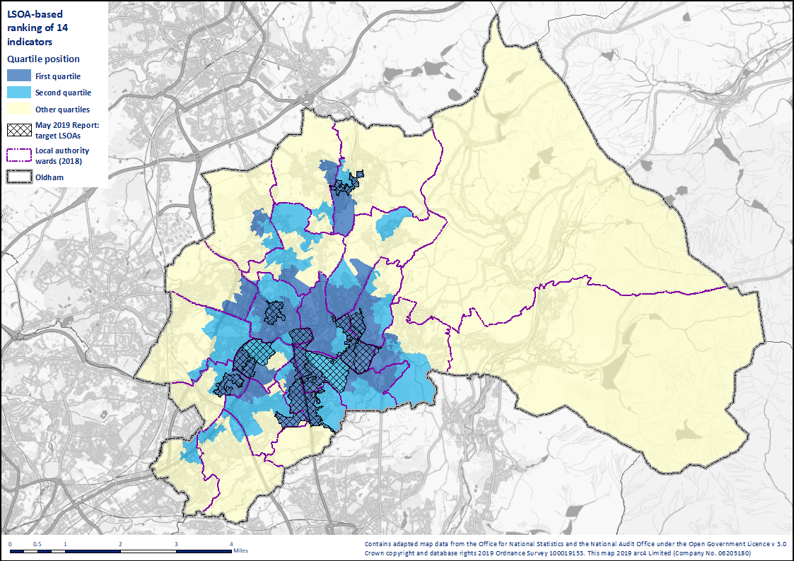
Map 3.4 LSOAs falling in quartile one in total of 14 indicators
