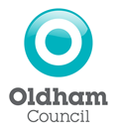

GAMBLING ACT 2005
Revision of Statement of Principles

Take notice that Oldham Council has today published its revised statement of principles under the Gambling Act 2005.

The statement comes into effect on Monday 17th January 2022.

Anybody wishing to view the statement can do so online at www.oldham.gov.uk/licensing
Or
By appointment at the Council offices below by emailing: licensing@oldham.gov.uk

Sir Robert Peacock House
Vulcan Street
OLDHAM, OL1 4LA

Signed:
John Garforth
For and on behalf of Oldham Council

Dated this 16th day of December 2021

