Guidance on Plans

General
An application for the grant of a Premises Licence must be accompanied by a floor plan of the premises you propose to licence.
In addition to this, if you propose to alter the layout of an existing licensed premises, an application is required to reflect these alterations and an updated floor plan is required.
This guidance has been created to assist applicants with what is required of a floor plan and how they can create one.

What is a floor plan?
For the purpose of the Licensing Act 2003, a floor plan is required of the premises you propose to licence. The best way to do this is to pretend you are floating above your premises and looking down at it – this is the view that you should draw.

Plan Requirements
There are certain things that are required by the Licensing Act 2003 to be included in any floor plan – outlined below.
The plan does not need to be in any particular scale, but it must be in a format which is “clear and legible in all material aspects” i.e. it must be accessible and provide sufficient detail for the Licensing Authority to be able to determine the application, including the relative size of any features relevant to the application. The plan must show the following information:

- Extent of the boundary of the building, if relevant, and any external and internal walls and, if different, the perimeter of the premises
- The location of access to and egress points from the premises
- Escape routes (if these are different from above)
- In a case where the premises is to be used for more than one licensable activity, the area within the premises used for each activity
- All fixed structures (including furniture) or similar objects temporarily in a fixed location (but not furniture) which may impact o the ability of individuals on the premises to use exits or escape routes without impediment
- Raised flooring areas (the location and height of each raised area)
- The location of any steps, stairs, elevators or lifts
- Public conveniences
- All fire safety equipment (location & type)
- Location of kitchen (if any)

The plan may include a key where items outlined above can be illustrated by use of symbols on the plan.

Other things to consider
In addition to the statutory requirements above, we also ask that the location of any CCTV cameras is included on the plan, however, this is not mandatory.

Example drawing
The below is an example of a floor plan. Please note – this drawing is for illustrative purposes only and has not been drawn to scale. Your plan must be tailored to your premises and include all relevant information outlined above.
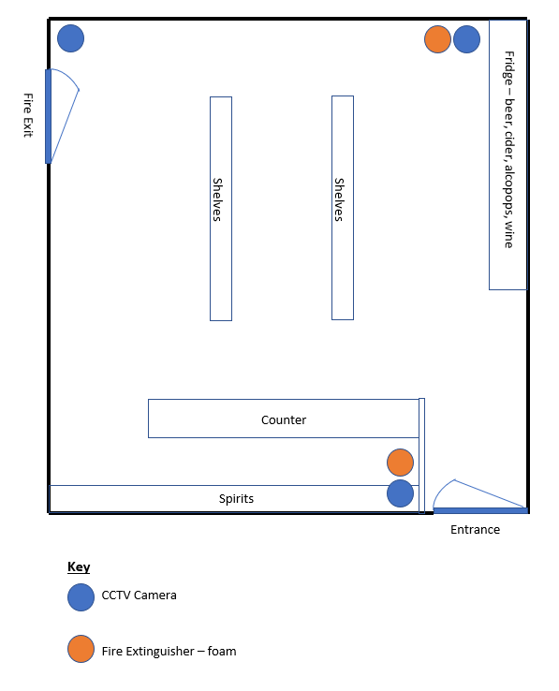

Useful contact information/links:
The Licensing Service receive applications and respond to queries by email. You can contact a member of the team at licensing@oldham.gov.uk
The Licensing Service provides all their application forms and guidance on the Council website. These can be found at www.oldham.gov.uk/licensing.
The Licensing Act 2003 can be found online at https://www.legislation.gov.uk/ukpga/2003/17/contents
Statutory Guidance can be found online at https://www.gov.uk/government/publications/explanatory-memorandum-revised-guidance-issued-under-s-182-of-licensing-act-2003

