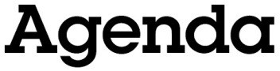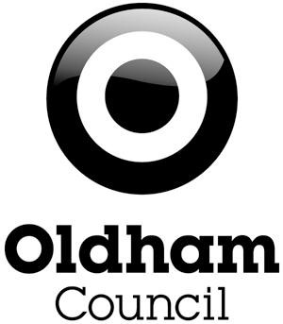

Oldham Town Deal Board Meeting

28th June 2021, 13.00-15.00
Virtual meeting over Microsoft Teams (see calendar invitation for joining instructions)

Welcome

Peter Holbrook, Chair of the Oldham Town Deal Board Councillor Arooj Shah, Leader of Oldham Council

Apologies for absence

Peter Holbrook, Chair of the Oldham Town Deal Board

Notice of any urgent business to be accepted onto the agenda and reasons for that urgency

Peter Holbrook, Chair of the Oldham Town Deal Board

Declarations of interest

Peter Holbrook, Chair of the Oldham Town Deal Board

Minutes of the previous meeting (5th March 2021)

Peter Holbrook, Chair of the Oldham Town Deal Board

Procedural business and any items accepted as urgent business

Peter Holbrook, Chair of the Oldham Town Deal Board

Substantive business

Peter Holbrook, Chair of the Oldham Town Deal Board
Roger Frith, Head of Regeneration and Development, Oldham Council

  - Grant award / Heads of Terms
  - Project allocations
  - Recommendation(s)
  - Vote

Next steps

Peter Holbrook, Chair of the Oldham Town Deal Board

AOB

Peter Holbrook, Chair of the Oldham Town Deal Board

- Time and date of next meeting: TBA for late July/early August

