Health Improvement and Weight Management Services

Public Engagement Exercise Results

January 2020

Contents
Executive Summary 3
Health Improvement Services 3
Key issues from the survey 3
Key issues from Focus Group Activity 3
Weight Management Services 3
Key issues from the survey 3
Key issues from Focus Group Activity 4

Background 5

Methodology 5
4.0 Results 7
4.1 Online Survey 7
4.2 Health Improvement Services 7
4.3 Weight Management Services 9
4.4: Bringing Services Together 11
4.5 ABL focus Group 12
4.6a: Access to services 13

Executive Summary
This engagement activity reached around 50 residents this included a mix of those with experience of services within scope of the commissioning activity and those with an interest. All respondents indicated one or more Health and/or wellbeing issues. A range of views were gathered around the provision and delivery of services. Around two-thirds of respondents agreed in principle to the merging of Health Improvement and Weight Management services.

Health Improvement Services

Key issues from the survey

- Two thirds have tried to access Health improvement services only 40% say services were easy to access.

- 7 in 10 would like to refer in to Health improvement services online. Next most popular is the GP

- Participants indicated that they would like to see Health improvement services delivered in the community or from a GP practice

Key issues from Focus Group Activity

The following key issues emerged from focus group activity

- Promotion and awareness raising
- Delivering services flexibly
- Sharing the right information at the right time to the correct audience
- Involving users in the design of services

Weight Management Services

Key issues from the survey

- Only four respondents indicated that they have accessed weight management services

- 43% of respondents strongly agreed that involving all members of the household would lead to changes towards a healthier lifestyle

- Respondents felt that their household were most likely to respond to activities tailored to the needs of their household (bespoke)

- 8 out of 10 respondents indicated that they preferred for services to be delivered in person. There was also support for online support and the use of an application

- Over half stated that services should be community based whilst half felt they should be delivered at GP practices

Key issues from Focus Group Activity

- Respondents praised the facilitators delivery and attitude and the positive nature of feedback. Respondents also indicated a favour of tools such as the food diary and the provision of information

- Keys areas for improvement included facilitation, flexibility, developing peer support mechanisms, routes into the service (referral).

Background
Health improvement services including support around diet, physical activity, support to stop smoking, safe alcohol consumption and concerns around wellbeing are currently commissioned by Oldham Council. Support for those with more complex weight management issues are currently delivered separately by an external partner on behalf of NHS Oldham Clinical Commissioning Group (CCG). Our plan is to bring these services together.

This public engagement was conducted by the Oldham Council Research, Engagement and Consultation team and Action Together Oldham.

Methodology
Explain the methodology that was used (questionnaire, focus group etc), communications undertaken, how many questionnaires (where appropriate) were sent out, and what the response rate was. You can also include the demographics of the achieved sample here if they have been collected and where relevant. A mixed method approach was taken to enable as wide an audience to take part. It was recognised that given the nature of the topic, that a widespread response was unlikely.

3.1 Online Survey
An online survey was conducted. This was shared vis social media. A total of 14 responses were received. The results of this survey can be found in section four of this report. The survey was available to the public for a period of 4 weeks (5 Dec 2019 to 3 January 2020)

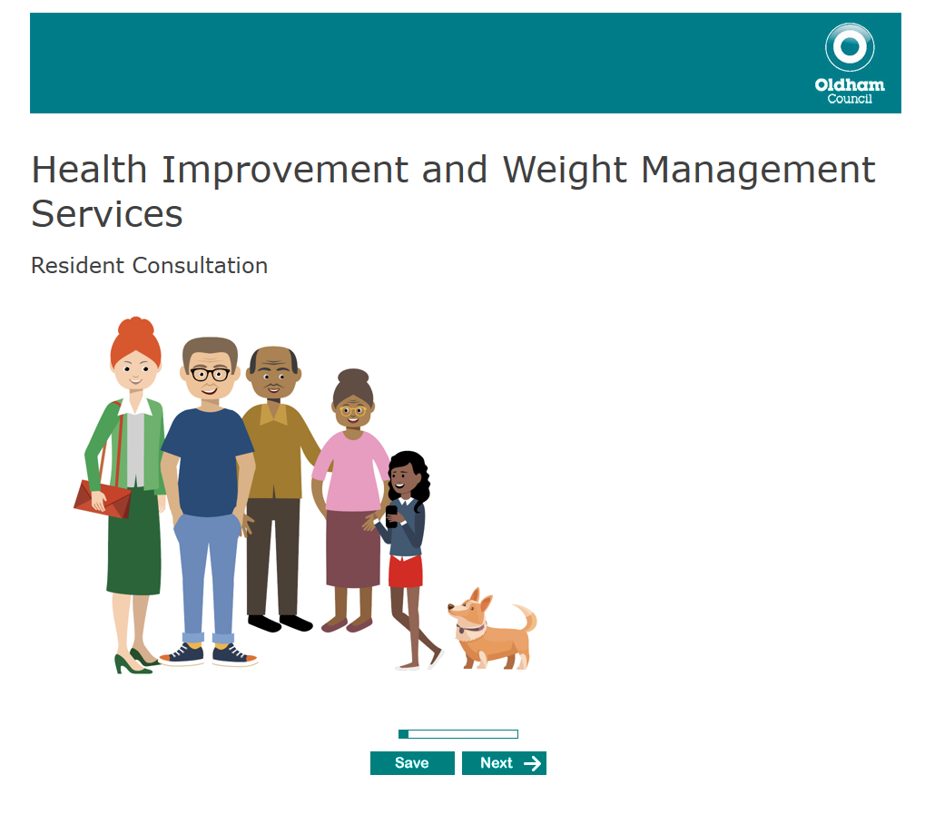
Figure 1: Online Survey

3.2 Focus Group

Focus groups were conducted, three of these with current ABL Service users and one with the people of Oldham.

3.2a ABL Focus Groups
Two groups were held in December 2019, with a total of twelve ABL users taking part.
Participants were asked the following questions:

- What is working well
- How can we improve the offer?
- Referral and delivery

3.2b General Residents
Inspire Women (Barn Street, Oldham) kindly allowed Nayan Joshi of Action Together Oldham, to conduct a focus group of 10 Oldham residents to discuss the following to help in the development of the market engagement exercise.

- How would participants like to access services?
- What experience have people had of accessing services?
- What do you think is important when considering new service offer? Levels of agreement 1-5
- How can we best ensure that residents are able to engage in the new service? What is important to you?

3.3 Respondent Profile
3.3a: Online
Responses were received from people in Royton, Shaw and Crompton, Failsworth, Springhead, Watersheddings Moorside.

86% respondents are female (n12) with one male (n1) one participant preferred not to state their gender.

Respondents were aged between the ages of 25 and 54 years. (see figure 2)
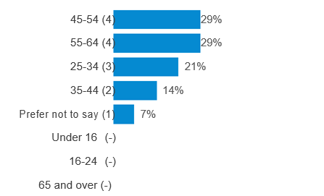
Figure 2: Online respondent age breakdown

3.3b: Focus Groups
Of the12 taking part in ABL focus groups nine are female and three males. Six of those attending was from Black and minority ethnic communities (BAME) and five white British. One attendee was Polish. Interpreters were used for two participants to allow all to take part in the conversation.

10 women took part in Inspire Women’s group, coming from across Oldham. A range of backgrounds were represented

4.0 Results
Section four explores the findings of all engagement activity. Given the low numbers any reported findings must be indicative and for information purposes only.

4.1 Online Survey

4.1a Health Issues
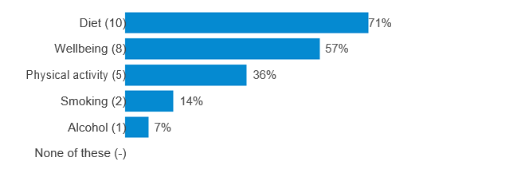
Figure 3:Do you, or any other member of your household have concerns about any of the following?

Over 70% respondents stated that they had issues with their diet, whilst nearly six in ten told us that they had concerns over their wellbeing. Physical activity was a concern for over a third of respondents.

4.2 Health Improvement Services

4.2a: Access to services

Around two thirds (64%) respondents have tried to access Health Improvement services. Those who have accessed services were asked to rate how easy or difficult it was to access these services.

Figure 4 shows that 40% respondents indicated that services were relatively easy to access, although one respondent did state that s/he had had some difficulty.

Figure 4:Have you or another member of your household tried to access Health Improvement Services?

Figure 5 indicates that respondents would most commonly wish to access services via an online self-assessment (71%). Other access avenues included GP and other health professionals. Other routes stated including access via the voluntary sector or through the workplace.

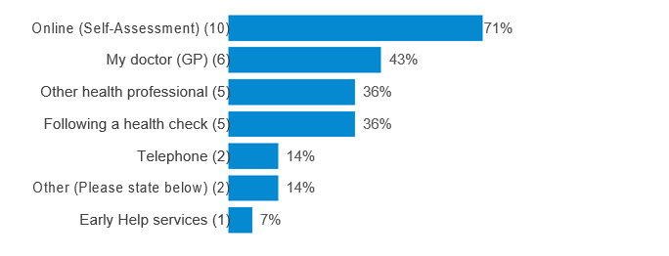
Figure 5:How would you like to be able to access Health Improvement Services?

4.2b Delivery of services
Figure 6 shows that around 8 out 10 respondents would like to see the services delivered in the community. Other population options included from a GP practice and from a central location

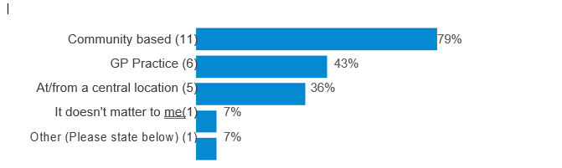
Figure 6:Where would you like to see Health Improvement Services delivered?

4.3 Weight Management Services

4.3a: Access to services
Only four respondents (29%) have tried to access weight management services. Those who have accessed services were asked to rate how easy or difficult it was to access these services.

Figure 7 shows that respondents found it more diffcult to access services.

Figure 7:How easy or not was it to access weight management services?

4.3b Approach
Oldham Cares believes that involving the entire household in support leading to behaviour change around weight management will lead to more ongoing sustainable change. This is called a family approach.

Or support could be designed around the individual. In this only the person with concerns about his or her weight would receive support on an individual basis independent of his/her household. This is called a person-centred approach.

Figure 8 shows that most commonly participants felt that the person-centred approach was most appropriate.

Person Family
Centred Centred

Figure 8:Overall, what approach do you believe would be best suited for the delivery of weight management support for your household?

43% of respondents strongly agreed that involving all members of the household would lead to changes towards a healthier lifestyle (figure 9)

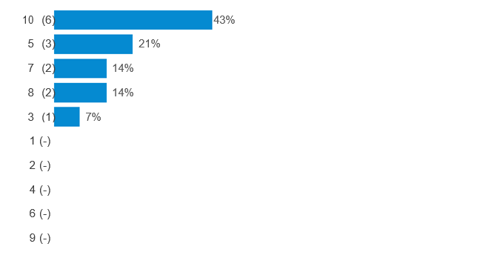

Figure 9:To what extent do you agree that involving all members of the household can lead to changes towards a healthier lifestyle?

Table one indicates that most commonly respondents felt that their household were most likely to respond to activities tailored to the needs of their household (bespoke) Conversely respondent’s resistance to support being delivered alongside other similar households

 | Very  Unlikely |  |  |  |  |  |  | Very  Likely
 | 1 | 2 | 3 | 4 | 5 | 6 | 7 | 8 | 9 | 10
Tailored to the needs of your household | 15% | 0% | 0% | 8% | 0% | 23% | 15% | 15% | 8% | 15%
Your household receives support alongside with other households | 46% | 15% | 8% | 0% | 8% | 8% | 8% | 0% | 0% | 8%
A combination of both | 36% | 7% | 0% | 7% | 21% | 14% | 0% | 7% | 0% | 7%
Table 1:How likely is it that members of your household would engage with support delivered in the following ways?

4.3c Delivery
8 out of 10 respondents indicated that they preferred for services to be delivered in person. There was also support for online support and the use of an application (figure 10)When asked where services should be delivered over half (57%) stated that services should be community based whilst half felt they should be delivered at GP practices (figure 11)

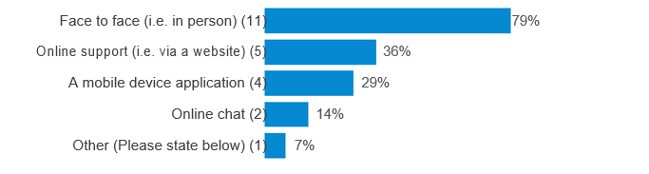
Figure 10: How would you like services and support do be delivered to your household?
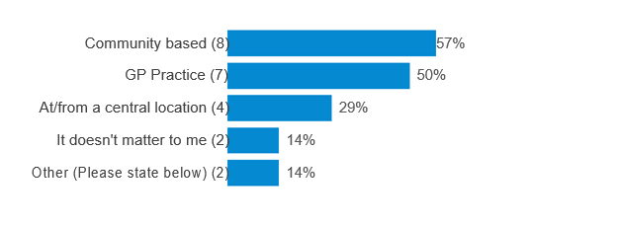
Figure 11:Where would you like to see services delivered?

4.4: Bringing Services Together
When asked to consider if Health Improvement and Weight management services should be amalgamated, half strongly agreed (Figure 12)

In the following question 1 is "Strongly disagree" and 10 is "Strongly agree"
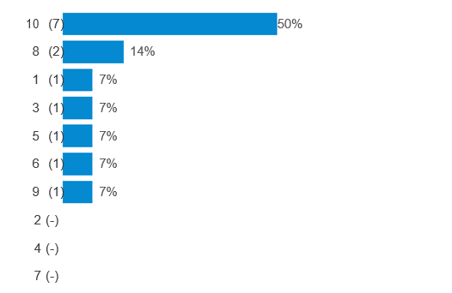
Figure 12: To what extent do you agree that we should bring together our Health Improvement and Weight Management Services?
When further asked to explain their response, the following comments emerged.

Only one respondent strongly disagreed with the proposal. S/he is expressing concern

“When Pennine Care used to deliver the Health Improvement Service it was better funded and had more impact. There is no proper smoking cessation service now which a scandal is. I would not want to see weight management go the same way.”

For those expressing a strong level of agreement expressed that a joined-up approach would be good in the following ways:

- Will work more effectively and everything under one service rather than being sent from pillar to post
- It will allow for a more joined-up approach, with all having access to the right and up to date information that can be tailored to the person's specific needs
- Because weight issues are more often than not linked to other issues so should not be dealt with separately but should address underlying issues.

4.5 ABL focus Group
The following is a summary of issues raising from the two ABL focus groups.

4.5a What is working well
Most commonly respondents praised the facilitators delivery and attitude and the positive nature of feedback. Respondents also indicated a favour of tools such as the food diary and the provision of information

Figure 13: Tree map of Things working well with weight management services (n38)

4.5b How can improve? (n27)

When asked how weight management services, respondents raised the following issues or concerns.

Facilitation.
Overall the facilitation of groups was praised however it was felt that more could be done to allow participants to be better prepared for the next session. There was also some indication that some participants felt that facilitators should be more aware of the varying levels of knowledge at each session.

Flexibility
Respondents noted that sessions could/should be delivered on a more regular basis and there should be flexibility around how and when sessions are delivered to allow for those unable to attend sessions. Suggestion included more regular (weekly sessions) as well as the use of technology

Peer Support
Respondents indicated the importance of peer support and encouraged the development of resources such as online support like that currently in place using the Facebook platform. Similarly, several respondents felt that they did not really know the other participants. Suggestions included buddying for gym sessions and group visits to the supermarket to fully understand the nature of food labelling

Diet and exercise
Respondents felt that information around diet and exercise was an essential part of the service. Suggestions included the sharing of recipes and exercise classes. Further, it was suggested that more could be done to improve links with Oldham Community leisure and Lifelong learning.

4.5c Referral (n32)

Health Professional
Eleven respondents commented on the role the General practioners play in the referral process. Most commonly respondents lamented the time taken for a referral to be made and the time taken between the initial referral and attendance at the first session. Anecdotally, this process could take several months to take part.

Some respondents also raised doubts over the awareness of GPs around the existence of services. Respondents also felt that training could be developed to enable GPs to have the initial conversation around weight, some indicating that it seemed that for some the topic of excess weight was still taboo.

Other referral routes
Respondents commented that users should not need to rely on a health professional to access the service. Suggestions included self-referral and via the place of work.

Promotion
Six respondents felt that more should be done to raise awareness of the services. Suggestions included the use of social media as well as more traditional methods such as posters in public places.

4.6 Inspire Women’s Focus group

4.6a: Access to services (n12)
Participants felt that they should be able to access services through pharmacists and health checks. Participants expressed the importance of sharing information regarding the services. Self-referral was also seen as being important either online or in person.

“Being able to walk in without appointment e.g. at doctors, pharmacies, walk in centres, libraries, voluntary sector organisations.”

4.6b: Experience of services (n20)

General Practioner

“Had a hard time with GPs don’t really get any advice on these things -but that maybe the way I am feeling…”

“GP are scare if you go in and cry they don’t have enough time to focus on the real problems”

- GP wanted to add more tablets before referring me
- GPs don’t really read notes
- I feel let down as I feel GPs don’t care and don’t help
- Lack of understanding /help
- Not being taken seriously (GP dismissive)

Difficulty with referral

“It has been very hard getting the right help at the right time -past from pillar to post having to start at the beginning each time.”

- Referral through social worker was quick and straight forward.
- Repeat prescription for smoking patches should be provided for continuity of treatment
- 3 year waiting to see a phycologist
- Long waiting time to access service 3 months from assessment to starting course

4.6c: Things to consider when designing the new service (n18)
Table 2 indicates the levels of importance attributed to respondents

 | Level of agreement
Your feelings | 5
Timescales being realistic | 5
Teach more people first aid | 5
Support for whole family | 5
More time with GP’s not rushed appointment | 5
Giving you the tools needed to make healthy choices | 5
Constant Motivation and engagement with patients | 5
Ask people that will use the services what they want not just decided for them | 5
A safe place that is close enough to get to in the community | 5
Will they really benefit those accessing them | 4
Links with community organisations | 4
Gender specific services | 4
A welcoming environment e.g. Informal coffee morning | 4
Where you can go in and have a chat about things with professionals | 3
Offer services in community centre instead of GP surgery | 3
Sympathetic workers that are willing to listen | -
On person to see you through the journey -having a person linked with mental health available with longer appointments and all the information you need, being able to book appointment with Mental Health professional or GP nurse without seeing GP first. | -
Table 2: What do you think is important when considering new service offer? Levels of agreement 1-5 (where 1 is low to 5 high)

4.6d: Engaging with residents (n24)
Participants were asked to consider how the people of Oldham could best be engaged with the new service

Promotion and raising awareness
Participants felt that efforts should be made to raise awareness of the service via tools such as social media, leaflets and posters. Participants felt that services should be promoted at locations such as public toilets, schools, colleges and community centres.

Flexibility
Suggestions included

- By having different options to suit different needs
- Later appointments/weekend appointments for stop smoking and weight loss
- Mobile health check units -that can go into schools and supermarkets, car parks.
- Services should be more flexible around individual need
- Stall in Market place like blood pressure checks and on the spot help

Provision of information
Participants stated the importance of ensuring the correct information is delivered to the right audience in the right way.

- By advertising in GP surgery and making sure the right information goes to the right people
- By giving them all the information needed at the start of their journey
- By holding drop-in sessions held in various places where you can get information and next step help
- Getting information out about available services
- Make sure people area ware of these things that are going on, make sure it’s the right thing for you.
- Wellbeing care for the professionals as well

Involving users in the design of services

- Do think research into what people want so the service is useful to them
- Getting people with lived experience to help shape and evolve the service
- Going into the community

