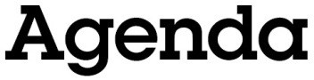

Oldham Town Deal Board Meeting

4th December 2020, 10.00-12.00
Microsoft Teams virtual meeting

Welcome, introductions and apologies

Peter Holbrook, Social Enterprise UK

Notice of urgent business to be accepted onto the agenda

Peter Holbrook, Social Enterprise UK

Declarations of interest

Peter Holbrook, Social Enterprise UK

Minutes of the previous meeting (5th November 2020)

Peter Holbrook, Social Enterprise UK

Community engagement activity

Liz Windsor-Welsh, Action Together

Capital acceleration grant update

Nawaz Khan, Oldham Council

Town Investment Plan review

Peter Holbrook, Social Enterprise UK
Stephen Cox and Anna Wallin, Mott MacDonald Nawaz Khan, Oldham Council

Recommendations and next steps

Peter Holbrook, Social Enterprise UK

AOB

Peter Holbrook, Social Enterprise UK

Close of meeting

Peter Holbrook, Social Enterprise UK

Time and date of next meeting: 10.00-11.00 on Friday, 5th February 2021

