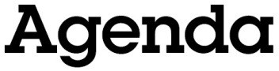

Oldham Town Deal Board Meeting
Friday, 24th July 2020, 13.30-15.30
Microsoft Teams virtual meeting

- Welcome, introductions and apologies

Peter Holbrook, Social Enterprise UK

- Notice of urgent business to be accepted onto the agenda

Peter Holbrook, Social Enterprise UK

- Declarations of interest

Peter Holbrook, Social Enterprise UK

- Minutes of the previous meeting (22nd May 2020)

Peter Holbrook, Social Enterprise UK

- Town Investment Plan update

Stephen Cox and Anna Wallin, Mott MacDonald

- Community engagement proposals

Liz Windsor-Welsh, Action Together

- Capital acceleration grant

Roger Frith, Oldham Council

- Recommendations and next steps

Peter Holbrook, Social Enterprise UK

- AOB

Peter Holbrook, Social Enterprise UK

- Close of meeting

Peter Holbrook, Social Enterprise UK

Time and date of next meeting: 13.30 on Friday, 21st August 2020

