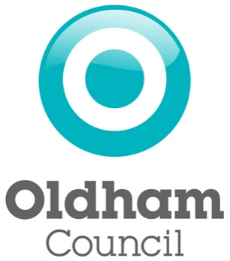

Contaminated Land Strategy for Oldham

June 2017
1.0 Introduction

Oldham and the surrounding towns were the centre of the Industrial Revolution in England. The Borough has seen intense industrial activity in many places from the 19th century to the present day.

Industrial activity in Boroughs such as Oldham has had a significant impact on the local environment. In particular it has left a legacy of potentially contaminated land at former industrial sites and at infilled mineral excavations. In a minority of cases there may be sufficient risk to health or the environment from this land and action will be required to address the risk.

Oldham’s former industrial land provides great opportunities for the Borough.

Such land is a major resource for:

- regenerating and developing existing communities

- meeting the demand for new housing using ‘brownfield’ land, thus preserving the nation’s treasured countryside

- developing new sustainable urban communities

In 2001 Oldham Borough Council published its first Contaminated Land Strategy. This Strategy stated how the Council was to take a proactive approach to:

Provide a risk based approach to identify and deal with any significant risk to health or the environment from potentially contaminated land

- Encourage the best use of this large urban land resource.

This 2017 strategy provides a review of the progress that has been made to implement the Contaminated Land Strategy and sets out our commitments for continuing this work.

2.0 Context

2.1 Legislation and national policies

Awareness of the problems associated with land contamination has increased greatly in recent years. The demand for more housing has put pressure on land resources and highlighted the need to use brownfield land effectively. The importance of contaminated land as a national issue is reflected in primary legislation and associated regulations and guidance:

- Part 2A of the Environmental Protection Act 1990: Providing a new regime for dealing with the problems arising from contaminated land.

- Contaminated Land (England) Regulations 2000 (SI 2000:227): Deals with the procedural matters, including the content and service of remediation notices and the appeals process.

The legislation, commonly referred to as ‘Part 2A’, came into effect in April 2000. It sets out the regime for identifying and remediating land contamination that presents an unacceptable risk to human health or the environment. It provides a definition of contaminated land (Appendix I) and provides local authorities and the Environment Agency with a consistent framework for tackling problem sites.

“The Government’s key objectives supporting the contaminated land regimes are:

- To identify and remove unacceptable risks to human health and the environment.
- To seek to ensure that contaminated land is made suitable for its current use.
- To ensure that the burdens faced by individuals, companies and society as a whole are proportionate, manageable and compatible with the principles of sustainable development.”

Every local authority in England and Wales has a duty to inspect their district for potentially contaminated land in a ‘rational, ordered and efficient’ manner. Ideally such land will be remediated voluntarily by those who caused the problem or, according to the legislation, is the ‘appropriate person’. However, in some cases, where no appropriate alternative solution exists, local authorities or the Environment Agency will have to use their regulatory powers to enforce remediation.

More recently, in April 2012, the Government issued updated Contaminated Land Statutory Guidance, https://www.gov.uk/government/uploads/system/uploads/attachment_data/file/223705/pb13735cont-land-guidance.pdf
which describes how local authorities should implement the above regime. It elaborates on and explains further specific aspects of the Part 2A of the Act and replaces previous statutory guidance, published as Annex 3 of the DEFRA Circular 01/2006.
Oldham Council has kept the strategy under review to ensure that it’s in line with the Statutory Guidance, is the updated Contaminated Land Strategy. The Council will aim to fully review the strategy at least every five years and update as necessary

2.2 Corporate Objectives

Oldham Council has taken a cooperative council approach and as such this strategy document will be tied into the Council’s wider environmental agenda through the Joint Core Strategy. Contaminated land issues are mainly dealt with through the planning process and conditions are applied through the planning consultation process to ensure that developments are suitable for use.
Historically former industrial sites in Oldham have been redeveloped for residential use prior to planning controls being implemented. In some cases, there is a possibility that the risk from land contamination was not assessed and there may potentially be contaminants on site. Oldham Council’s Contaminated Land Team, in implementing the strategy and following Government Guidance, uses the starting point that land is not contaminated unless there is a reason to consider otherwise. As such the Team has used information from the Planning and Building Control Teams, and any archived information in relation to these sites, to assess the level of risk to health and the environment.
This strategy has been developed to detail how Oldham Council responds to and deals with the issues of contaminated land in the borough. This strategy also ties in with achieving the council’s key corporate objectives.
Key Corporate Objectives

- Priority Outcome 1: A place to invest with confidence
- Priority Outcome 2: A dynamic, skilled and relevant workforce for the future.
- Priority outcome 3: An enterprising and co-operative culture.
- Priority outcome 4: Well-connected communities and businesses.
- Priority outcome 5: A healthy, confident and empowered population

Opening up land for new uses and tackling derelict sites in the Borough also contributes indirectly to other Corporate Objectives by increasing economic activity, creating jobs, stimulating growth, and reducing crime and anti-social behaviour.

3.0 The Contaminated Land Strategy

Our Contaminated Land Strategy is the basis for the sound management of our brownfield land resource. It underpins the work needed to deal with land contamination and contributes to fulfilling the Council’s wider Objectives.

Aims of the Contaminated Land Strategy:

- To improve the quality of life for Oldham people

- To protect people from risks to health

- To protect the land and water environment

- To support the regeneration of the Borough

- To encourage the re-use of previously developed land

We will achieve these aims by:

- Ensuring that Oldham Borough Council fulfils its duties under Part 2A in particular:

  - to inspect the district to identify potentially contaminated land

  - to investigate land to determine the extent of any contamination problems

  - to bring about the remediation of contaminated land

  - to encourage voluntary remediation wherever possible

- Working towards consistency in managing land contamination across all relevant Council services

- Working in partnership with the Environment Agency and other stakeholders

4.0 Oldham Industrial History
Prior to the industrial revolution Oldham was little more than a scattering of small settlements spread across moorland and dirt tracks which linked Manchester to York. Much of Oldham’s history is concerned with textile manufacture during the industrial revolution. Prior to the industrial revolution the land was used for grazing sheep which provided the raw material for a local woollen weaving trade.
By 1756 Oldham had emerged as the centre of the hatting industry in England. It was not until the last quarter of the 18th century that Oldham changed from a cottage industry township producing woollen garments via domestic manual labour to a sprawling industrial metropolis of textile factories. Due to its poor geology, topography and no major rivers Oldham played no part in the initial period of the industrial revolution. It was later seen as an important territory to industrialise because of its convenient position between the labour forces of Manchester and south / west Yorkshire.
Cotton spinning and milling were introduced to Oldham when its first mill (Lees Hall) was built in 1778. Within a year, 11 other mills had been constructed and by 1818 there were 19. Urban growth also increased in this time with Oldham becoming a factory town. Oldham became the world’s manufacturing centre for cotton spinning in the second half of the 19th century. In 1851, over 30% of Oldham’s population was employed within the textile sector (compared to 5% across Great Britain) and Oldham became the productive spinning town in the world over taking Manchester and Bolton. At its peak there were over 360 mills operating day and night. During the 20th century cheaper foreign yarns were imported and Oldham’s economy declined into a depression. The last cotton mill closed in 1998.
The textile industry also led to the development of extensive structural and mechanical engineering sectors during the 18th and 19th centuries. The manufacture of spinning and weaving machinery in Oldham happened in the last century when it became a leading centre in the field of engineering. The centre of the engineering industry was the New Hartford Works in Werneth. This works was also served by a railway which later became the Oldham Werneth Station.
On the back of the industrial revolution Oldham also developed an extensive coal mining sector to support the local cotton industry and the inhabitants of the town. Small scale mining was undertaken from as early as the 16th century. The Oldham coalfield stretched from Royton in the North to Bardsley in the south and included the towns of Middleton and Chadderton. The Oldham coalfield was the site of over 150 collieries during its history. The amount of coal was over estimated and production began to decline before the local spinning industry. The only visible remnants of the mines today are disused shafts and boreholes.

5.0 Achievements

The Council is committed to delivering its Contaminated Land Strategy. The Contaminated Land Section:

provides a customer-oriented service for developers, consultants and members of the public

provides a consultancy for planning applications on contaminated land and supervises the investigation and remediation of new developments

acts as the central point within the Council for information on ground contamination

carries out environmental information searches

5.1 Action Taken

The Council secured funding in the 1990s to remediate the following landfill sites:

- Breezehill Landfill – Roundthorn Road and Coverham Avenue ( 2 landfills next to each other) – passive venting system installed [1994/95, 1995/96 and 1996/97];
- Oldham-Lees Railway Line (runs up lees road behind Moorhey Street and the houses, crosses over Lees Road and runs up Glen Road) – passive venting system installed – [1992 to 1994, 1994/95]
- Crossley Playing Fields – Broadway, Chadderton – passive venting system installed and monitored [1992/93, 1993/94, 1994/95, 1995/96]
- Land adjacent to Royton Cricket Club – Albert Street/Thorp Road, Royton - passive venting system [1995 to 1997]
- Chapel Road Playing Fields – Chapel Road, Oldham – passive venting system [1989-1996]
- Abbeyhills/Snipe Clough – venting trench and boreholes

GMWDA currently maintains a methane stripping plant on Hardman Fold Landfill

Contaminated land remediation is currently being undertaken through the planning system where conditions are placed to ensure that the site is suitable for use following development.

5.2 Managing our information efficiently

A Geographical Information System (GIS) and a database are being used to manage the large amount of information being acquired. They enable us to store all of the data in a single secure system that it is fully validated and provides a facility that gives immediate access to the history of sites, maps and photographs of its current use and links to the information contained within the Sections records including any action that has been taken to manage contamination problems. Digital historical maps have been purchased to allow the history of land within the district to be traced. The current use of land is assessed using both current Ordnance Survey mapping and recent digital aerial photography.

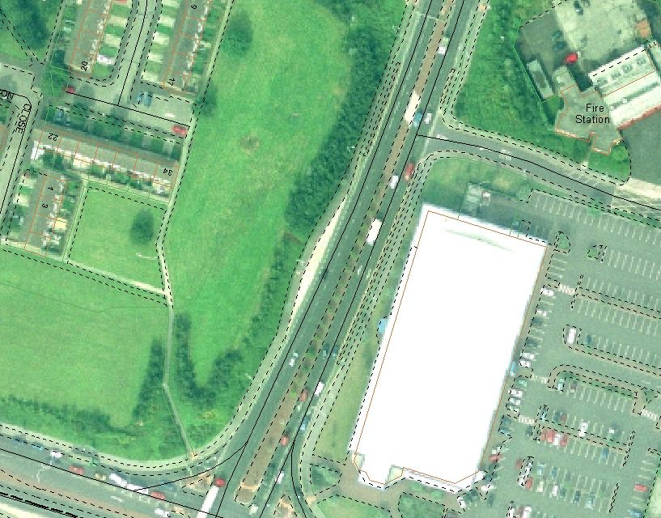
Digital historical mapping allows the history of land to be traced. | Recent aerial photography is used in conjunction with Ordnance Survey mapping to determine the current use of the land.

5.3 Identifying land that may be contaminated

A systematic procedure has been developed to identify potentially contaminated sites and assess the possible risks. Historical maps are first reviewed to trace former industrial uses. The sites are then ranked according to the potential for the industries to have contaminated the land, taking into account the sensitivity of the current use.

The prioritisation system currently being used in Oldham for the purposes of Part 2A complies with national statutory guidance, and was developed for use by all the Greater Manchester Authorities. The system is known as the PG01 Risk Prioritisation Methodology (PG01) and can be found described in Appendix II.

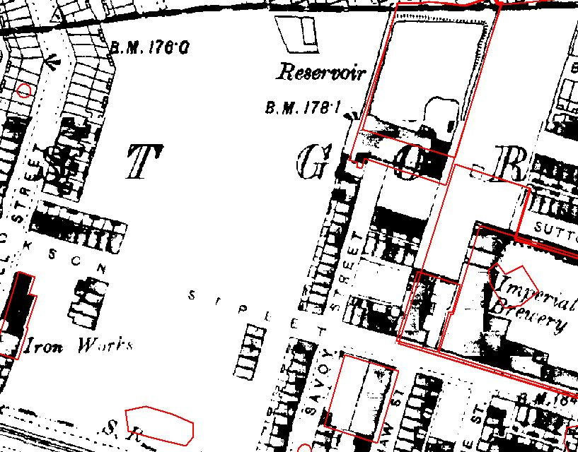
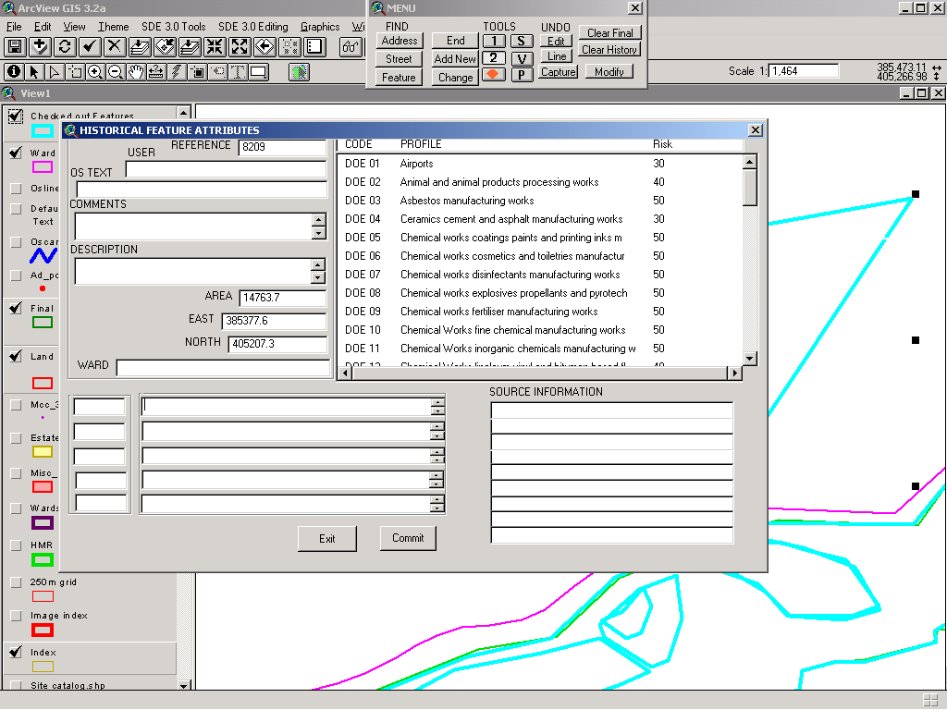
Recording the boundaries of historical  industrial sites. | Entering data to obtain a risk score.

Using the PG01 method, over 6500 potentially contaminated sites have been identified in the Borough.

The initial identification and prioritisation of sites (Phase 1) is an informed estimate of the potential for contamination to be present at a site and the possibility that it may pose a risk to health or the environment.

Phase 2 of the strategy has now begun. This consists of carrying out detailed inspections of the 6500 sites, in order of priority, to identify whether contamination is actually present.

This assessment has started with the high risk sites from the initial review with 29 sites being shortlisted for further investigation to date (based on cross checks with planning applications to see if the sites have been remediated for their current use).

The table below outlines the other sources of information that are being used in addition to historical maps

Table 1: Main types and sources of information to be used in identifying contaminated land

Information type  or layer name | Information source | Format | Use
Current ‘base maps’ | Ordnance Survey MasterMap, StreetView, 1:10,000, 1:25,000, 1:50,000 and 1:250,000 maps | Digital | Present-day base map information layer on which to overlay subsequent layers of  information.
Aerial photography | Aerial photography has been provided from various sources, dating back to the 1940s up to the current day. | Digital | To locate potential  contaminative landuse  types.
Geological maps | Digital maps of drift and solid geology have been made available from the BGS | Digital | To characterise potential sources and pathways.
Groundwater Vulnerability  Maps | Groundwater Vulnerability Maps for drift and solid geology are available digitally from the Environment Agency. | Digital | To locate potentially  sensitive (controlled  water) receptors and  corresponding pathways
Hydrogeological  maps | Hydrogeological information has also been made available as part of the geological maps supplied. | Digital | To show Principal  aquifers – highlighting potential pathways to  groundwater receptors.
Source Protection Zones | Source Protection Zone data is  supplied in digital form for the GIS by the Environment Agency. | Digital | To locate potential  (controlled water)  receptors.
Waste Management  Licence information | Supplied by the Environment Agency. | Digital | To locate potential sources of contamination.
Closed landfill / former waste disposal sites | Council’s own records and information supplied by the Environment Agency. Paper forms have been digitised for  use in the GIS | Digital | To locate potential  sources of contamination.
Current and former Integrated Pollution Control /Alkali Act sites | The Environment Agency can  provide lists of potentially contaminated sites where it has  knowledge or has had involvement. | Paper / digital | To locate potential  historical sources of  contamination.
Water Quality data, vulnerable Controlled  Waters / Surface Water  Abstraction Points | The Environment Agency can supply this data upon request. OBC does not  hold this information locally, as it is subject to change. | Digital | To locate controlled  water receptors potentially being  affected by contaminated land.
Local Development  Framework | Will be available digitally. | Digital | Locates potential  receptors (particularly  protected areas of the environment).
Environmental Health Information | Environmental Health service hold records of pollution complaints and  investigations on the Civica APP system. | Digital | To identify known  information on contamination.
Planning information | Development Control and Building Control files on development in the Borough. Paper files and digital  Information. Useful sections of  paper files have been digitised when  encountered. | Paper /  digital | To identify known  information on  contamination.
Radon information | Digital radon maps have been  provided for use within the GIS  from PHE/BGS. | Digital | To identify sources of  contamination.

5.4 Information Evaluation

In each instance information on potentially contaminated land that is obtained and produced will be assessed using current UK Government technical guidelines. The documents used in the information evaluation process are presented, but not limited to the, below:

British Standards Documents
- BS10175:2011 Code of Practice for the Investigation of Potentially Contaminated Sites;
- BS 5930:1999 Code of Practice for Site Investigations; and
- BS 8485: 2007 Code of practice for the characterisation and remediation from ground gas in affected developments.

Environment Agency Documents
- CLR11: Model Procedures for the Management of Land Contamination;
- Science Reports pertaining to contaminated land; and
- CLEA: Contaminated Land Exposure Assessment Model and associated documents.

Department of Industry (DOI)
- Industry Profiles.

Department of Environment, Food and Rural Affairs (DEFRA).
- The Environmental Protection Act 1990: Part 2A
- The Environment Act 1995; and
- Contaminated Land Statutory Guidance (April 2012).

Other relevant documents are also widely available and these will be utilised as and when is deemed necessary.

6.0 Consultation and partnership working

6.1 Ensuring best practice is adopted for new development

The new contaminated land regime is designed to deal with contamination problems that cannot be addressed under other legislation such as the planning system. Given the extensive redevelopment of land now taking place across the Borough, it is particularly important that any contamination problems at new development sites are identified straight away and not left for the future. To help facilitate this, a guide has been produced for developers and consultants, which explains how planning controls are used, and sets out the Council’s standards for remediation when any problems are found. This will ensure that land is properly assessed before any development work starts, and that a high standard of remediation is implemented in any new schemes. The guide is now available to all prospective developers within the Borough.

https://www.oldham.gov.uk/downloads/file/2070/contaminated_land_planning_guidance

6.2 Working with other local authorities in the region

Relationships between the Greater Manchester Authorities were developed through the Greater Manchester Public Protection Partnership (GMPPP) Land and Water Group. Although the group has now been disbanded officers continue to share experiences and work together towards greater consistency in managing contaminated land across the region.

The Contaminated Land Officers are also making use of developments in technology and social media with regards to pooling resources, sharing opinions and ensuring consistency through the use of contaminated land forums such as Yammer.

7.0 Our Future Commitments

The actions identified for the implementation of the Contaminated Land Strategy are:

to continue to respond to the Council’s strategic management priorities

to progress the detailed inspection and remediation of sites identified as potentially contaminated, in order of priority

to assess the potential risks at each of our landfill sites

to continually review progress to ensure that the Council’s objectives and strategic priorities are being fulfilled.

Listed below are some specific examples of how these commitments will be met.

7.1 Assessment of landfill sites

The Council has 394 officially designated landfill sites (many being infilled mill lodges) within its area, some of which were filled before record keeping of such activities was undertaken. Consequently relatively little information is held regarding what went into many of the sites. The information we do hold is under review and some of the sites will be inspected in order to establish the condition and extent of the landfill. This work will ensure that reliable and consistent information is provided to other Council departments, developers, and landowners. It will also identify at an early stage any landfill sites requiring remediation.

7.2 High Risk site review

OBC are currently reassessing the original prioritisation exercise undertaken by a third party in 2001. Starting with the sites with the highest risk score to see if any information is held through planning or through historic contaminated land work, which would result in a decrease in the risk score. The review has already identified sites that were digitised in error which have been removed from the list. This exercise will be an ongoing process so no timescales are available for completion.

7.3 Review processes

The review schedule for this document is 5 years unless circumstances dictate otherwise.

8.0 Conclusion

The Contaminated Land Strategy is linked to other Corporate Strategies and priorities contributing to the improvement in health of Oldham residents.

Potentially contaminated land in the Borough is being reviewed starting with the high risk sites to identify land that may be contaminated. Work is also being undertaken via the planning system to ensure that contaminated land conditions are being adhered to and land is suitable for its intended use.

We have an ongoing programme of work focused on the Council’s Corporate Objectives for health, the environment, and the Council’s statutory responsibilities under Part 2A. Our work will continue with detailed site inspections for those potentially contaminated sites that have been identified under the prioritisation process. Our priority remains to protect the health of those living and working in the Borough.

Contact details

The Contaminated Land Section
Oldham Council
Chadderton Town Hall
Middleton Road
Chadderton
Oldham
OL9 6PP

Telephone: 0161 770 2244
e-mail: environmentalhealth@oldham.gov.uk

