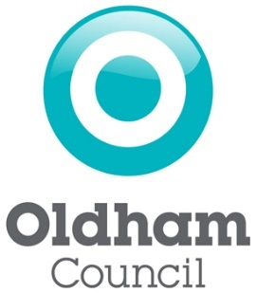
Annual Equality Data Report

Oldham Council

20 March 2019
Contents

Click on the links below to go to the relevant section of the document.

Introduction Page 3
Our Demographic Data Page 4
Our Service Data Page 6
Corporate and Commercial Services
- Local Welfare Provision Page 6

People and Place
- Contact Centre Page 9
- Hate Crimes and Incidents Page 11

Reform
- Libraries Page 12

Children’s Services
- Schools Page 14
- Children’s Social Care Page 16
- Lifelong Learning Page 18

Community Health and Social Care Services
- Adults Social Care Page 20

Our Workforce Data Page 22

Introduction
Oldham Council is committed to delivering excellent service to the borough. This involves delivering a wide range of services to a diverse range of individuals, groups, and communities. Ensuring continuous improvement in the promotion of equality, and celebration of diversity, is of great importance.

As part of our on-going commitment, we are collecting relevant equality information from our service users, and from our communities. This information helps us to understand if we are meeting service user needs, and how we can improve the services which we offer.

The Equality Act 2010 replaced previous anti-discriminatory laws with a single Act. It simplified the law, removed inconsistencies, and made it easier for people to understand and comply with. It also strengthened the law in important ways, in order to help tackle discrimination and inequality. (Source: “Equality Act 2010: Specific duties to support the equality duty….” Government Equalities Office)

The specific duties of the Equality Act 2010 require the Council, as a Local Authority, to publish information showing compliance with the Equality Duty, at least annually; and to set and publish equality objectives, at least every four years.

This document publishes information which demonstrates that the Council has due regard in the need to:
- Eliminate unlawful discrimination, harassment and victimisation and any other conduct prohibited by the Act,
- Advance equality of opportunity between people who share a protected characteristic and people who do not share it, and
- Foster good relations between people who share a protected characteristic and people who do not share it.

In particular, as per the Equality Act, we will focus on persons who share a relevant protected characteristic. In terms of the Equality Act, these characteristics are: Age, Disability, Gender Reassignment, Pregnancy and Maternity, Ethnicity, Religion or Belief, Gender, and Sexual Orientation. We will focus on these characteristics both for our employees, and those who are affected by our policies and practices.

Oldham Council’s policies and practices affect our service users. As such, this year’s publication provides information for key service areas.

For more information, please contact the Business Intelligence Service at Oldham Council: business.intelligence@oldham.gov.uk .

Protected Characteristics – Oldham’s Population
The Equality Act stipulates that we publish information relating to persons who share a relevant protected characteristic who are a) employees, or b) other persons affected by our policies and practices.

Below is information on the proportion of Oldham’s residents who share the protected characteristics covered in this report. These can be used as a benchmark for the proportion of employees, and other persons affected by our policies and practices, we would expect to share each of the characteristics. Information is not collected by any of the service areas covered in this report, on either gender reassignment, or pregnancy and maternity.

Age
ONS 2017 mid-year estimates for Oldham split the population as follows:

Under 16 | 16 to 24 | 25 to 34 | 35 to 44 | 45 to 54 | 55 to 64 | 65 to 74 | 75 to 84 | 85+ | Total
52,979 | 25,708 | 31,857 | 28,414 | 31,805 | 25,743 | 21,098 | 11,755 | 4,400 | 233,759
23% | 11% | 14% | 12% | 14% | 11% | 9% | 5% | 2% | 100%

Disability
Per the 2011 Census, 19.7% of people in Oldham have a Limiting Long-
Term Illness (LLTI), health problem, or disability.

Ethnicity
Per the 2011 Census, Oldham’s population of 224,897 is broken down as follows:

 | White | Pakistani | Bangladeshi | Black (African / Caribbean) | Indian | Mixed | Other Ethnic Groups
Number | 174,326 | 22,686 | 16,310 | 2,797 | 1,555 | 4,057 | 3,166
Percent | 77.5% | 10.1% | 7.3% | 1.2% | 0.7% | 1.8% | 1.4%

Oldham Council’s estimates for 2018 show Oldham’s 224,897 residents as:

 | White | Pakistani | Bangladeshi | Black (African / Caribbean) | Indian | Mixed | Other Ethnic Groups
Number | 172,890 | 29,698 | 21,353 | 4,065 | 1,457 | 5,229 | 4,168
Percent | 72.4% | 12.4% | 8.9% | 1.7% | 0.6% | 2.2% | 1.7%

Religion or Belief
Per the 2011 Census, religious beliefs in Oldham are broken down as follows:

 | Christian | Muslim | No Religion | Hindu | Buddhist | Jewish | Sikh | Other | Not Stated
Number | 134,167 | 39,879 | 36,169 | 1,233 | 371 | 108 | 70 | 406 | 12,494
Percent | 59.7% | 17.7% | 16.1% | 0.5% | 0.2% | 0.0% | 0.0% | 0.2% | 5.6%

Gender
ONS 2017 mid-year estimates for Oldham are 50.7% female, and 49.3% male.

Sexual Orientation
The 2011 Census did not collect information on sexual orientation, so we must use an estimate instead. The following are ONS estimates for Oldham, for 2013 to 2015:

 | Heterosexual  or Straight | Gay or Lesbian | Bisexual | Other | Not Stated
Number (000s) | 168 | 2 | 1 | <1 | 6
Percent | 94.5% | 1.3% | 0.5% | 0.2% | 3.5%

Corporate and Commercial Services

Local Welfare Provision

Local Welfare Provision provides short term, emergency support, to vulnerable people. It also assists vulnerable people in establishing or maintaining a home in the community. Data on Local Welfare Provision is recorded via a database and is collected from all users. However, not every customer answered every question fully.

The following tables provide information on claims to the Local Welfare Provision in Oldham for the 2017/18 financial year.

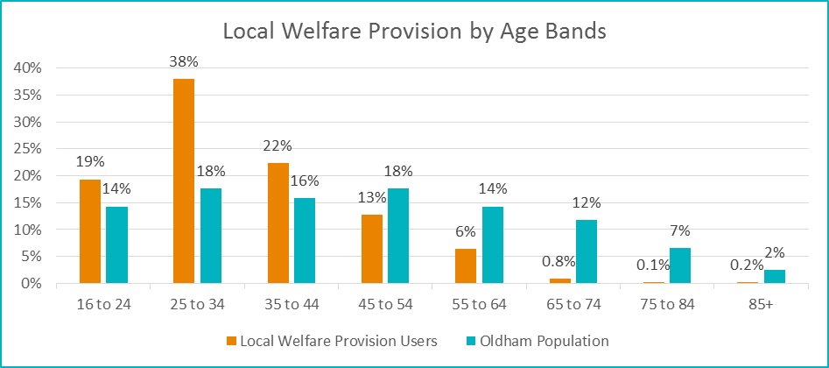
Claims for Local Welfare Provision by Age Band

Age Bands | Under 16 | 16 to 24 | 25 to 34 | 35 to 44 | 45 to 54 | 55 to 64 | 65 to 74 | 75 to 84 | 85+ | Not Provided | Total
Number | N/A | 163 | 320 | 188 | 108 | 54 | 7 | <5 | <5 | 65 | 905
Percent | N/A | 18% | 35% | 21% | 12% | 6% | 1% | <1% | <1% | 7% | 100%

Claims for Local Welfare Provision by Age Band – Excluding “Not Provided”

From the above, we can see that Local Welfare Provision is claimed disproportionately often by those aged under 45. Those aged 25 to 34 claim Local Welfare Provision at a particularly high rate. As Local Welfare Provision is an emergency support service, this is not unexpected. Those aged 25 – 34 have been adversely affected by Welfare Reforms (such as Universal Credit) and are more likely to be unemployed, in low paying jobs, or in temporary accommodation than other age bands. This same age group is also more likely to use services such as food banks.

Claims for Local Welfare Provision by Gender
Gender | Male | Female | Total
Number | 380 | 528 | 908
Percent | 42% | 58% | 100%
Oldham Population | 49% | 51% | 100%

Claims for Local Welfare Provision by Ethnicity
Ethnicity | White | Asian or Asian British | Black or Black British | Mixed / Multiple | Any Other Ethnicity | Not Provided | Total
Number | 562 | 103 | 44 | 36 | 30 | 133 | 908
Percent | 62% | 11% | 5% | 4% | 3% | 15% | 100%

Claims for Local Welfare Provision by Ethnicity – Excluding “Not Provided”
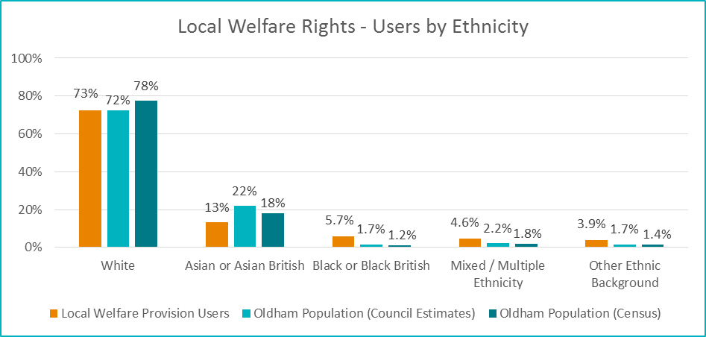
Claims for Local Welfare Provision by Religious Belief
Religion / Belief | Buddhist | Catholic | Christian | Hindu | Jewish | Muslim | Sikh | Other | None | Not Provided | Total
Number | <5 | 74 | 199 | <5 | <5 | 121 | <5 | 22 | 351 | 130 | 897
Percent | <1% | 8% | 22% | <1% | <1% | 13% | <1% | 2% | 39% | 14% | 100%

Claims for Local Welfare Provision by Religious Belief – Excluding “Not Provided”
Religion / Belief | Christian | Muslim | Hindu | Buddhist | Jewish | Sikh | Other | No Religion | Total
Number | 273 | 121 | <5 | <5 | <5 | <5 | 22 | 351 | >773
Local Welfare Provision | 35% | 16% | <1% | <1% | <1% | <1% | 2.8% | 45% | 100%
Oldham Population | 63% | 19% | 1% | 0.2% | 0.1% | 0.0% | 0.2% | 17% | 100%

In the 2011 census, 63% of respondents reported that they are Christian. 35% of Local Welfare Provision claimants reported that they are Christian. 17% of census respondents reported they have no religion, whilst 45% of LWP claimants reported they have no religion.

Claims for Local Welfare Provision by Sexual Orientation
Sexual Orientation | Heterosexual | Bisexual | Gay
Number | 772 | 16 | 22
Percent | 95% | 2% | 3%
Oldham Population | 98% | 1% | 1%

People and Place

Contact Centre

The contact centre deals with enquiries across 18 separate service lines on behalf of Oldham Council and the Council’s switchboard service, providing easy access to a wide range of services over the phone and also via email.

From April 2017 to March 2018, 434,762 calls were handled and 4,923 surveys were completed. During this period, enquirer’s ethnicity and disability breakdown was as below. However, it is important to note that these figures only relate to less than 1% of total contacts made. As such, it is impossible to say if this is a representative sample.

The software employed for customer satisfaction surveys collects ethnicity and disability data which are the core equality statistics agreed contractually when the system was purchased.

Enquiries to the Contact Centre by Ethnicity - 2017 to 2018
Ethnicity | Rather not say | White | Asian or British Asian | Mixed / Dual Heritage | Black or Black British | Other | Total
Number | 1,562 | 160 | 22 | 26 | 16 | <5 | 1,786
Percent | 87% | 9% | 1% | 2% | 1% | <1% | 100%

From the table above we can see that 87% of individuals chose not to disclose their ethnicity when contacting the Contact Centre. Combined with the fact that the data accounts for less than 1% of contacts to begin with, this means any results should be interpreted with caution. With 226 out of 434,762 people disclosing equality info, this gives us a confidence interval of approximately 6. As such, the proportions given for Contact Centre users by Ethnicity and Disability should be taken with a grain of salt.

The table below shows the breakdown of contacts by ethnicity, when the “rather not say” responses have been removed. We can see that those with dual heritage contact the contact centre at a much greater rate than we would expect, as do black people. Asian people contact the Contact Centre less frequently than we would expect, and to a lesser degree, so do White people.

Enquiries to the Contact Centre by Ethnicity Excluding “Rather not Say”
Ethnicity | White | Asian or British Asian | Mixed / Dual Heritage | Black or Black British | Other | Total
Number | 160 | 22 | 26 | 16 | <5 | 224
Percent | 71% | 10% | 12% | 7% | <1% | 100%
Oldham Population (Council Estimates) | 72.4% | 21.9% | 2.2% | 1.7% | 1.7% | 100%
Oldham Population (Census) | 77.5% | 18.1% | 1.8% | 1.2% | 1.4% | 100%

Enquiries to the Contact Centre by Disability - 2017 to 2018
Disability | Not Disabled | Disabled | Rather not Say | Total
Number | 1,334 | 372 | 131 | 1,837
Percent | 73% | 20% | 7% | 100%

Individuals contacting the contact centre were much more willing to disclose their disability status than their ethnicity. Only 7% of people chose not to disclose their disability status, compared with 87% not disclosing their ethnicity.

The table below shows the breakdown of contacts by disability status, when the “Rather not Say” responses have been removed.

Enquiries to the Contact Centre by Disability Excluding “Rather not Say”
Disability | Disabled | Not Disabled | Total
Number | 372 | 1,334 | 1,706
Percent | 22% | 78% | 100%
Oldham Population | 20% | 80% | 100%

We can see that the proportion of enquiries made to the contact centre by disabled individuals aligns with the proportion of Oldham’s population which has a disability.

Hate Crimes

Greater Manchester Police are the primary recorder of hate crimes. Oldham Council works in partnership with GMP, providing victim support and advocacy, and raising awareness.

In 2017/18, 9,076 hate crimes were recorded by Greater Manchester Police. Of these, 805 were recorded in Oldham:

2017/18 | Ethnicity | Sexual Orientation | Religious | Disability | Gender Identity | Alternative Lifestyle | All Hate Crimes
GM | 7,243 | 923 | 2,044 | 438 | 88 | 65 | 9,076
Oldham | 623 | 80 | 108 | 41 | 8 | <5 | 805
Percent | 8.6% | 8.7% | 5.3% | 9.4% | 9.1% | <5% | 8.9%

(One hate crime may have more than one motivating factor, hence the above numbers sum to more than the total number crimes recorded.)

Oldham’s population makes up 8.4% of Greater Manchester’s population. As such, the proportion of hate crimes reported in Oldham is broadly in line with what we would expect, given the total number reported in Greater Manchester.

Hate Incidents – Schools

Oldham schools report all hate and bullying incidents through the NOHIB System (Notification of Hate Incidents and Bullying).

Below is a summary of Hate Incidents which occurred in 2018;

2018 | Ethnicity | Sexual Orientation | Gender | Disability | Other | All Hate Incidents
Oldham | 207 | 72 | 6 | 12 | 16 | 308

(An incident may have more than one characteristic, hence the above numbers sum to more than the total.)

As context, schools across Oldham completed 4,084 returns during the year, 3,697 of which (91%) were nil returns – meaning there were no hate or bullying incidents recorded.

It should be noted that
- there is no legal requirement for schools to report incidents to the Council, and participation is therefore voluntary;
- Oldham Council is proactive in encouraging schools to report all hate incidents, and provides an on-line system to enable them to do this;
- Comparisons between the numbers of hate incidents in different districts are likely to be misleading because of the different reporting systems in place. If there are few hate incidents in an area this could genuinely be because not many incidents have happened, or it could be a consequence of low rates of reporting.

Reform

Libraries

Oldham Library Service’s mission is to be a continually improving and modern library service. This involves engaging the local community, forging important partnerships, and linking with community services, voluntary organisations, and local businesses. At the heart of all of this, is the promotion of reading and lifelong learning.
Oldham Library Service provides access to digital services, teaches how to use digital amenities, and supplies facilities which are open, accessible, inclusive, and plays a significant part in establishing the local community identity.

There are two groups of library users: those who borrow books, and those who use the computer facilities. It is possible for someone to be in both groups, and indeed, this is the case for around a third of library users. For this report, an active user is one who accessed the service between 1 January 2018 and 31 December 2018. As such, there is one group of active users for borrowing, and one group of active users for computer facilities.

Library Users by Age Group – 2017 to 2018
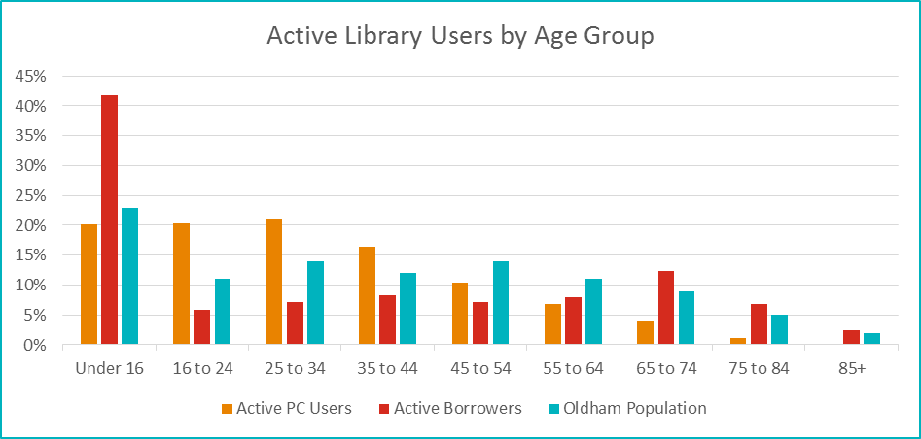
The clear takeaway from this graph is that those aged under 16 are the most likely age group to be active borrowers. This may be due to a number of factors - from young children first learning to read, to older children borrowing books for school. Those aged 16 to 44 are active PC users more than their population size would predict, and those aged over 44 are active OC users less than their population size would predict. Those aged over 65 are more likely to be active borrowers more than their population size would predict. Those aged 16 to 64 are active borrowers less than their population size would predict.

Library Users by Gender – 2017 to 2018
Gender | Male | Female | Other | Total
Active PC Users | 49% | 51% | <1% | 100%
Active Borrowers | 39.5% | 60.5% | <1% | 100%
Oldham Population | 49% | 51% | - | 100%

Whilst active PC users are split along population lines, females are more likely than males to be active borrowers.

Library Users by Disability – 2017 to 2018
Disability | Disabled | Not Disabled | Total
Active PC Users | 1.2% | 98.8% | 100%
Active Borrowers | 1.8% | 98.2% | 100%
Oldham Population | 19.7% | 80.3% | 100%

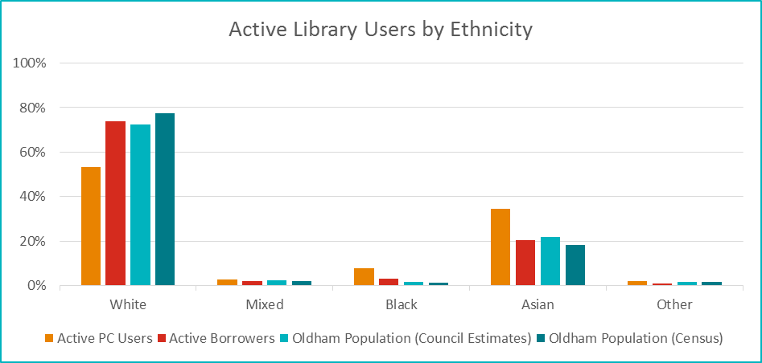
Library Users by Ethnicity – 2017 to 2018

Active borrowers seem to be split evenly across ethnicities, but white people are less likely to be active PC users, whilst Asian people are more likely to be active PC users.

Children’s Services

Schools

The Council gathers information on schools and school pupils via the School Census. This is a statutory return which must be completed by all schools on a termly basis. It gathers information such as: postcode, gender, age, ethnicity, special educational needs, free school meals eligibility, and educational history. Ethnicity is only collected in the January release.

The following information provides a breakdown of the gender and ethnic group of all school pupils for both primary and secondary education.

School Pupils by Gender – Jan 2018
Gender | Boys | Girls | Boys (%) | Girls (%)
Primary Schools | 13,415 | 13,329 | 50% | 50%
Secondary Schools | 8,026 | 8,119 | 50% | 50%

School Pupils by Ethnicity – Jan 2018
Ethnicity | White | Asian or Asian British | Black or Black British | Mixed / Dual Heritage | Other Ethnicity | Not Stated | Total
Primary | 56% | 34% | 3.5% | 4.9% | 1.1% | 0.7% | 100%
Secondary | 58% | 31% | 3.1% | 4.3% | 0.8% | 2.6% | 100%
Total | 57% | 33% | 3.4% | 4.6% | 1.0% | 1.4% | 100%

BME pupils are defined as those pupils with an ethnic group that is not White British, and does not include those pupils whose ethnicity was refused, or was not obtained. The BME population is 44.9% for the total pupils in primary, secondary and special schools.

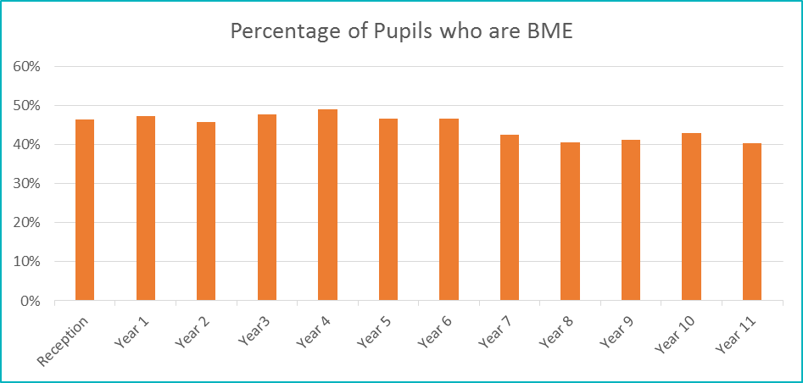
Percentage of Pupils in Oldham Schools who are BME (Black Minority Ethnic)

Year 11 has the lowest proportion of BME students, with 40%. Year 4 has the highest, with 49%.
Attainment Gaps
On average, disadvantaged groups across England (by deprivation, prior attainment, first language, or other factors) tend to get poorer results than their peers; Oldham reflects this trend, albeit with success in some cohorts more than others. Indeed, the attainment gap for Bangladeshi students has decreased so much over the last 5 years that it is now negative. This means that they perform better than Oldham’s average.

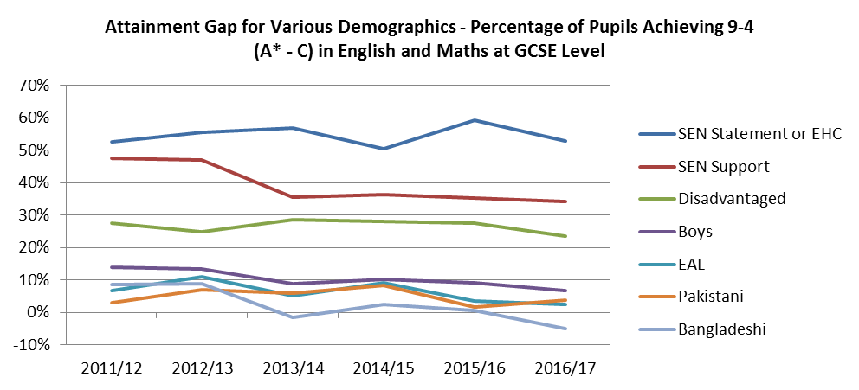
Source: DfE, Oct 2018

Children with Special Educational Needs have the largest performance gap, followed by disadvantaged students. In 2016/17 Bangladeshi students performed better than the Oldham average. This is a large improvement from 2011/12 and 2012/13 when Bangladeshi students’ scores were lower than Pakistani students’ scores.

How we use this Data to Inform Services
This data provides demographic statistics for Oldham, including information on BME (Black Minority Ethnic), First Language, SEN (Special Educational Needs) and FSM (Free School Meals) populations. The data is also used to calculate pupil population forecasts and projections. This data feeds into monitoring attainment by vulnerable groups, which the Council uses to inform the finance, planning, and delivery of school services.

Children’s Social Care

All of the Children’s Social Care data presented below is pulled from the Children’s Social Care Database, and is accurate as of February 2019.

Children’s Social Care by Gender
Gender | Male | Female
Children's Social Care | 53% | 47%
Oldham Population | 49% | 51%

There is a fairly even split between the genders for Children’s Social Care, though there are slightly more males than females.

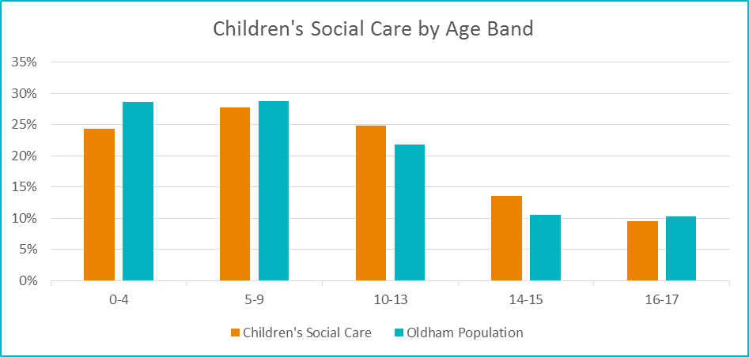
Children’s Social Care by Age Bands

The distribution of children in Social Care largely mirrors the distribution of Oldham’s children as a whole.

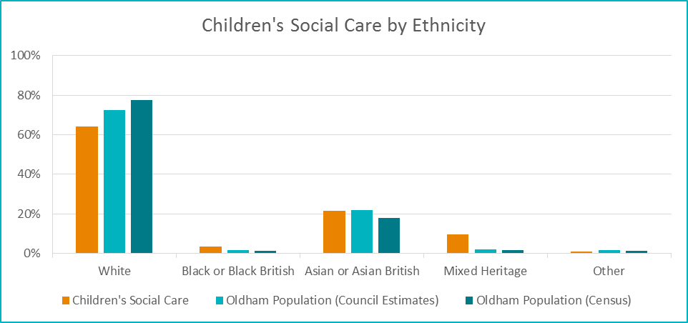
Children’s Social Care by Ethnicity

There seems to be a disproportionately high number of Mixed Heritage children in Social Care. There also seems to be a slightly fewer White Children in Social Care than we might expect. However, the Oldham Population data applies to all age groups, whilst Children’s Social Care is only available to young people. In the School Census section below, we see that around 55% of school children in Oldham are white. This is more in line with the number of children who access Children’s Social Care.

Children’s Social Care by Religion/Belief
Religion / Belief | Christian | Muslim | Hindu | Buddhist | Jewish | Sikh | Other | No Religion
Children’s Social Care | 652 | 538 | <5 | <5 | <5 | <5 | 5 | 581
Children’s Social Care | 37% | 30% | - | - | - | - | 0.3% | 32.7%
Oldham Population | 63% | 19% | 0.6% | 0.2% | 0.1% | 0.0% | 0.2% | 17.0%

To preserve confidentiality, those beliefs which had fewer than 5 respondents have had their numbers suppressed.

Lifelong Learning

Oldham Lifelong Learning is committed to delivering an excellent service to learners, whilst continuously improving how we promote equality, and celebrate diversity. As part of this ongoing commitment, we collect relevant equality information about our learners. This information helps us to understand if we are meeting learner needs, and how we can improve the services we offer.

Oldham Lifelong Learning Service is a direct deliverer of post-19 learning opportunities. The Local Authority is committed to providing learning in the most appropriate and convenient locations for learners. Lifelong Learning offer two types of courses: Formula Funded (FF), and Non Formula Funded (Non FF).

Lifelong Learners by Ethnicity – 2017/18 Academic Year
Ethnicity | White | BME | Total
All Provision | 49% | 51% | 100%
Non FF Courses | 48% | 52% | 100%
FF Courses | 40% | 60% | 100%
Oldham Population | 73% | 27% | 100%

The Service provides courses across Oldham and targets learners in the disadvantaged areas of Oldham which have high representation of BME heritage residents. The Service continues to work in areas of deprivation where the population is largely White-British heritage.

The 2015 Population figures show that 79% of Oldham’s population aged 19 and over were from a White Background and 21% were from a Black and Minority Ethnic Background. However, the BME population in the top 10 most deprived wards in Oldham is 36%.

The Service offers provision in venues in communities with high levels of deprivation. 38% of learners across the Service’s courses (from all ethnic backgrounds) came from the top five most deprived wards in Oldham as defined by the index of multiple deprivation; 57% of our learners came from the top 10 most deprived wards in Oldham. In addition, 66.7% of our learners had a home postcode that appeared in the disadvantage uplift table.

Lifelong Learners by Gender – 2017/18 Academic Year
Gender | Male | Female | Total
All Provision | 23% | 77% | 100%
Non FF Courses | 23% | 77% | 100%
FF Courses | 25% | 75% | 100%
Oldham Population | 49% | 51% | 100%

The 2015 Population Projections indicate that Oldham had a total population of 172,580 residents aged 19 or over. Of this population, 49% of Oldham’s population were male and 51% were female.

However, men have traditionally been under-represented in Adult and Community Learning across the country. According to the Department for Business Innovation and Skills (BIS) Review of Informal Adult and Community Learning (IACL): Equality Impact Assessment, Revised Screening Document published in September 2011 - 25% of participants in IACL nationally were male. Following an exercise undertaken by Adult and Community Learning Providers in 2013-14, it was established that the SFA National Average for providers similar to the Service was 28%.

The Service has explored the potential reasons for this shortfall in male participation, and has agreed strategies to address this in 2018/19 Academic year.

Lifelong Learners by Age Bands
Age Bands | 19 to 24 | 25 to 34 | 35 to 44 | 45 to 54 | 55 to 64 | 65+
All Provision | 7% | 25% | 27% | 17% | 12% | 11%
Oldham Population | 10% | 20% | 17% | 18% | 14% | 21%

The Service statistics show that people of all ages accessed the service. The age profile of our learners continues to compare well with the age range of the total population.

Lifelong Learners by Disability
Disability | Disabled | Not Disabled | Total
All Provision | 22% | 78% | 100%
Non FF Courses | 22% | 78% | 100%
FF Courses | 24% | 76% | 100%
Oldham Population | 20% | 80% | 100%

Adult (19+) demographic summary of FE and skills participation (2015/16) data showed that 16% of learners aged 19+ declared a learning difficulty / disability

Community Health and Social Care Services

Adults Social Care

All of the Adults Social Care data presented below is pulled from the Adults Social Care Database, and is accurate as of February 2019.

Adults Social Care by Gender
Gender | Male | Female
Adults Social Care | 42% | 58%
Oldham Population | 49% | 51%

We can see that Females access Adults Social Care more often than males do. This is interesting given that Children’s Social Care is accessed more by males than females. This could, in part, be due to females in Oldham living longer on average than males. This is also compounded by females in Oldham actually having a shorter Healthy Life Expectancy than males. Males in Oldham have a life expectancy at birth of 77.2 years, and a Healthy Life Expectancy of 60.3 years. Females have a life expectancy at birth of 80.9 years, and a Healthy Life Expectancy of 58.6. As such, females have an average of an extra 5.4 years spent in poor health, in which they are more likely to access Adult Social Care.

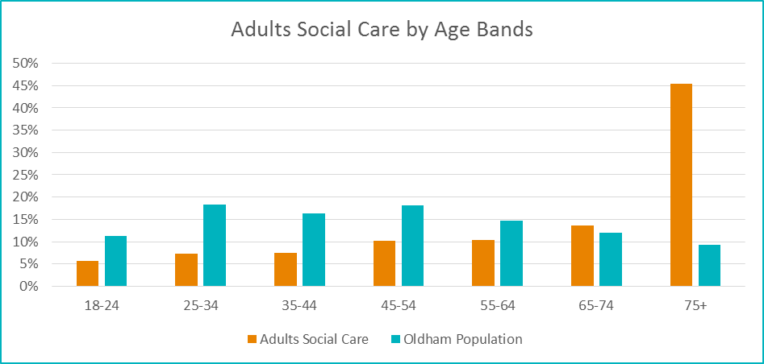
Adults Social Care by Age Bands

45% of Adult Social Care Users are aged 75 or over. 59% of Adult Social Care Users are aged 65 or over.

Adults Social Care by Ethnicity
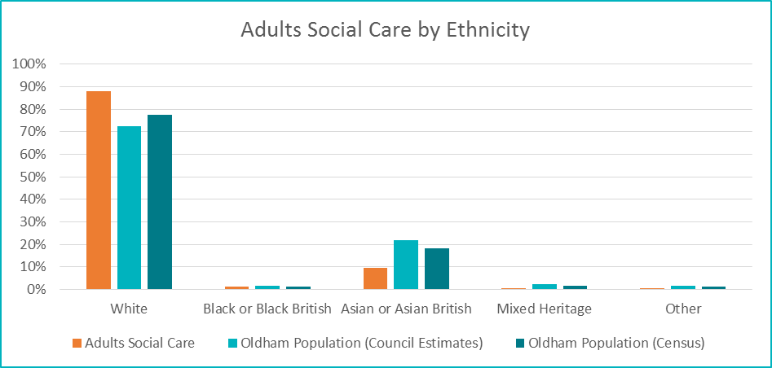
White people access Adults Social Care more than the size of their population would predict. This differs from Children’s Social Care, which White people access less than the size of their population would predict. Adults Social Care is accessed more by older people in Oldham. Older people in Oldham are more likely to be white than individuals in Oldham as a whole. As such, it is to be expected that more white people access Adults Social Care. Asian people access Adults Social Care less than the size of the population might predict. This is likely due to the same reason as above.

Adults Social Care by Religion/Belief
Religion | Christian | Muslim | Jewish | Buddhist | Hindu | Sikh | No Religion | Other
Adults Social Care | 2,156 | 282 | <5 | <5 | 12 | <5 | 232 | 28
Adults Social Care | 79.6% | 10.4% | - | - | 0.4% | - | 8.6% | 1.0%
Oldham Population | 63.2% | 18.8% | 0.1% | 0.2% | 0.6% | 0.0% | 17.0% | 0.2%

To preserve confidentiality, those beliefs which had fewer than 5 respondents have had their numbers suppressed. From those that remain, Christians are over represented, whilst Muslims and Atheists are under-represented. This is likely due to the advanced aged profile of Adult Social Care users.
Our Workforce Data

All of the information outlined below, relates to the Council’s centrally employed workforce (i.e. does not include those working within schools). The data has been taken at the end of the third quarter of 2018/19.

Headline Measures
Description | December 2018
Number of Current Employees | 2,919
Leavers in the Last Year as a Percentage of the Average Total Staff | 9.0%
Percentage of New Starters Still in Post after 12 Months | 99.7%
Top 5% of Earners who are Women | 56.9%
Top 5% of Earners from Ethnic Minority Communities | 5.5%
Top 5% of Earners who have Declared a Disability | 2.1%
Percentage of Employees who Consider Themselves Disabled - Percentage of Workforce | 4.42%
Percentage of Staff aged over 50 | 44.9%
Employees from BME Communities as a Percentage of Workforce | 11.4%

Council Employees by Gender – Full Time Staff
Directorate | Chief Executive | Children's Services | Corporate and Commercial Services | Community Health & Adult Social Care | People and Place | Reform | Total (Number) | Total (%)
Female | 3 | 404 | 98 | 153 | 93 | 92 | 843 | 55%
Male | 5 | 95 | 59 | 47 | 402 | 81 | 689 | 45%
Total | 8 | 499 | 157 | 200 | 495 | 173 | 1,532 | 100%

The council employs more full time females than males. However, there are large differences between directorates: Children’s Services is around 80% female, whilst People and Place is around 80% male.

Council Employees by Gender – Part Time Staff
Directorate | Chief Executive | Children's Services | Corporate and Commercial Services | Community Health & Adult Social Care | People and Place | Reform | Total (Number) | Total (%)
Female | 1 | 371 | 29 | 38 | 578 | 108 | 1,125 | 85%
Male | - | 42 | 10 | 8 | 105 | 40 | 205 | 15%
Total | 1 | 413 | 39 | 46 | 683 | 148 | 1,330 | 100%

Part time staff are vastly female, across all directorates.
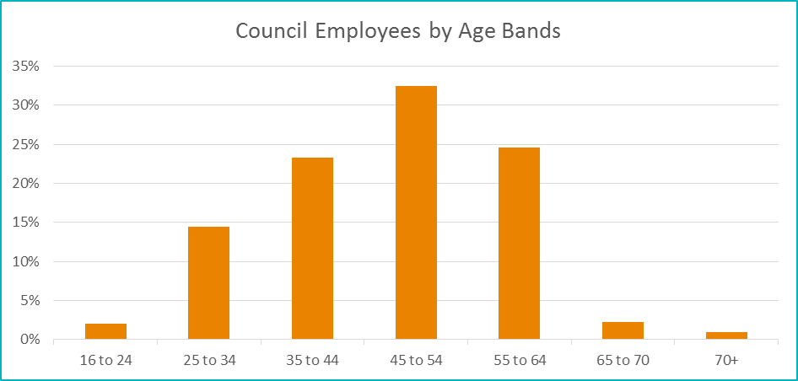
Council Employees by Age Bands

We can see that the number of employees in each age band increases up to and including the 45 to 54 age band.

Council Employees by Ethnicity
Ethnicity | White | Asian or Asian British | Black or Black British | Mixed / Multiple Ethnicity | Other Ethnicity | Total
Number | 2,343 | 221 | 73 | 33 | 10 | 2,680
Percent | 87% | 8% | 3% | 1% | 0.40% | 100%
Oldham Population (Council Estimates) | 72% | 22% | 1.7% | 2.2% | 1.7% | 100%
Oldham Population (Census) | 78% | 18% | 1.2% | 1.8% | 1.4% | 100%

The average age of council employees is 47. As such, we would expect employees to have a more white composition than Oldham as a whole.

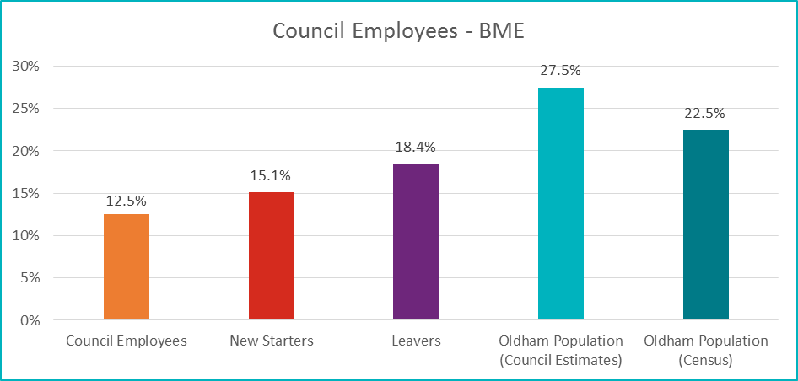
Council Employees – BME

Fewer BME individuals are employed by the council than the proportion of the population which they comprise. This is the case for new starters, and total staff employed. Since the Annual Equality report was first published in 2013, the proportion of the workforce made up of BME individuals has increased from 8.8% to 12.6%.

Council Employees by Disability
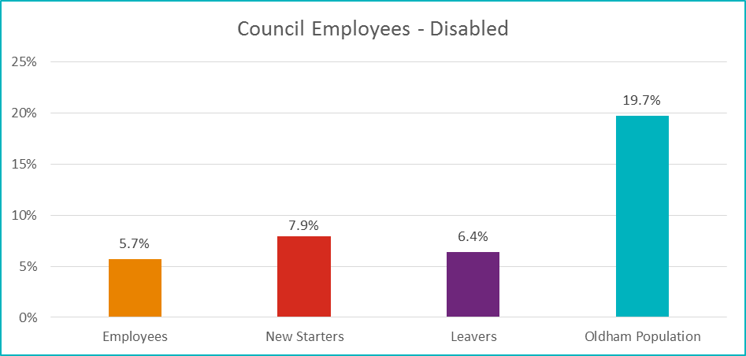

Responses to Job Adverts
Female | Male | Prefer Not to Say
64% | 35% | 1%

White | Asian | Black | Dual | Chinese and Other | Undeclared
69% | 19% | 6% | 2% | 1% | 2%

Heterosexual | Gay | Bisexual | Other | Prefer not to say
92% | 2% | 1% | 0.5% | 4.5%

Declared Disabled | None or Blank
6% | 94%

Christian | Muslim | Hindu | Buddhist | Other | None | Undeclared
42% | 18% | 1% | 0.2% | 2% | 32% | 4%

16 to 24 | 25 to 34 | 35 to 44 | 45 to 54 | 55 to 64 | 65 to 70 | 70+
15% | 35% | 21% | 18% | 9% | 0.5% | 1.5%

1 Statistical First Release DS/SFR12
Department for Education: Further Education and Skills in England July 2017
https://fingertips.phe.org.uk/search/healthy%20life%20expectancy#page/0/gid/1/pat/6/par/E12000002/ati/102/are/E08000004

