Free Entitlement Funding Portal Training Guide

Early Years and Childcare Services
September 2025



Contents

- Logging onto the provider portal
- Home Page
- Funding
- Eligibility checker – checking a Working Family eligibility codes
- Summary
- Estimates
- Actuals
  - Deleting a child
  - Editing a child’s record
  - Adding a child
- Validating Working Family codes
- Submitting actuals claims – 3&4 year old funding
- Adjustments
- Uploading documents
- Child funding summary
- 15/30 hours – LA audits and parent reconfirmations
- Logging out of the portal

Logging onto the Provider Portal
  - The provider portal can be accessed using the following link; https://myapps.microsoft.com/

or alternatively, log onto the Oldham council website and select:

Education / Early Years / Free Early Education (Provider Information) / PVI agreement for funding/ Provider Portal

Note: We recommend that you do not save this page in your favorites for future use, as this may cause issues with logging in.

  - Once at the provider portal, you will be required to enter your Microsoft apps username and password.

Please ensure that you use the Username and Password provided by Oldham Council IT Service Desk to sign into Microsoft as this will give you access to the synergy provider portal.
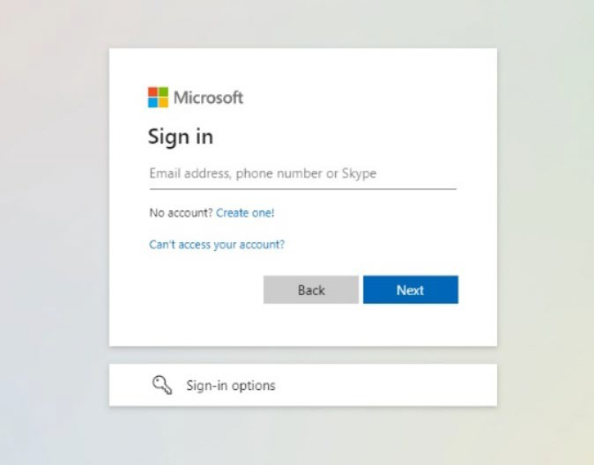

If you are having any issues with your Microsoft apps log in details, you will need to contact our IT department on 0161 770 1000, as the free entitlement team cannot assist providers with their Microsoft log in issues.

If you do not have a Microsoft account, please email the free entitlement team on free.entitlement@oldham.gov.uk with your full name, email address and direct contact number (without a holding message) and the team will request a new user from the IT department.

  - Once you have signed into the Microsoft apps section, you will come to the synergy live sign in page where you must enter your Synergy username and password.

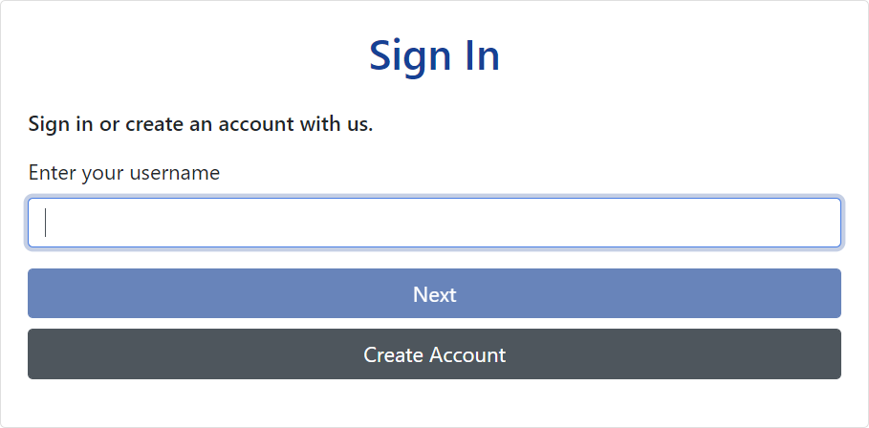

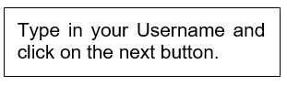

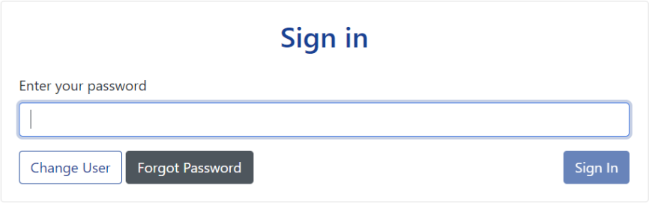
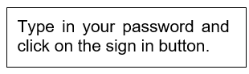

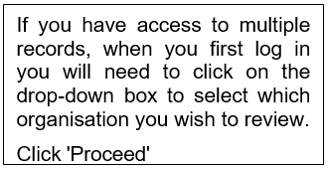

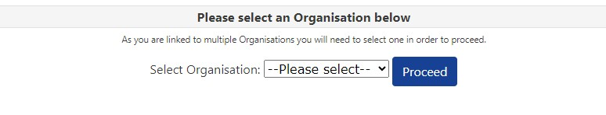

If you forget your password for the synergy portal, email the free entitlement team to
request a password reset.

Home Page

  - The home page is where all portal functions are accessed. The ones that providers will be using are:

    - Home – takes you back to this home screen from wherever you are in the portal
    - Forms – used to update your details i.e. vacancies, costs, and EY Census data collection.
    - Funding – this is where you view your provider headcount records and submit headcount claims

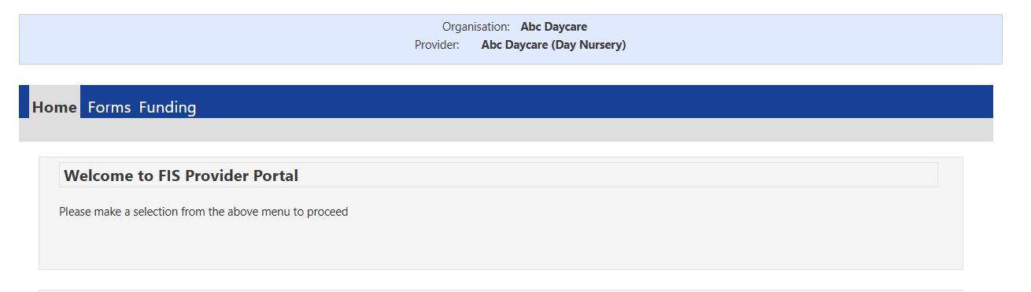

Funding
  - The first page in the funding tab is the Provider Headcount records page. Here you will find funding details for the current and previous terms. All the headcounts that you are registered for will be visible here.

Please note, only records on the current term can be amended, all previous terms can be selected to view as read only.

  - Within the funding tab, you are able to select from the following options;

      - Summary – allows you to view a breakdown of the funding you will receive within the relevant term
      - Estimates – allows you to submit an estimate of funded hours based on the number of children you expect to attend your setting the coming term.
      - Actuals – lists funded children in your nursery and allows you to submit new child details
      - Adjustments - method of informing the free entitlement team if a child starts or leaves the setting after the actuals deadline.
      - Eligibility Checker – allows you to check the eligibility for working families. This can be used to check eligibility before you offer a place or to check if a parent has reconfirmed their eligibility.

Summary

  - Select the Term you wish to open
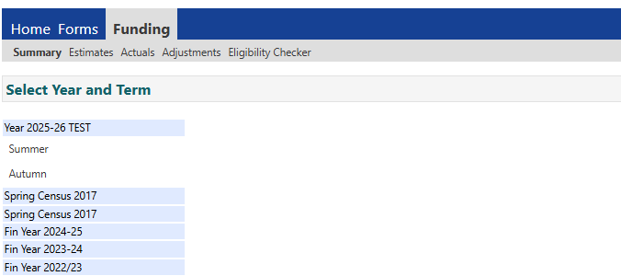

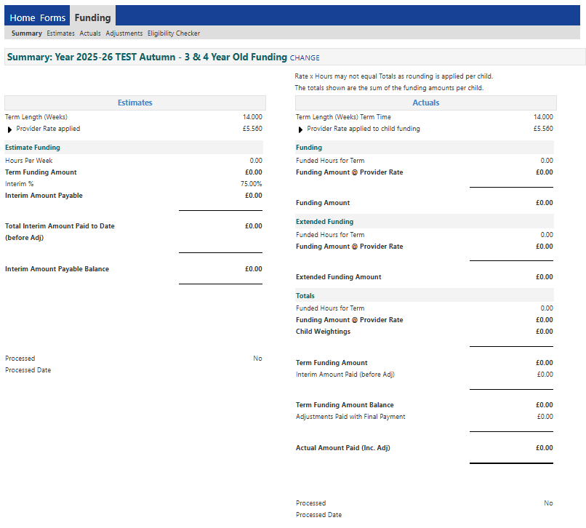
  - Below is an example of what you will see on the summary screen

  - The summary page provides details of your payments and the page is split in 2 to show estimate and actual payments. The amounts will populate once you have submitted your estimate figures and child level details (actuals) and these have been imported by the Free Entitlement Team. Providers are expected to check the summary

page to confirm they have successfully submitted both their estimates and actuals. Please note, the summary page will show zero hours until your submissions have been imported.

The values on the Summary page should be checked to make sure they are in line with the funding you are expecting. By doing this on a termly basis you reduce the chance of missing children off your headcount.

Please be aware if a negative value is displayed this means you have overclaimed at estimates and this money will need to be repaid.

  - If you have selected ‘nominated for DAF’ for any child in the child’s record, the DAF payment due will also show on the summary page however, this will only be paid if the DAF process has been followed, please see annex B: Business Planning & Quality Improvement Processes.

  - The processed date is the date the Free Entitlement Team creates the payment production report and sends the payment request to Accounts Payable. It can take up to 5-10 working days from this date for the payment to reach your bank account.

Estimates

  - You must submit an estimate of the number of weekly hours you expect to be funded for the selected term. The submission of estimates should be in line with the dates on the payment schedule. It is from this estimate that the payment you receive at the start of the term is calculated from. Please Note, if no estimate is submitted you will NOT be paid at the payment run.

  - To enter your estimate, you need to select estimate from the top menu. Select the term

And the funding type you wish to claim for.

  - Enter the number of hours you expect to be funded for the selected term. This will be the total amount of weekly hours for all expected children, for example, if you have 6 3&4 year old children doing 15 hours and 3 doing 30 hours, the amount you will enter is 180.
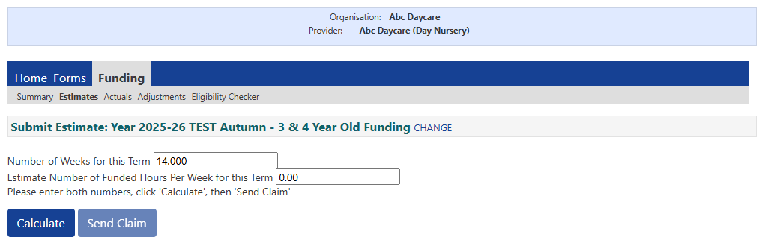

  - Select calculate and the system will calculate the total number of estimated hours for the term for you. The estimate payment is based on 75% of the value of hours you have submitted. The remaining 25% will be paid at actuals along with any new starters not accounted for at Estimates and any weightings the child is eligible for (EYPP, DAF, Deprivation).

You can change the number of hours you have estimated even if you have already submitted your hours up until the submission deadline date. Simply enter the new number and click send claim to resubmit.

Eligibility Checker – checking an eligibility code (Working Families)

6.1 Eligibility codes need to be verified before additional free childcare can be offered. The DfE eligibility checking service (ECS) provides the facility for verifying eligibility of children for up to 30 hours free childcare per week. Providers can verify codes by entering the eligibility code into the Synergy online provider portal and this code will automatically be checked against the ECS database. To carry out the check you will need the eligibility code (11 digits), parent’s National Insurance number and the child’s date of birth. Ensure you have written consent from, or on behalf of the parent to receive confirmation of the validity of the parent’s working families eligibility code. This is obtained via the parental declaration form.

The following shows how to check if a working family code is eligible, it does not add the child to your term headcount.

In the provider portal select the funding tab and then select eligibility checker;

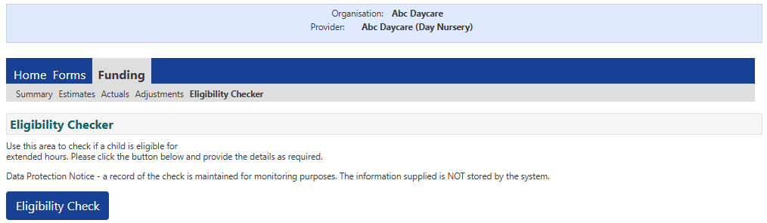
Select Eligibility Check

To validate an eligibility code, you must complete all fields marked with an * and then click submit. The mandatory details required are:

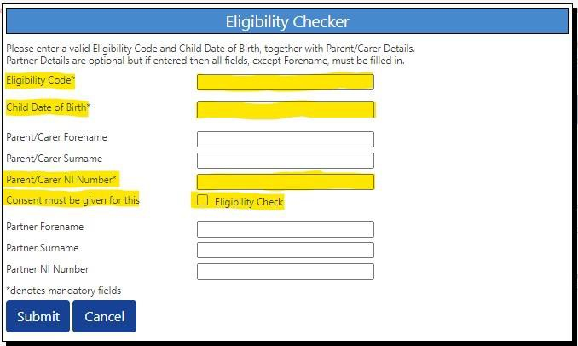
    - Eligibility code
    - Child date of birth
    - Parent/carer NI number
    - Consent for eligibility check

Once completed, click submit.

The system will now connect to the ECS checker and return the result.

If the details are correct, you will be given a start date, end date and grace period end dates of the code. You will then be able to offer places if the dates meet the criteria for the funding (start date prior to start of term date). For more details on the criteria see the Early Years Entitlement Operational Guidance.

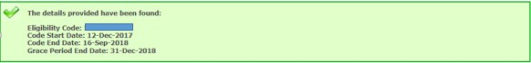

If a code is ‘found’ as above, it does not necessarily mean that the code is valid for the term. Please ensure that you check the dates of the code to determine if the code is valid for the term.

For example: for a code to be valid for the Autumn term, the start date must be on or before 31 August to be valid for the term and accepted on the portal. If a code is applied for, or reconfirmed late, the code may show as ‘found’ as it meets the working families criteria, however if the start date is after 31 August, the portal will not accept this once you come to add the child onto your Actuals. It is the parent’s responsibility to make sure they apply and reconfirm their codes in time to prevent falling out of eligibility.

If the actuals portal is open, you can add the child to your term headcount via the ‘add child’ function.

Actuals

7.1 The Actuals tab will show you a list of funded children attending your setting. Select the Term and Funding Type you wish to open and select the Actuals tab to see a list of children brought forward from the previous term.

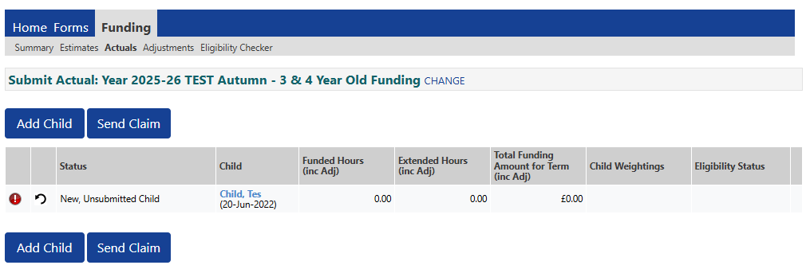

  - Please note, only eligible children will be automatically carried forward into subsequent terms. For example, if a child has turned 5 years old and is therefore out of the date range for the next term, they will automatically be removed by the system. Additionally, if this is the first term entering child details, no previous terms will appear.

On this page you can:
- delete,
- edit and
- add a child and their details

You will need to review the list of children and update their details accordingly for the current term.

Deleting a child

You will only need to do this at the start of a term when a child has been brought forward by the Free Entitlement Team but is no longer attending the setting.

If you need to delete a child from your records, click on the X. Selecting the X will bring up the following message:
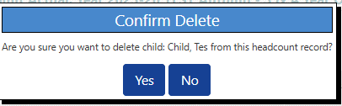

Selecting yes changes the status of the child to ‘delete pending, submitted’ The child will be removed once your request has been actioned by the Free Entitlement Team.

Editing a child’s detail
All details apart from hours attended are brought forward from the previous term therefore, you will need to input the child’s attendance hours. You are also able to correct any incorrect information in a child’s records i.e. update address details etc. Once you have made the necessary corrections, click Save to take you back to the Actuals headcount page. The status of this child’s record will change to ‘Edit pending’. The following symbol will appear informing you that an action is pending, in this case it means the claim needs to be submitted.

Adding a child
To add a new child click the add child button.

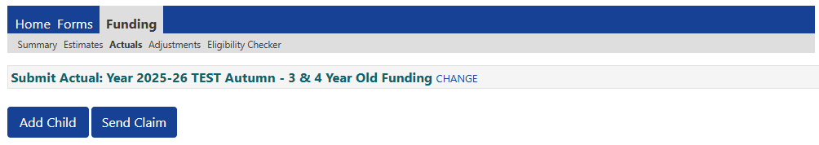

A blank form will appear for you to complete. Please note, there are 4 separate tabs, you must complete the first 3 tabs: child details, parent/carer details and funding details. Tab 4 should be completed if you have documents to share with the Free entitlement Team i.e. evidence to support claim for DAF.
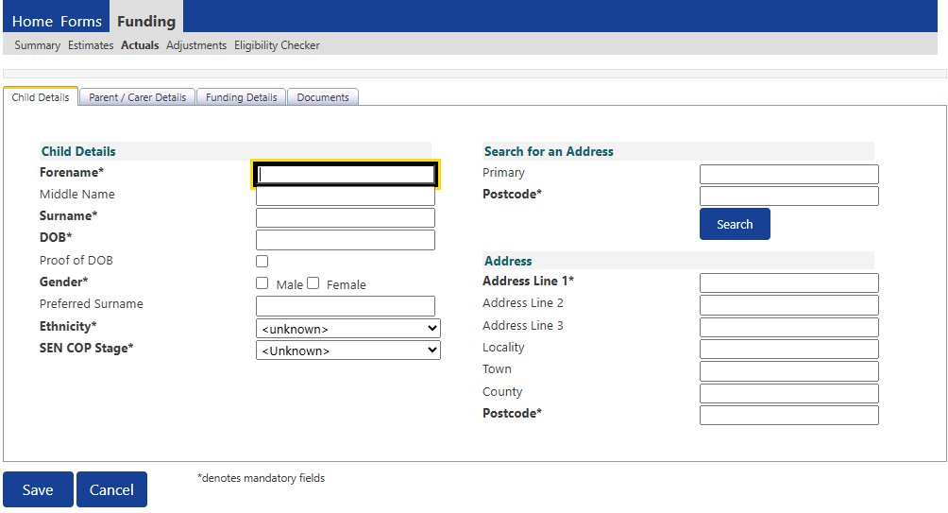
All fields marked with an * on the Child Details tab must be completed.

The Parent/Carer Details tab shown below must be completed fully using the information collected on the Parental Declaration form. This will enable the Free Entitlement Team to carry out any additional checks against the ECS checker including eligibility for EYPP, Working Family Eligibility and Additional Support (formerly 2YO disadvantage).

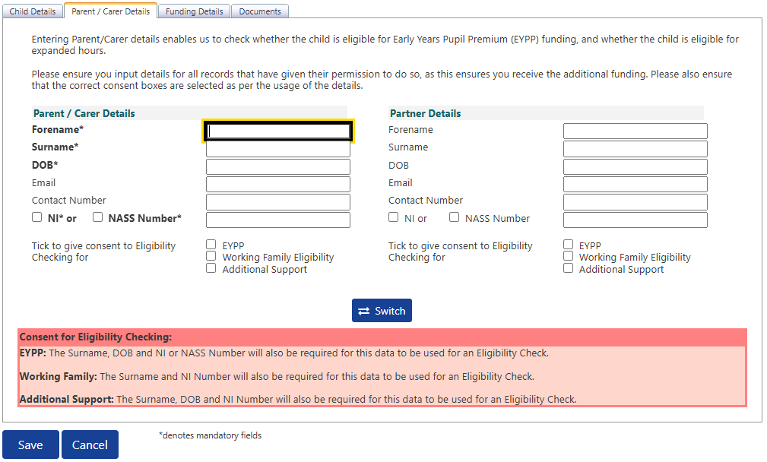

You must tick the consent boxes to allow for these checks to be carried out. Parent/carers need to provided these details on the parental declaration form. This forms their consent for eligibility checks to be carried out.

If you fail to tick the EYPP box, no EYPP eligibility check will be carried out and you will not receive EYPP funding even if you know the child is entitled.

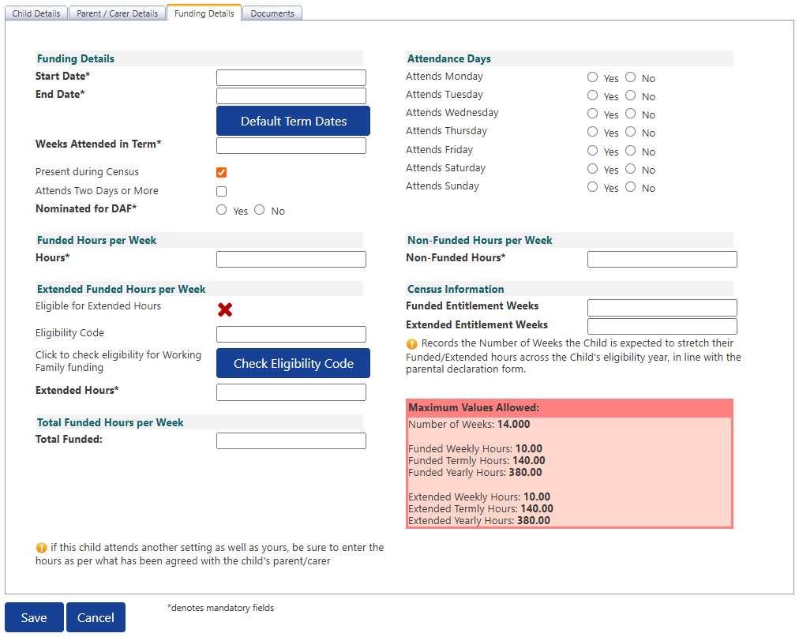
Funding Details

On the Funding Details tab you will need to do the following for each child claim:

- Input the attendance start and end dates. For full term claims you can then click on the 'Default Term Dates' button and the funded term dates will then be populated. However, if the claim is for only part of the term, you will need to input the dates using the calendar that appears when you click in the Start Date or End Date box.
- Input the number of weeks to be claimed. The maximum number of weeks for each term can be viewed on the Free Entitlement webpage.
- Tick the 'Present During Census' box for all children that you are making a claim for, for example, all children that are booked in or planned present during the headcount week.
- Tick 'Attends Two Days of More' box if the child attends two days or more. If they do not attend 2 days, then leave this blank. Please note: If this box is not ticked when the

child attends two days or more, you will not be allowed to input more than 10 funded hours per week.
- Tick Nominated for DAF Yes or No radial buttons to reflect the parent's consent for you to claim DAF as per the Parental Agreement. Please note: You only tick 'Yes' if you can provide evidence for the additional funded to be added.
- Complete the Attendance Days by clicking the Yes or No radial button as appropriate against each day of the week.
- Input the number of Funded and Non-Funded Hours per Week completing the relevant eligibility checks. For non-funded hours, these are the additional hours that the parent is paying for. Enter zero if there are no hours being paid for.
- The red box shows how many funded weeks are available in a term and what the maximum weekly, termly and yearly hours are. This box will change depending on your claim. If children attend 2 days or more you can claim up to the maximum of 15 hours per week, however if children don’t attend 2 days or more you can only claim 10 hours per week.

  - Claims for 2YOs

From Autumn Term 2025 there will be a single headcount that includes both Working Family 2YOs and 2YOs with additional support (formerly 2YO disadvantaged).

7.3.1 To claim a child who has a 2YO Additional Support code (six digit code) you will need to click on the ‘Enter EY Voucher’ button:

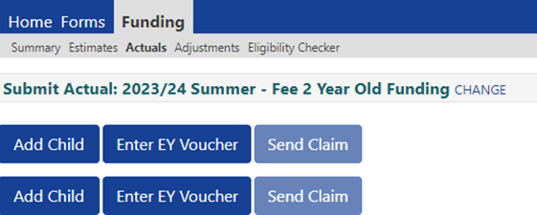

7.3.2 Enter the EY voucher code as shown on the child's eligibility letter, child's date of birth and surname and click on the Submit button.

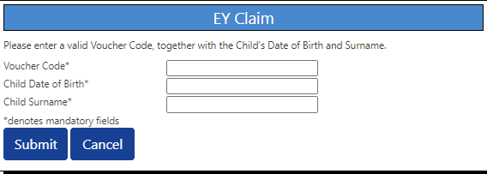

Please note: The details you enter must match the details we have on our system from when the application was made by the parent/carer. If any of these details do not match you will get an error message. If this happens, please verify the information with the parent or contact the Free Entitlement Team.

7.3.3 To claim a 2YO child who has a Working Family code you will need to click on the ‘Add Child’ button which will bring up the below message. To add the claim you will need to click ‘Continue’.

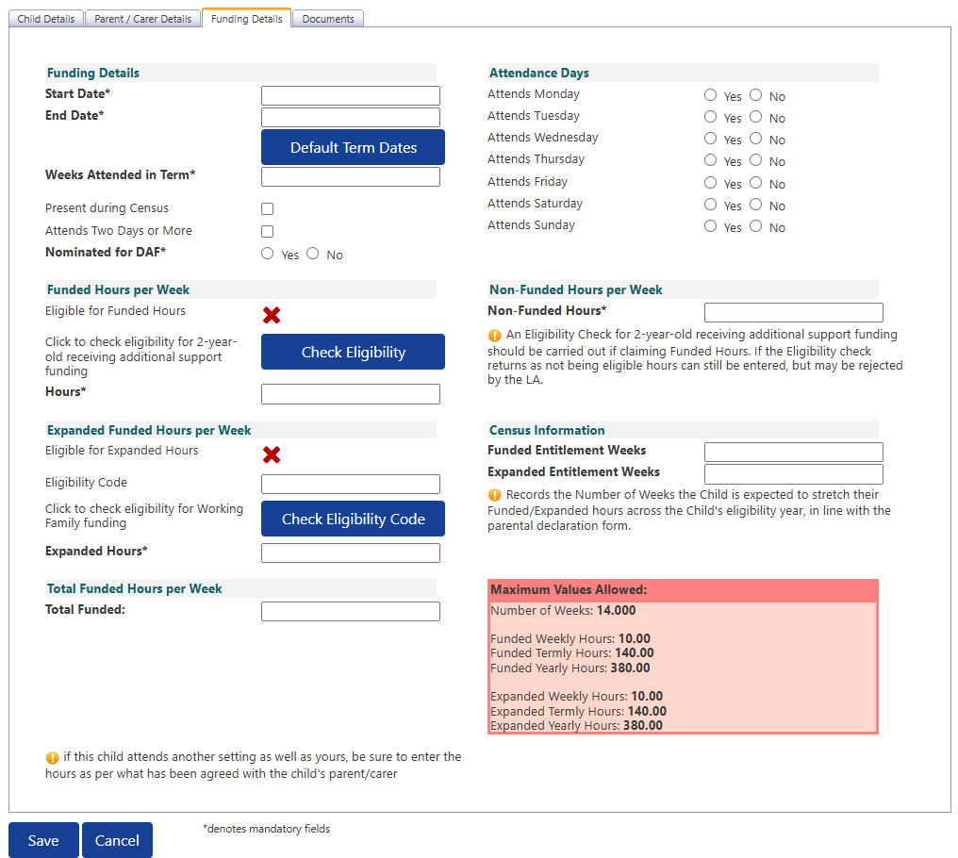
7.3.4 From Autumn 2025, all 2YO claims will need to have eligibility checks completed for Additional Support. The updated ‘Funding Details’ window allows providers to complete the check for Additional Support funding and Working Family eligibility

7.3.5 If a child is eligible for just the Additional Support you will need to add the number of funded hours per week (max 15). If a child shows to be eligible for the Additional Support and has an eligible Working Family code you will need to complete both eligibility checks and, as stated previously, add the number of funded hours and up to 15 hours of expanded hours. The total funded hours can not equal more than 30 hours per week.

7.3.6 For children that are only eligible for the Working Family entitlement you will need to submit the number of hours per week (up to the max of 30 hours) in the ‘Expanded Hours’ section.

Validating a Working Family Code

8.1 If you are claiming the extended/expanded hours for any children, you are required to validate their 11-digit prior to the start of term.

8.2 To check the eligibility of a working family code you can use the eligibility checker in the funding tab
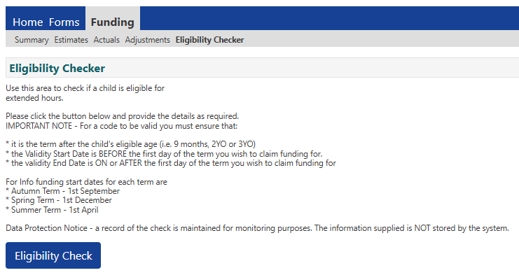

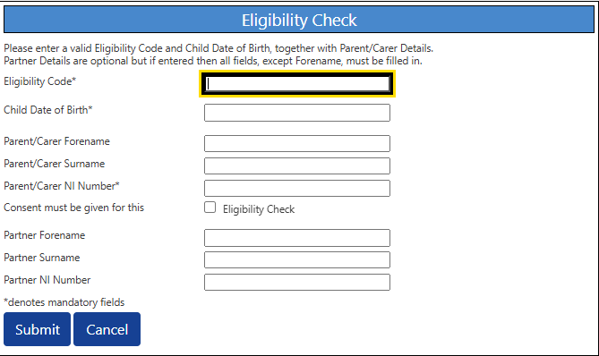
8.3 To validate an eligibility code, you must complete all fields marked with an * and then click submit. The mandatory details required are:
    - Eligibility code
    - Child date of birth
    - Parent/carer NI number
    - Consent for eligibility check

8.4 Once you have submitted the relevant information you will then see a message box which will either confirm that the eligibility code is valid or that the eligibility code is not valid for the extended/expanded hours. You will need to make a note of the result along with the eligibility code start date, end date and grace period end date and check the dates are valid for the term you wish to claim funding for.

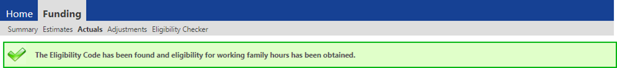

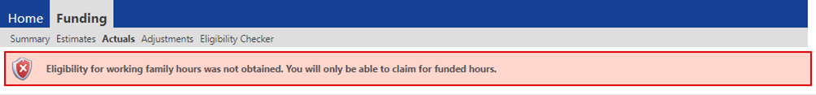

8.5 If you receive an eligibility code that returns a result of not eligible, please check that all the details have been input correctly, for example, the parent's details you have input relate to the parent who requested the voucher code via the Childcare Choices website and that the name is spelt correctly, the child's date of birth is correct, and the eligibility code is correct.

8.6 For a code to be valid you must ensure that:

    - It is the term after the child has reached the relevant age of eligibility.
    - The Voucher Start Date is before the first day of the term you wish to claim funding for.
    - The Voucher End Date is on or after the first day of the term you wish to claim funding for.

Please note: If the code has been found but is not valid in the term you are applying for you will see the following message:

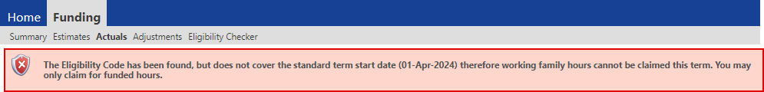

Submitting your headcount form

  - You must submit your headcount information by the specified deadline date, please refer to the Payments Submission Timetable.

  - To submit the headcount, select the ACTUALS tab and select the appropriate Term to open the chosen headcount.

Please Note - if you cannot see the funding type you wish to claim for, please contact the team on FREE.ENTITLEMENT@Oldham.gov.uk

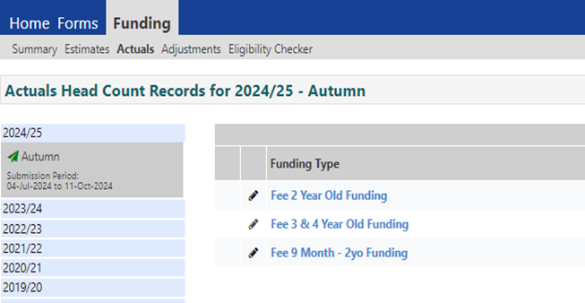

  - From this screen you will be able to manage your headcount claim as you will need to Add, Edit or Delete child claims for the term. Once you have all the children’s details added to the headcount check all names and hours are correct. Once you are happy to proceed, click Send Claim.

  - If you have completed your headcount correctly, you should receive a Submission successful message. If your submission is not successful, you will need to check your records and resubmit.

  - You can update and resubmit child records as many times as you need up to the deadline for Actuals. The child records will be overwritten with the latest information.
  - To check if you have successfully submitted all claims, log out and log back into the portal. If your claim has been submitted, no message will show on the Home page.
  - After the deadline for submission has passed you will no longer be able to add further children or edit your headcount.

Adjustments

  - Once the Actuals deadline date has passed, the Actuals screen for that term will show a summary of the records submitted including the breakdown of Universal and Extended hours. Individual child records can still be viewed on the Actuals tab but no further amendments can be made.

  - To add children who may have started after the submission cut-off date, or to make other amendments i.e. inform of a child leaving early, an adjustment will need to be made.
  - To submit an adjustment, click on the child’s name if the change relates to an existing child or click Add Child if it is a new child.
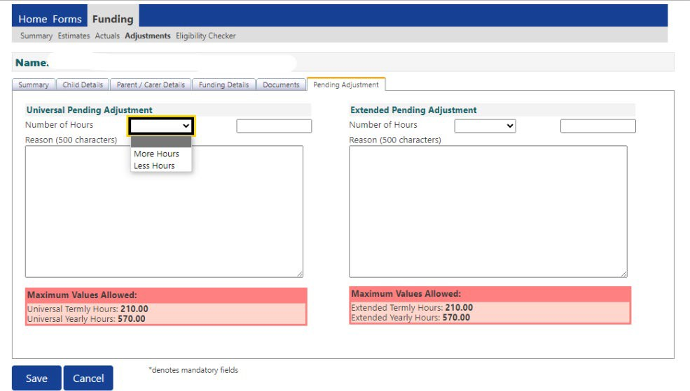
  - When making an adjustment claim the child’s details can be amended via the Child Details tab, the term start date and end date can be amended via the funding details tab and the parent/carer details can be amended via the parent/carer tab. Child hours are recorded in the Pending Adjustment tab.

  - This screen enables providers to add a positive or negative adjustment to the Universal Hours, Extended hours or both and enter a reason to support the adjustment.

In the drop down box More Hours should be used add a positive adjustment i.e. increase in hours or new starter. Less hours should be used for negative adjustments
i.e. reduction in hours or child leaving before the end of the term. If the child leaves early and there are no exceptional circumstances, in accordance with the Annex B – Business, Planning Processes, the funding will remain with the setting however, you still must submit an adjustment at zero hours and provide a reason for the adjustment so that the system records that the child is no longer attending your setting.

Once you have made the necessary changes, click save. If there are any errors in input, these will be displayed upon saving the record.

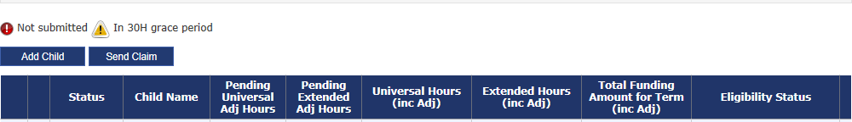
The adjustment will be displayed on the adjustment headcount page with the hours showing under Pending Universal/Extended Adj Hours column.

  - Click send claim to submit your adjustment. If your submission is successful, the submission successful message will appear and the status will change from Edit Pending to Edit Pending, Submitted.
  - Once the adjustment has been imported by the Free Entitlement Team, the status on the adjustment tab will change.

Uploading Documents
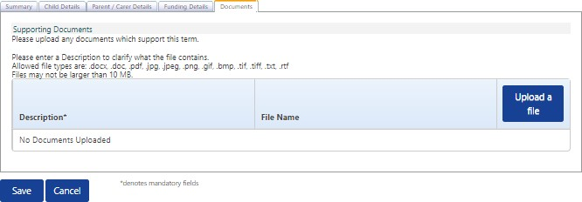
11.1 Documents needed to support your claim for funding can be sent to the Free Entitlement Team via the Documents Tab on the provider portal. This includes: evidence to support a claim for DAF funding and parental declaration forms where children have started the setting midterm or left the setting before the end of the term.

11.2 To add the evidence, click upload a file. Select the required file and click open.
The selected file will upload, and you will be asked to name the file. Please make clear what this uploaded document relates to i.e. name the file: midterm starter, midterm leaver, DAF, birth certificate etc.
Save and Send the claim.

Child funding summary

  - Within this tab you will be able to see a breakdown of the child’s claim including if they are eligible for EYPP and/or nominated for DAF.
Within the Funding tab, select Actuals and open the appropriate term.

  - This will bring up the list of children (headcount) for that term. Select the child by double clicking on the child’s name

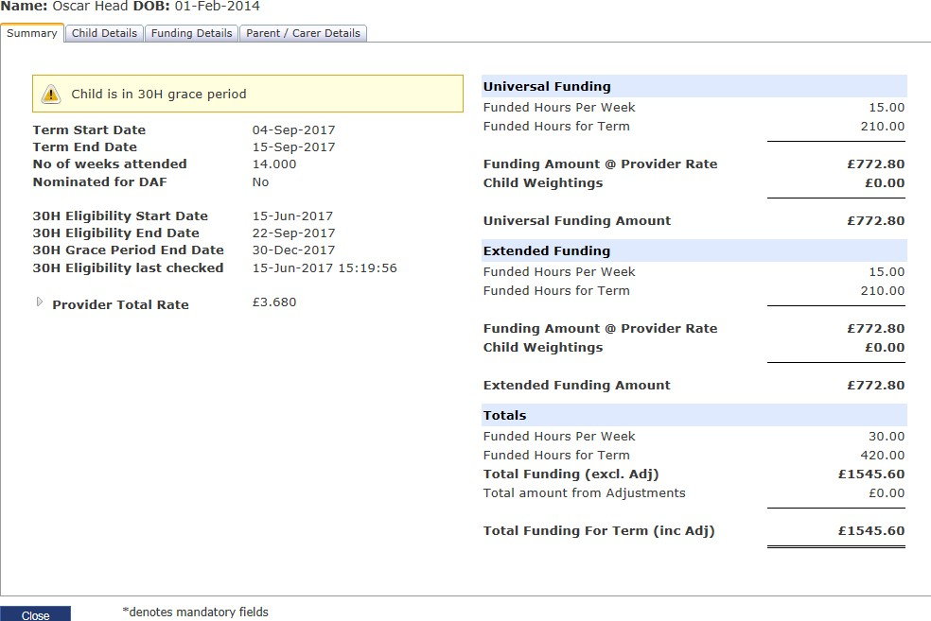
Select the summary tab to see the breakdown

Where this symbol is visible the information can be extended to provide a breakdown of the weightings applied to that child.

15/30 hour – Local Authority audits and parent reconfirmations

  - Parents need to re-confirm their eligibility every three months via the Government Gateway Childcare Services Account. Parents will be notified via their chosen method of communication prior to their validity end date. If the parent successfully reconfirms, new period dates will be issued.
  - If a parent does not re-confirm their eligibility or loses eligibility, a grace period will come into effect. The grace period enables parents to retain their childcare place for a short period. The Operational Guidance outlines specific grace period cut-off dates.

  - Local Authorities will carry out an audit of codes at six fixed points within the year and childcare providers will be notified once these have been done. A warning triangle will appear beside the child’s name for children who are in their grace period. These parents should be reminded to reconfirm their eligibility otherwise they will lose eligibility for the extended hours the following term.

  - Please note, warning triangles will not show for children whose grace period has lapsed and are no longer eligible for the extended hours.

  - It is the responsibility of the parent to meet reconfirmation deadlines.

More information on audit dates and grace period dates can be found in the Operational Guidance.

Logging out

14.1 When you have finished using the portal, exit the site via the Logout button:
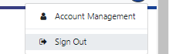
Each time you leave the site you must always log out to allow updates to refresh and for security reasons.

