Light Duty Vehicle Crossings Policy

April 2024

1 Introduction

1.1 This policy specifies how Oldham Council will deal with applications for the provision of or widening of Light Duty Vehicle Crossings (LDVCs) to a single dwelling, commonly known as ‘dropped kerbs’ or ‘dropped crossings’.

1.2.1 This policy only applies to domestic LDVCs for access to single dwellings.

1.2.2 Applications for medium or heavy duty vehicle crossings (for vehicles ≥ 3,500kg), or for access to multiple dwellings, or commercial premises, are not covered by this policy. In these instances, applicants should contact the Council’s Development Control and Planning service in the first instance as planning permission is usually required.

1.2.3 Although this policy does not apply to crossings other than to a single domestic dwelling, many of the principles of this policy will apply to other types of crossings, so council officers may have regard to this policy when considering applications for other types of crossings.

1.3 The decision to grant a vehicle crossing is at the discretion of the highway authority (in this case, Oldham Council). Oldham Council will normally allow such crossings except where provision or widening will cause demonstrable harm to highway operation, safety or the amenity of the street.

1.4 The policy has been written to:

- Meet legal and planning requirements
- Ensure that the Council deals with requests in a consistent manner
- Ensure construction quality and safety of vehicle dropped crossings

1.5.1 Applications for an LDVC over the footway or verge are investigated and priced individually.

1.5.2 Oldham Council will assess applications in line with this policy but reserves the right to refuse applications on highway safety grounds or for other engineering reasons not specifically covered in this policy.

1.5.3 If the Council agrees to provide an LDVC, the works can only be carried out by the Council. The Council will provide the applicant with a quotation for the cost of the proposed works and if the applicant wishes to proceed, then the costs must be paid for in full before the works begin. The crossing will not be constructed until the driveway is complete.

2 Legislative background

2.1 It is unlawful to drive a motor vehicle over the kerb and across the footway (commonly known as the pavement) in order to gain access to premises where there is no dropped crossing to allow this. This is an offence under section 72 of the Highways Act 1835. Furthermore, Rule 145 of the Highway Code states: “You MUST NOT drive on or over a pavement, footpath or bridleway except to gain lawful access to property, or in the case of an emergency.”

2.2 Lawful access to a property may be obtained by applying to the highway authority for a vehicle crossing. Under normal circumstances, it is not lawful to drive over a raised kerb to access a property.

2.3 Any person who drives a motor vehicle across the pavement or verge without an authorised and properly constructed vehicle crossing could cause damage to the surface and kerb, and any underground service cables or pipelines laid beneath the surface. The person responsible for causing the damage would be liable for the cost of repairs.

2.4 Under Section 184 of the Highways Act 1980, a person may to apply to the Council for an LDVC. There is no right to the provision or widening of an LDVC to provide driveway access to premises - it is at the discretion of the highway authority as to whether such a crossing should be allowed.

2.5 In determining whether to exercise the powers under Section 184 of the Highways Act, the Council will have regard to the need to prevent damage to a footway or verge and will also have regard to the need to ensure, so far as practicable, safe access to and egress from premises and the need to facilitate, so far as practicable, the passage of vehicular traffic on highways.

2.6 There is a precedent in law, which states that the Council is liable for any hazards that it creates in the highway, Gautret v Egerton (1867) LR 2 CP 371 in which Willes J (the judge) said:

“if I dedicate a way to the public which is full of ruts and holes, the public must take it as it is. If I dig a pit in it, I may be liable for the consequences; but if I do nothing, I am not. Similarly, if a highway already has cellar doors or trees in it, there is no duty on the highway authority to remove them. Having said that, they must not make the situation worse, by, for example, altering a carriageway to a design which increases the likelihood of vehicular collisions with the trees”

2.7 Oldham Council is liable for any hazards that it creates in the highway. Therefore, the Council will not permit the construction of an LDVC in a location where it is considered to be a hazard.

2.8 The provisions of Section 184 of the Highways Act 1980, which empower the highway authority to construct an LDVC, apply only to highway land. The highway authority does not have the power to authorise access to a property over non-highway land owned by a third party, including non-highway land that is owned by the Council. Any applications that would involve crossing non-highway land to access a property will be refused unless that land is owned by the applicant and / or there is an easement (or other legal agreement) in place granting access over that land to the property, which will still be in place for future owners of the property – in such instances planning permission may also be required.

3 Planning Permission

3.1 LDVCs with accesses onto classified roads (A, B or classified unnumbered roads) require planning permission.

3.2 Planning permission may also be required for listed buildings or properties in a conservation area for any alterations that might be needed to the property, such as constructing a driveway or knocking down a wall to create an entrance. Applicants should contact the Council’s Development Control section for advice on this.

3.3 Applicants for affected properties will be asked to provide the relevant planning application number. LDVCs that require planning permission will not be constructed until the highway authority has verified that planning consent has been granted, or that confirmation has been received from the Council’s Development Control section that planning permission is not required.

3.4 Where planning permission has been granted, it is still necessary to obtain highway authority consent. A successful planning application does not necessarily mean that highway authority consent will be granted and vice versa. Applicants should liaise with both the planning and highway authority from the outset to avoid any confusion or disappointment.

3.5.1 Sustainable Urban Drainage Systems (SUDS) – Constructing a parking area or driveway on a property may also require planning permission. An applicant who wishes to construct a parking space in their front garden greater than 5 square metres in area must either use a permeable form of construction, or obtain planning permission from the Council. This requirement was introduced to reduce the risk of flooding by allowing more water to soak away into gardens.

3.5.2 Furthermore, it can be an offence under Section 163(1) of the Highways Act 1980, to allow surface water from private land to flow on to or over the footway of the highway.

3.5.3 Where the applicant wishes to construct a driveway of unbound materials (e.g. gravel), to comply with SUDS requirements, they must include a strip of at least 1m of hard standing (e.g. tarmac, concrete or block paving) across the full width of the driveway at the property boundary. This is to prevent loose materials being dragged from the property onto the highway.

3.5.4 Applicants who wish to retain grass for aesthetic or SUDS purposes, must ensure that they prevent mud from being dragged onto the highway. Reinforced grass may be used, or a strip of grass between two-wheel tracks, however, no part of the wheels should come into contact with any loose soil or mud.

4 LDVC Requirements

4.1 The Council takes the following requirements into consideration when determining an application for a new or extended LDVC:

4.2.1 Size of the intended parking area – The parking area must be at least 5 metres deep and 3 metres wide – exceptions are outlined in 4.2.4, below.

4.2.2 If the driveway also forms part of the primary means of pedestrian access to the property, it should be a minimum 3.2 metres wide.

4.2.3 Applications will be refused if the length of the driveway is less than 5 metres from the back of the pavement to the front of the building as this may result in the parked vehicle overhanging the highway. Vehicles must be parked perpendicular (at a right angle) to the highway. Requests for bays to be parallel to the highway or where the vehicle will need to be parked at an angle will not be accepted. This would restrict driver visibility and require an unacceptable number of vehicle movements over a footway, possibly causing a hazard and nuisance to pedestrians. It will usually be expected that the vehicle will be able to enter and leave a frontage in one manoeuvre.

4.2.4 The Council may agree to reduce the distance to an absolute minimum of 4.7 metres for a residential property if the applicant can demonstrate, via the vehicle logbook that the vehicle will not overhang onto the highway (including the footpath) and cause an obstruction.

4.2.5 Please note that where the Council does agree to a driveway length shorter than the 5-metre requirement, this does not in any way authorise the parking of any vehicles overhanging the highway and the Council will use any current or future enforcement powers available to it to tackle this behaviour.

4.2.6 Please note that paragraph 4.2.4 does not apply to any properties that

- already have access to allocated or off-street parking
- were built since 1 April 2018
- have a suitable alternative area for parking within their property
- have reduced the space available for parking within the property, for example by constructing a porch or an extension
- fails to meet one or more of the other criteria in this policy

4.2.7 If the driveway is directly in front of a garage, the minimum length required is 5.5 metres. This will allow sufficient space for the garage door to be opened with the vehicle standing clear of the highway.

4.2.8 If the vehicle crossing is to span across the front door (or other main access) to the property, then the minimum length required is 6 metres. This is to ensure that there is enough space on the driveway to allow a vehicle to park but leaving the area immediately outside the front access clear to enable residents to leave as quickly as possible in the event of an emergency without their route being blocked by a parked car.

4.2.9 Where the minimum distance at the front door cannot be met, there must be a full-height kerb at this location.

Property
Vehicle
5m (min)
5.5m (garage)
6m (front door)
3m (min)
3.2m (pedestrian access)
Driveway
Fig. 4.2 – Minimum dimensions of parking area

4.3.1 Kerb Length – The minimum length of a new LDVC is 3 standard sized Bull-Nosed (flat) kerbs plus up to and 2 Transition* kerbs. The length of a standard sized kerb is 914mm.

4.3.2 Creation or widening of an LDVC to a kerb length greater than 6 Bull-Nosed kerbs (approx.. 5.5 metres) per property will not be permitted. Excessively long dropped kerbs may have a detrimental effect on the amenity of the street and the provision of kerb side parking. Research has shown that excessive lengths of dropped kerbs make it difficult for a person who is blind and using a long cane or a guide dog to follow the kerb line.

*Transition kerbs are shaped to link the standard height kerb to the dropped kerb.
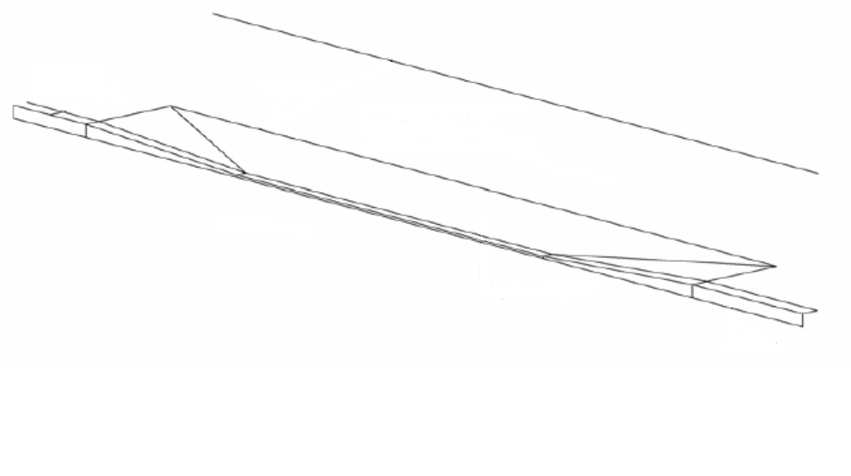Fig 4.3 – Diagram of kerb types
Bull-nosed (flat) kerbs
Transition kerbs

4.4.1 Driveway Gradient – An LDVC will not be allowed where the parking area within 5 metres of the rear of footway is of greater gradient than 1in10 (10%). This could cause difficulties for the driver entering and exiting the driveway and reduce visibility of pedestrians and vehicles on the highway.

4.4.2 Steep driveways can also result in a severe change in gradient between the driveway and highway to an extent where there is not enough clearance for a car to be able to enter or exit the driveway without scraping the underside of the car, or its bumper, to scrape on the highway. The council will not change the level of the highway to accommodate a vehicle crossing – it is the applicant’s responsibility to ensure that their driveway is constructed at the appropriate gradient.

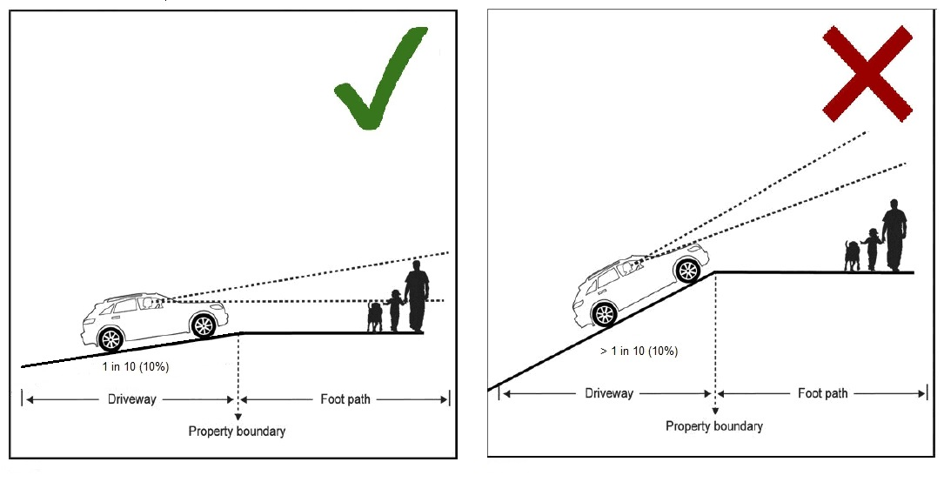
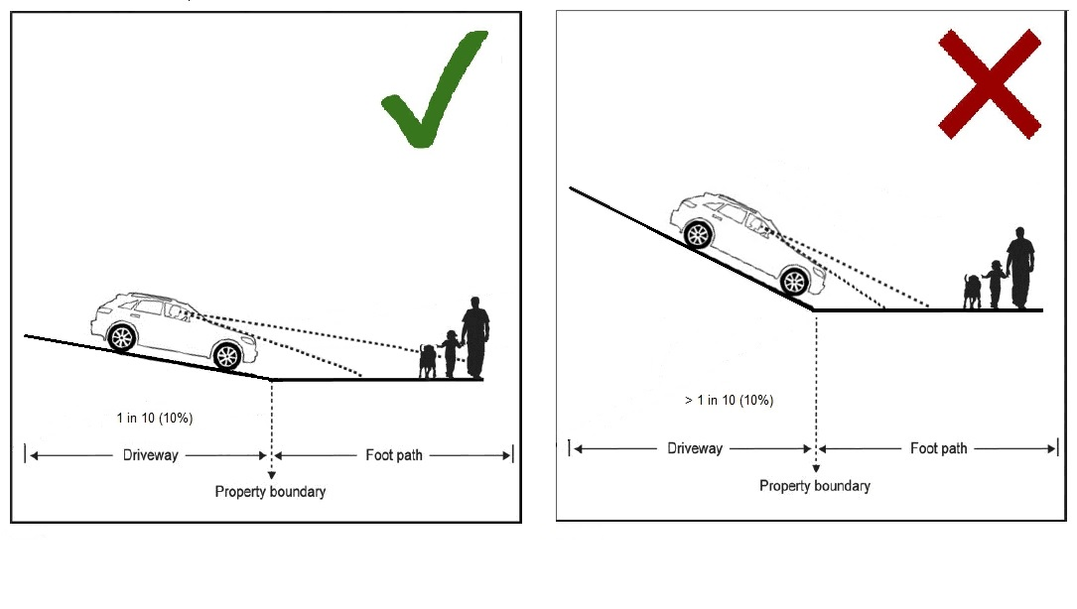
Fig. 4.4 – Driveway gradient

4.5.1 Footway Drainage – LDVCs need to ensure that pedestrian areas are properly drained and are neither washed by runoff or subjected to standing water. There should be a crossfall of at least 1in40 (2.5%) to allow water to flow from the footway onto the carriageway. When constructing a hardstanding, it is the applicant’s responsibility that the hardstanding is level with the highway at the property threshold.

4.5.2 In no circumstances will it be acceptable to allow water to flow from the footway onto the property. This could lead to a property being flooded.

4.5.3 Where sufficient crossfall cannot be achieved without maintaining the desired driveway gradient (see Sec 4.4.1), the application will be refused. Standing water on the footway can be a danger to pedestrians, especially during winter months when it could freeze.

4.6.1 Junctions and Roundabouts – The Council will not allow an LDVC closer than 10 metres to a junction or roundabout (including mini-roundabouts) on an unclassified road or 15 metres on a classified road. This distance will be extended to at least 20 metres* on all road types for a junction with traffic lights. When located too close to a junction, there is an increased risk of conflict between vehicles using the junction and the LDVC.

*this distance may be extended subject to section 5.8.1.

4.6.2 Where a property is situated on the junction of a major road and a minor road, the LDVC should be located on the minor road wherever possible.

4.7.1 Visibility – A visibility splay of 1m x 1m must be provided either side of the driveway to ensure inter-visibility between pedestrians using the footway and a vehicle manoeuvring from the drive onto the highway. Pillars, fences, walls or planting greater than 0.6 metres in height will not be allowed within this area as it would obstruct the view of a driver to a child or buggy on the footway.

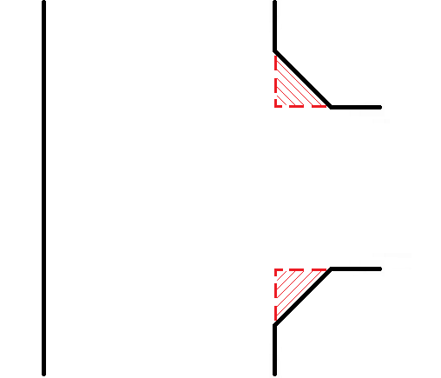
Pedestrian Visibility
Pedestrian Visibility

Footway or Verge
Carriageway
↑
1m
↓
↑
1m
↓
←1m→
←1m→

Fig 4.7.1 – Pedestrian visibility splay

4.7.2 When a vehicle is being manoeuvred from the driveway, there must be adequate visibility for the driver to see oncoming traffic and vice versa. On a flat road at a position of 2 metres (X distance) back from the kerb edge, a visibility splay of 25 metres (Y distance) along the kerbline in either direction will be needed on a road with a 20mph speed limit. On a road with a 30mph speed limit, a Y distance of 43 metres would be necessary. Visibility requirements for roads with a higher speed limit or on a hill will be assessed on an individual basis using the guidance detailed in “Manual for Streets 2” or any superseding document.

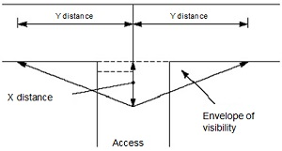

Fig 4.7.2 Vehicular visibility splay

4.7.3 Any location where there is a single or double solid white line in the centre of the carriageway, as per Diagram 1013.1, will be deemed to have insufficient visibility even if it meets the distance criteria in 4.7.2.

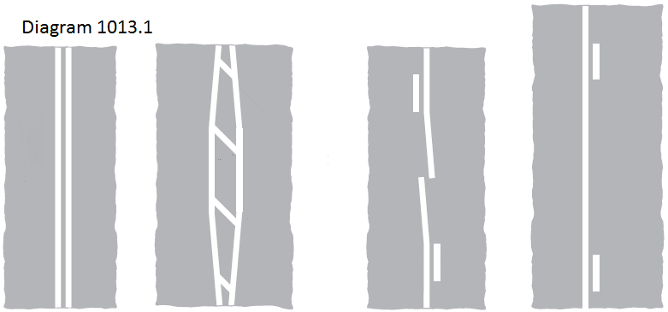

4.8.1 Difference in Footway/Carriageway Levels – Applications where the footway is significantly higher than the carriageway will be assessed on an individual basis. Any additional works identified should be paid for in full by the applicant and completed before the construction of the LDVC commences.

4.8.2 As a general rule the following criteria shall apply:

- Alterations to a highway structure, such as a retaining wall, will not be permitted.
- The gradient of the LDVC should be a maximum of 1in10 (10%) across the footway (from the driveway to the road).
- The footway should be re-profiled to a maximum gradient of 1in40 (2.5%) to facilitate wheelchair access – given the hilly nature of some parts of the borough, this may not be achievable, in which case, the gradient should not increase from its existing level.
- This may mean that an extensive length of the footway would have to be re-profiled to achieve the desired gradients. This could expose the foundations and affect the stability of garden walls/fences. Therefore, existing walls/fences would have to be removed prior to the works commencing.
- Oldham Council will not agree to re-profile a footway where it will alter the level outside another property. In such cases the application will be refused.
- Many utilities are located in footways and verges. Re-profiling a footway would most likely require the relocation of utility apparatus. Prior to granting a vehicle crossing access, the applicant will be required to pay for a trial dig to verify the depth of any services. It would then be the applicant’s responsibility to liaise with the relevant utility companies to relocate their apparatus (See section 5.2).

4.8.3 Where the carriageway is higher than the footway, the application will be refused. This would lead to water flowing from the highway onto the property, potentially leading to flooding.

4.9 Gates – It is an offence under Section 153(1) of the Highways Act 1980 to allow a gate to open outwards towards the highway. Any gates fitted outside a property must be fitted in a manner that they open inwards or sideways for sliding gates – in all circumstances, gates must not open onto the highway.

4.9.1 If a gate is to be used, the length of the driveway will need to be increased so that there is sufficient room for the gate to be opened and closed whilst a vehicle is parked on the driveway. (See section 4.2.1)

5 Obstructions

5.1.1 Where there is a physical obstruction to a proposed LDVC, or its construction will have a detrimental impact on traffic, then the application will be refused, unless the obstruction can be overcome by technical means (such as relocation). In all cases, any accommodation works to overcome obstructions must be paid for in full by the applicant and the works must have been completed before the LDVC is constructed.

5.1.2 If the obstruction is unable to be relocated, or the resident chooses not to pay the costs of relocation, the obstruction must be behind at least one full-height kerb to prevent it from getting hit by vehicles manoeuvring on and off the driveway. The vehicle crossing will begin by placing the transition kerb adjacent to the full height kerb protecting the obstruction.

5.2 Utility Apparatus – Location of Telegraph poles or other Statutory Undertaker apparatus – Where the LDVC affects the location of a telegraph pole, a utility box or chamber or other elements of the utility network, the applicant will need to obtain agreement from the Utility concerned to move/alter the apparatus. The Utility will, in turn, need the agreement of Oldham Council to move the apparatus to the new location. In all cases, all costs for the relocation of the apparatus will be a matter of negotiation between the applicant and the utility company. The Council will not install an LDVC until all affected apparatus have been relocated.

Please note that the cost of relocating utility apparatus can be prohibitive, potentially in the tens of thousands of pounds.

5.3 Street lighting columns – Street lighting columns are arranged to provide an even level of illumination to the highway for safety reasons. Relocating them to facilitate an LDVC may affect the level of illumination offered and if this cannot be overcome by technical means, then the application will be refused. If it is acceptable to move a column, then all costs of the relocation will be charged to the applicant.

5.4 Highway Trees – An LDVC will not be allowed where its construction would require either the removal of, or cutting the roots of, a healthy highway tree. Generally, the Council will only agree to the removal of a highway tree if it is dead, diseased, dying, or considered to pose a health and safety risk. In all cases, where it is agreed to remove a tree, the applicant will be required to pay for the cost of its removal and for three replacements to be planted.

5.5.1 Bus Stops – An LDVC will not be allowed where there is potential for conflict with buses using bus stops. No LDVCs will be permitted:

  - within bus stop clearway markings
  - within *5.5 metres in front of the bus stop pole
  - or within *17.5 metres to the rear of the bus stop pole

*These distances are necessary to ensure that a bus has sufficient space to pull into a bus stop, straighten up, and drive away from the stop free from obstruction. However, they may need to be increased in special circumstances such as for double bus stops or stops that serve articulated (bendy) buses.

5.6 Road humps - where an applicant requests a new vehicle access crossing or seeks an extension to a vehicle access crossing in circumstances where an existing road hump or similar feature is judged to create an unacceptable hazard or hindrance to the operation of the crossing, the application will not be approved.

5.7 LDVCs are not suitable at pedestrian crossing points. Blind or partially sighted people need to be able to distinguish between LDVCs and places where it is safe to cross. Where there is a pedestrian crossing point, the LDVC should be constructed separately with at least one full-height kerb stone between the LDVC’s transition kerb and the pedestrian crossing’s transition kerb.

5.8.1 Traffic Signals – LDVCs should not affect the operation of traffic lights. The Council will not allow an LDVC on any side of the road where traffic regularly queues at traffic signals or within 20 metres of a set of traffic lights.

5.8.2 Crossings Points – LDVCs will not be permitted within the confines of the zigzag lines at a controlled crossing, such as a zebra or pelican crossing.

5.9.1 Cycle Lanes – LDVCs will not be permitted over a shared use footway / cycleway, over a cycle track or over a mandatory cycle lane in the carriageway. LDVCs may be permitted over an advisory cycle lane if it assessed to be safe.

5.9.2 A mandatory cycle lane is distinguished by a solid white line between the main carriageway and the cycle lane. For an advisory cycle lane, this white line is broken. Motorised vehicles are not permitted to enter mandatory cycle lanes and should not enter advisory cycle lanes unless the driver has seen that it is safe to do so.

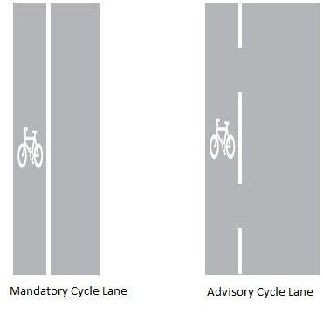

5.10.1 Designated Parking bays – The Council has the power to enforce the prohibition of parking in front of a dropped crossing. However, this power does not apply to designated parking places (e.g. laybys or other areas constructed for parking), or any area on the carriageway where parking is specifically authorised, such as a marked parking bay.

5.10.2 An LDVC will not be permitted in a designated parking place.

5.10.3 In areas where parking is specifically authorised, such as in marked parking bays, the applicant will also have to apply for Access Protection Markings and pay to have any existing road markings amended. This is so that motorists are able to distinguish between where they are and are not allowed to park. If the road markings are not amended, then the Council will not be able to enforce the prohibition of parking in front of the dropped kerbs.

6 Enforcement of Illegal Crossings

6.1 The unlawful act of driving a motor vehicle over the kerb and across the footway (commonly known as the pavement) in order to gain access to premises where there is no dropped crossing could be subject to formal action by the Council or the Police. The Council’s approach to enforcement will be to offer advice and guidance as the first and preferred way to deal with illegal crossings. However, the Council will use formal powers, where necessary, to prevent illegal crossings.

6.2 The Council has a number of formal options under Section 184 of the Highways Act 1980, available to it to prevent illegal crossings. For example, serving a notice on the occupier/owner of the property, imposing conditions on the use of a crossing or to carry out work to construct an LDVC and re-charge the occupier/owner. There is a right of appeal to the Secretary of State in relation to the service of a notice under Section 184. Other measures could include installing physical barriers, such as guardrails or bollards to prevent access to the driveway where a crossing is not permitted.

7 Removal of Redundant Dropped Kerbs

7.1 When carrying out works to refurbish or improve the highway, Oldham Council will remove any dropped kerbs where it reasonably believes that the crossing is no longer in use and construct a full height kerbline. For example, where the access to a property has been closed off by a fence or wall.

8 Representations

8.1 In some cases, applicants may not be entirely satisfied with the outcome of their application. In situations like this, any representations should be made in writing to the Head of Highways at Oldham Council, Moorhey Street Depot, Moorhey Street, Oldham, OL4 1JF.

8.2 Any representations should include details of why the applicant thinks they have grounds for an appeal, such as, that the policy has been incorrectly applied, or there are special circumstances as to why this policy should not apply to their property.

8.3 The Council will not consider an applicant’s individual circumstances when making its decision. When an LDVC is constructed, it will be permanent, even after the applicant’s personal circumstances may have changed or they have moved out of the property.

8.4 Any decisions made will be considered on their own individual merits and on whether the proposed location of the crossing is in an appropriate place. The Council will not take into account any historic crossings at nearby or similar properties that were constructed according to requirements at that time.

