**SEND Guidance:**

**The Graduated Response**

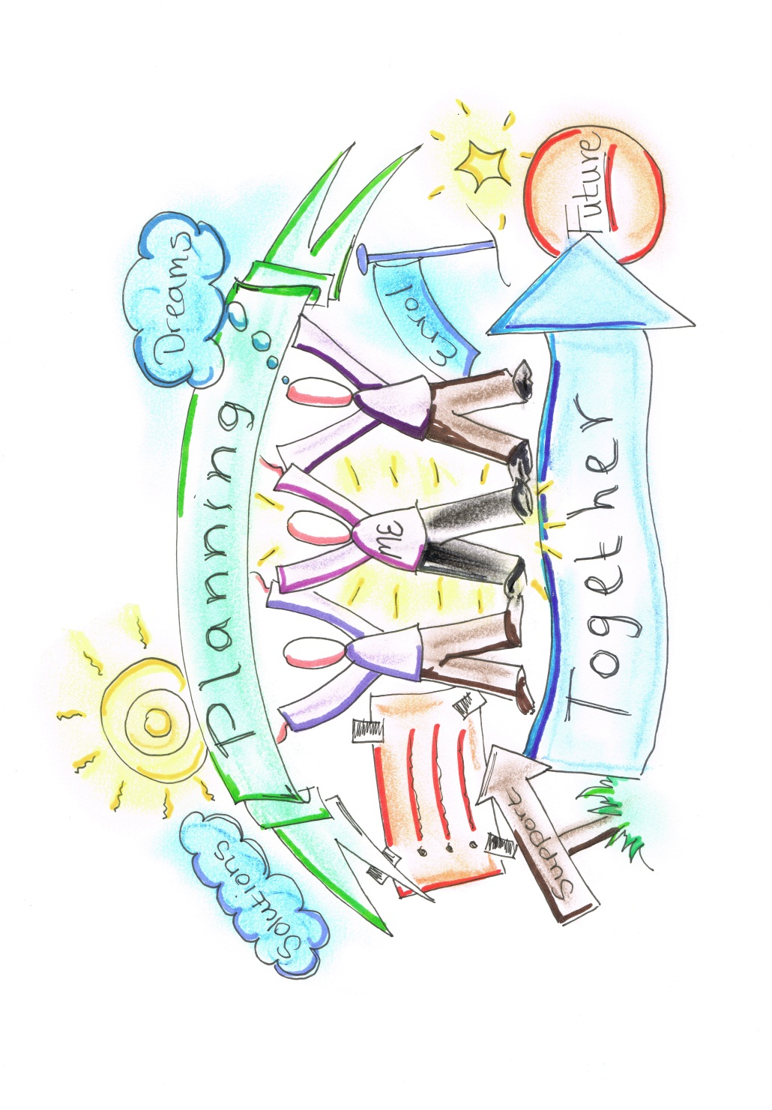

March 2019

# 1 Introduction and Context

The Code of Practice sets out its vision for children, young people and adults with special educational needs and/or disability which is no different than the vision for all children and young people – that they achieve well in their early years, at school and college and go on to lead happy and fulfilled lives.

The reforms aim to ensure that children and young people’s experience of the system will be less confrontational and more efficient. They should have their special educational needs picked up at the earliest point, be able to access support quickly when it’s needed and their parents will know what services they can reasonably expect to be provided. There is also emphasis placed on increased involvement with children, young people and their parents or carers being fully involved in decisions about their support and what they want to achieve. There should be an increased focus on life outcomes, including employment and greater independence and that by doing this the aspirations of children and young people will be raised.

Equality and inclusion is at the core of our vision for meeting SEN within Oldham. We also have an ambition that ‘all children and young people, including those with special educational needs and disabilities (SEND) have the best start in life and can reach their full potential academically, across wider achievements, socially and in employment.This vision is outlined in our Draft Inclusion Strategy that will be published in summer 2019.

Oldham is committed to working in partnership with all education, health and social care agencies to jointly plan and commission services for children and young people who have special educational needs or are disabled and to ensure that meeting the needs of children and young people with Special educational needs and/or disability remain central to both policy and practice.

This guidance is one of a set that has been written to support education and learning settings in meeting the requirements of the Code of Practice and aims to reflect the cultural shift that is one of the underlying principles of the Code of Practice. This booklet explains the graduated response which is a key concept in the code of Practice. It also explains how Person Centred Approaches can be used to support one of the key ambitions of the code – putting children and young people at the centre of what we do.

The other booklets are

* Graduated Response Toolkit
* Person Centred Toolkit
* Guidelines for requesting an EHC plan

This guidance is designed to provide information for early years providers, schools and post 16 and post 19 providers, parents, children and young people (CYP), Health and Social Care Professionals on expectations in terms of delivering the Special Educational Needs and Disability Code of Practice:

0 to 25 years. Whilst statutory duties vary slightly depending on the sector, what is set out here is our expectation for all educational and learning settings and is based on what we see as good practice.

**2 The principles underpinning the Code of Practice**

Section 19 of the Children and Families Act 2014 makes clear that local authorities, in carrying out their functions under the Act in relation to disabled children and young people (CYP) and those with special educational needs (SEN), must have regard to:

* The views, wishes and feelings of the child or young person, and the child’s parents
* The importance of the child or young person, and the child’s parents, participating as fully as possible in decisions; and being provided with the information and support necessary to enable participation in those decisions
* The need to support the child or young person, and the child’s parents, in order to facilitate the development of the child or young person and to help them achieve the best possible education and other outcomes, preparing them effectively for adulthood.

These principles are designed to support:

* The participation of children, their parents and young people in decision making
* The early identification of children and young people’s needs and early intervention to support them
* Greater choice and control for young people and parents in relation to the support they receive
* Collaboration between education, health and social care services to provide support
* High quality provision to meet the needs of children and young people with special educational needs (SEN)
* A focus on inclusive practice and removing barriers to learning
* Successful preparation for adulthood, including independent living and employment.

The Code outlines how local authorities must ensure the children, their parents and young people are involved in discussions and decisions about their individual support and about local provision. It also states that early years providers, schools and colleges should also take steps to ensure that young people and parents are actively supported in contributing to assessments and developing and reviewing education health and care plans.

It also refers to articles 12 and 13 of the United Nations Convention on the rights of the child, which states that children have a right to receive and impart information, to express an opinion and to have that opinion taken into account in any matters affecting them from the early years. The view should be given due weight according to their age, maturity and capability.

A key approach in delivering this ambition is through the use of Person Centred Approaches.

9.21 of the Code highlights how using a person centred approach in assessment and planning can ensure that children, young people and parents are involved in all aspects of that planning and decision-making. Section 9.99 also makes reference to Person Centred Approaches as part of the development of EHC plans.

# 3 What are Person Centred Approaches?

Person Centred Approaches are about discovering and acting on what is important to a person, what is important for them and finding the balance between them. It is a process of continual listening and learning, focusing on what is important to someone now and in their future, and acting on this.

The listening is used to understand the person’s capacities and choices. Person Centred Approaches from a basis for problem solving and negotiation to mobilise the necessary resources to pursue a person’s aspirations. These resources may be obtained from someone’s own network, service providers offer non-specialist, non-service sources (Department of Health 2001).

The principles of Person Centred Practice are fundamental to the use of person centred tools. These principles are about listening, sharing power, responsive action and connecting with citizenship. In writing about these principles Thompson et al (2008) suggest they are written with an implicit hierarchy and that each principle underpins and interconnects with the others. As an example they suggest it is not possible to share professional power effectively without listening to what is important to a person first. Each of these four principles is described below.

**Listening**

Listening in Person Centred Planning and approaches involves earnest attention and intention. Attention to body language, words, meaning, inspirations and aspirations. There is an intention to understand, to know, to connect with, to make possible, to be alongside and to support a person. Listening with intention and attention is important to create conditions that give voice to those who are at risk of or have been silenced or ignored.

Listening in Person Centred Practice involves listening both to what is important to someone and what is important for them.

**Sharing Power**

Person centred planning support self-determination by offering ways to listen to what is important to act upon these things. Person Centred Approaches challenges power balances between people with learning disabilities and professionals. In the past the power to know what a person needs was located with professionals who then figured out how to meet this professionally identified need using service structures. Person Centred Approaches focus on working with people and not doing things to them.

**Responsive Action**

Listening alone is insufficient if there is not a sense of a clear intention of acting on what is heard. Responsive action involves being clear about what we are responsible for in our professional roles with people and what is outside our sphere of influence or none of our business. In the exchange model there is a core assumption that the person is the expert on their own life problems, and a professional expertise lies in helping to create a shared understanding of the person in the situation, to go shaking, problem-solving and co-designing solutions.

**Connected with Citizenship**

Person centred planning, thinking and practice should make a significant contribution to the journey towards citizenship for individuals. Person centred planning is granted in beliefs and actions which serve to shift political location of people with learning disabilities from needy recipients to equal citizens.

Duffy (2003) proposed six keys that collectively enable the achievement of full citizenship

1. Self-determination - the authority to control our own lives
2. Money - to live in control our own life
3. Direction - plan or an idea of what we want to achieve
4. Home - a place that is our own base and a base for life
5. Support- help to do things that we need help to achieve
6. Community life and active engagement in the life of the community and the development of our own network of relationships.

The new Code of Practice sees these principles underpinning the new approach to SEND and highlights how the assessment and planning process should:

* Focus on the child or young person as an individual
* Enable children and young people and their parents to express their views, wishes and feelings
* Enable children and young people and their parents to be part of the decision-making process
* The ease of children, young people and their parents or carers to understand, and use clear ordinary language and images rather than professional jargon
* Highlight the child or young person’s strengths and capabilities
* Enable the child or young person, and those that know them best to say what they have done, what they are interested in and what outcomes they are seeking in the future
* Tailor to support the needs of the individual
* Organise assessments to minimise demands on families
* Bring together relevant professionals to discuss and agree together the overall approach, and
* Deliver an outcomes focused and coordinated plan to the child or young person and their parents.

A person centred approach is about listening and acting on what has been heard. It is about co-production and equalising power. It’s not about ‘telling’ which is disempowering but about ‘asking’.

A Person Centred Approach should underpin education and learning settings responses to meeting the SEN of their pupils, where participation and coproduction are core themes. Key behaviours to support this are summarised in Oldham’s coproduction values:-

* Equal partnership
* Communicate
* Be transparent
* Be accountable
* Value my contribution

(Coproduction values can be found in the Graduated Response section of the Local offer page)

The aspiration of the Oldham local partnership (which includes the local authority, education settings, social care, health services and parental representation) is that every one of these young people will thrive during childhood and adolescence and go on to achieve their ambitions while enjoying the best life possible. Listening carefully and responding to the ‘voice of the child’ is key to our moral purpose.

**Person Centred Tools.**

Person centred tools can be helpful in supporting a person centred conversation. The table below summarises some of the common person-centred thinking tools and how they can be used with CYP and their families:-

| **Person-centred thinking tool** | **What this tool can do** | **How it can be used** |
| --- | --- | --- |
| What is important to… and what is important for …? | Identify what matters to the young person and what is important for them to stay healthy and safe, and find a balance between them. | To create a one-page profile that captures what matters to them and how best to support them,  along with what people like and admire about the young person.  This can then form the basis of a person-centred plan. |
| What is important in the future | Capture young person’s aspirations and ideas about the future. | Opportunity to capture information about what is possible and an important part of a person centred review. |
| What’s working / not working | Help to reflect on the child’s life and school experience. | Can be looked at from different perspectives: - CYP, family, school others. To enable people to build on what is working and to identify what is not working, who it is not working for and what can be done about it. |
| Like and admire | Provides a way to appreciate and recognise the positive qualities of a CYP. | To create ‘feel good’ folders for young people that describe what other people appreciate and admire about them. It helps staff working with them to understand what others like and admire and provides a counter focus to ‘what’s wrong’. |
| Relationship circle | Provides a way to identify who is in the child or young person’s life and their relationship. | To identify relationships that can be developed and or strengthened. |
| Communication charts | Provides a way to describe in a simple way how the CYP communicates through their behaviour and how others communicate with them. | Provides vital information for children and young people who do not communicate through words. |
| The Doughnut | Identifies specific responsibilities- what is core, where people can use their judgement and creativity and what is not part for the job. | A way to clarify who is responsible for what in a young person’s life. Teachers and other staff are helped to identify what are their core responsibilities, where they can use creatively and judgement. |
| Learning Log | A record of what happened and what was learned. | Is a way of recording situations that focus on learning. |
| 4+1 Question Tool | This is another tool for reflection and learning about what works and doesn't work. Answering the first 4 questions lead to the +1 question – what should we do next. | These questions are powerful to use in meetings and reviews.  It can be an easy way to update one-page profiles and develop more detailed person-centred descriptions.  It can be an efficient way to gather collective learning and to make this visible to everyone. |

# 

# 4 SEND Pathway – A Graduated Response

High quality teaching that is differentiated and personalised will meet the individual needs of the majority of children and young people. Some children and young people need educational provision that is additional to and different from this and will have these needs met from within the resources available to school. These CYP will have an SEN Support Plan. A small minority of CYP who are not making progress with SEN support may need to be considered for an Education, Health and Care Plan needs assessment in order that the local authority can decide whether it is necessary for it to make provision in accordance with an EHC Plan.

1. **Definition of SEN**

A child or young person (0-25) has a learning difficulty or disability if they have either:

* A significantly greater difficulty in learning than the majority of others of the same age;
* Have a disability which prevents or hinders them from making use of learning facilities of a kind generally provided for others of the same age in mainstream schools or mainstream post-16 institutions.

**Setting High Expectations for all Children and Young People**

Oldham has approximately 82,000 children and young people between the ages of 0-25 growing up in the borough. Approximately 10% of children and young people across the borough of Oldham have SEND. In recent years we have also seen an increase in the complexity of children and young people’s additional support needs in the community. For these children and young people this can lead to extra challenges and barriers to overcome if they are to achieve their hopes and dreams and to go on to lead healthy, happy and successful lives. Our ambition is that ‘all children and young people, including those with special educational needs and disabilities (SEND) have the best start in life and can reach their full potential academically, across wider achievements, socially and in employment.’

The Graduated Response starts at the whole setting level and starts from the position of all children and young people being entitled to ‘an appropriate education, one that is appropriate to their needs, promotes high standards and the fulfilment of potential and that this should enable them to:

* Achieve their best
* Become confident individuals living fulfilling lives and
* Make a successful transition into adulthood, whether into employment, further or higher education or training.

Educational and learning settings should know precisely where children and young people who have SEN are in their learning and development and the identification of SEN should be built into the overall approach to monitoring the progress of all pupils.

The quality of teaching for pupils with SEN, and the progress made by CYP, should be a core part of the education and learning settings performance management and its approach to professional development for all teaching and learning staff.

There should be regular assessments undertaken by those who have direct responsibility for teaching (e.g. class and subject teachers in primary and secondary schools) supported by the senior leadership team. These assessments should seek to identify pupils ‘making less than expected progress’ given their age and individual circumstances.

This progress can be characterised by progress which

* Is significantly slower than that of their peers starting from the same baseline
* Fails to match or better the child’s previous rate of progress
* Fails to close the attainment gap between the child and their peers
* Widens the attainment gap.

It should also include progress in areas other than attainment, for example a child or young person may need to make additional progress with wider developmental social needs in order for them to make a successful transition into adult life.

The first response to a child or young person not making expected progress should be high quality teaching targeted at their area of weakness. Additional intervention and support cannot compensate for a lack of good quality teaching. This high quality teaching should include appropriate differentiation and should cover four areas of provision

* Curriculum and teaching methods
* Behaviour policies and practices
* Interval and lunchtime practices
* Managing all key transition points.

Where progress continues to be less than expected the adults responsible for teaching the child or young person working with the SENCO should assess whether the child or young person has SEN.

**Broad Areas of Need.**

The code identifies four broad areas of need:

* Communication and interaction
* Cognition and learning
* Social, emotional and mental health
* Sensory and/or physical needs.

**Communication and Interaction**

Children and young people who have speech, language and communication needs may have difficulties understanding what is said to them or have difficulties saying what they want to. They may find it difficult to understand and use social rules. Children and young people with autism are likely to have particular difficulties with social interaction as well as language communication and imagination which may impact on how they relate to others. Individual children may have difficulties with some or all aspects of language and it is therefore important to understand each child’s individual profile of language difficulties.

**Cognition and Learning**

Where children and young people learn at a slower pace than their peers even with appropriate differentiation they may require additional support.

The term learning difficulties covers a wide range of need including moderate learning difficulties, severe learning difficulties through to profound and multiple learning difficulties.

Specific learning difficulties are where one or more specific area of learning is affected for example dyslexia, dyscalculia and dyspraxia

**Social, Emotional and Mental Health Difficulties**

Children and young people with social emotional and mental health difficulties can present with a wide range of behaviours. For example they may become withdrawn or isolated or display challenging, disruptive or disturbing behaviour. Whilst these behaviours may reflect underlying mental health difficulties such as anxiety or depression, self-harming, substance misuse, eating disorders or physical symptoms that are medically unexplained. Other children and young people may have neuro diverse conditions such as ADHD or may have attachment difficulties. When looking at this area it is also important to ensure that an assessment to determine causal factors such as undiagnosed learning difficulties or difficulties with communication as well as mental health are thoroughly explored. This area has clear links to the Whole School and College Approach to Emotional Health and Mental Wellbeing <https://www.oldham.gov.uk/info/200807/mental_health/1795/the_whole_school_and_college_approach_to_emotional_health_and_mental_wellbeing>

**Sensory and/or Physical Needs**

Where children or young people have a disability which prevents or hinders them from making use of the educational facilities generally provided they may require special educational provision. Children and young people with hearing impairment of vision impairment or multi-sensory impairment may require specialist support and/or equipment to access their learning or habilitation support.

Whilst it can be useful to think of these four broad areas of need they are not necessarily discrete and rather than thinking about trying to fit CYP to a category it is more helpful to try to understand their strengths and needs holistically as well as considering environmental factors that may impact on these.

Environment

**SEN Support**

The Code goes on to recognise that some children and young people will need educational provisions that are additional to or different from this and that schools and colleges must use their best endeavours to make sure that such provision is made for those who need it. The Code emphasises that special educational provision is underpinned by high quality teaching and is compromised by anything less.

If, despite appropriate high quality teaching, the child/young person is not making expected progress then more adjustments, interventions and support should be put in place with support from the special educational needs coordinator (SENCO). Any intervention should be agreed in consultation with the parent/carer, child or young person, teacher and SENCO (usually at a person-centred review since, using person centred tools), as well as the expected impact on progress along with a clear date for review. Where a CYP is identified as having SEN, settings should take action to remove barriers to learning and put effective special educational provision in place. This SEN support should take the form of a four-part cycle through which earlier decisions and actions are revisited, refined and revised with a growing understanding of the pupil’s needs and of what supports the CYP in making good progress and securing good outcomes. This is known as the graduated approach. It draws on more detailed approaches, more frequent reviews and more specialist expertise in successive cycles in order to match interventions to the SEN of CYP. The next sections will look at each of these 4 stages.

The four-part cycle of assess, plan, do, review which forms the graduated approach increasingly draws on more personalised approaches, more frequent reviews and drawing on specialist expertise in successive cycles in order to tailor interventions to meet the particular needs of children and young people. The early years key worker/class or subject teacher remains responsible for monitoring progress and evaluating the impact of interventions to improve outcomes for the child or young person.

It is critical that the children and their parents and young people are actively involved and so where there are concerns the setting must inform parents. In order to follow the principles of the Code of Practice this can be done through a person centred conversation. The involvement of children and young people should increase as the child grows older. For a very young child we will need to ‘listen’ to them through observation as they will not have the language to tell us directly. Consideration should always be given to how the child can be involved and the degree to which they are involved will increase over time. This cannot be prescriptive as it will depend on children’s individual circumstances but it is essential that the child’s aspirations are sought as these may not necessarily coincide with other’s aspirations for them.

Adopting a Person Centred Approach is a key way of supporting and actively promoting the involvement of CYP and their families.

# *What is the assessment telling you?*

# *What are the CYP aspirations?*

# *What outcomes – Longer term and short term? (to meet aspiration but also to address what is important for)*

# *SMART?*

# *Link aspiration/need/outcome and provision*

# *What does HQT and differentiation look like*

# *Can be summarised in an SEN Support Plan*.

**Assess, Plan, Do, Review**

*Education, Health and Social*

* *Attainments*
* *CYP views*
* *Parental Views*
* *Baseline skills*
* *Behaviour*
* *Observation*
* *(Specialist Assessments)*

**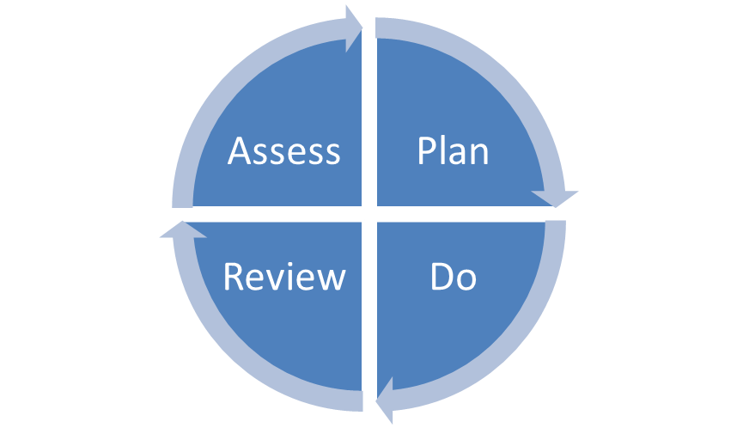

* *Have the outcomes been achieved?*
* *Measures:-*
* *Retest against baseline*
* *Behaviour – happening less frequently, for shorter duration with less intensity? Or are skills/ behaviours we want to see happening more frequently?*
* *Pupil perspective- increased confidence*
* *Parental perspective.*
* *Person centred tools are useful**way of doing this.*

**Assess**

Here there needs to be a clear analysis of CYP need and should involve some of the following as appropriate:

* Class Teachers/Subject teacher’s assessment
* Experience of the pupil, previous progress and attainment as well as information from the school’s core approach to pupil progress, attainment and behaviour
* Baseline assessment of current skills in the areas of concern
* Information from observations
* Functional Behavioural Analysis (looking at where, when and the likely reasons why a behaviour of concern happens)
* Subject teacher’s assessment where appropriate
* Views and experience of parents
* The pupils views
* Consideration of health and social needs.
* Where appropriate advice from external support services
* Liaison with health or social services where they are involved to inform assessments.

(The Graduated Response Toolkit can be found in the Graduated Response section of the Local offer page)

**Plan**

Based on the information gathered from the assessment, and in consultation with the parent and CYP, staff (usually the teacher in schools) and SENCO (in schools and preschools) there should be an agreement reached about:

* The outcomes sought for the child based on the information and assessment to date including the child’s response to earlier intervention, their aspirations and what is important to them and what has been identified as important for them
* The evidence based adjustments, interventions and support to be put in place
* The expected impact on progress, development or behaviour,
* The HQT and differentiation that needs to be implemented as part of everyday curriculum planning
* Monitoring and review arrangements
* Date for review.

The plan should be drawn up using person centred approaches and the plan can be summarised in an action plan. The action plan should state the agreed actions (including outcomes sought for the child), what will be put in place, who will be responsible and when it will be reviewed.

**Writing Outcomes**

Outcomes are not provision but are a clear description of what a child or young person will be doing at a specific point of time in the future.

They should be written from the perspective of the CYP and are not about what services may do. There does need to be a clear link to aspirations but outcomes should also address what is seen to be important for a CYP as well. For example a child’s aspiration may be to have more fiends and what is seen to be important for their future is to attain qualifications. Outcomes identified should encapsulate both. Outcomes may be steps to aspirations but should be clear and SMART

**S Specific**

**M Measurable**

**A Achievable**

**R Realistic and Relevant**

**T Time limited**

Outcomes should be:

* Something the child or young person will be doing in the future that they are not doing now
* Medium or long-term
* Developed from what we know is important to and important for the child
* Developed from what’s working and what’s not working taken from different perspectives can also help to identify issues that need to be addressed.

There should be a golden thread between aspirations, needs out come and provision.

* Aspirations- describe what someone wants their life to be like in the long term (or what parents want their child’s life to be like)
* Needs- These describe areas of difficulty
* Provision-Is what is put in place to help achieve outcomes identified.

Common error when writing outcomes:

* Confusing outcomes with aspirations
* Embedding the solution or provision into the outcome
* Not being specific enough to be able to measure whether it has been successfully achieved.
* A good outcome is:
  + Building on something that is working well
  + Changing something that doesn’t work well
  + Addressing needs
  + Moving the person towards their future aspirations.
* If the outcome being considered doesn’t address any of these issues, then it probably isn’t an outcome.
* A person-centred outcome can be described as:
  + Being expressed from a personal perspective, not a service perspective
  + Within the control and influence of the person and/or those involved
  + Specific to the person and measurable.

When writing outcomes consider the following:

* They should be focused on the child
* They're not about the intentions of staff
* Use action verbs
* Typically written in the future tense- Billy will be....
* Remember outcomes are not limited to learning – other areas need to be considered – Health, Social, Preparing for Adulthood.

The following test can be applied to clarify if something is an outcome.

What would it:

* Give you
* Do for you
* Make possible for you
* Where, when and with whom do you want it to happen
* What is stopping you
* What would you do instead
* Does it just describe provision? Then it’s not an outcome.

Specific Teaching Programmes

Outcomes should by definition be long term (12 months +). In terms of teaching these long term outcomes there will be a need to be broken down into smaller steps or targets. These targets build towards the outcome and should also have smart targets. These can be thought of as Specific Teaching Programmes. There will need to be a STP for each outcome:

|  |  |  |  |  |  |
| --- | --- | --- | --- | --- | --- |
| Specific Teaching programmes. Date Review date. | | | | | |
| Outcome | Specific target | baseline | intervention | evaluation | Next steps |
|  |  |  |  |  |  |
|  |  |  |  |  |  |
|  |  |  |  |  |  |
|  |  |  |  |  |  |

**DO**

The class or subject teacher/tutor should remain responsible for working with the CYP on a daily basis. Where the interventions involve group or one-to-one teaching away from the main tutor group or subject teacher, they should still retain responsibility for the pupil. They should work closely with any teaching assistants or specialist staff involved, to plan and assess the impact of support and interventions and how they can be linked to classroom teaching. In the case of schools and preschools, the SENCO should support the class or subject teacher in the further assessment of the child’s particular strengths and weaknesses, in problem solving and advising on the effective implementation of support.

**Review**

A review using person centred principles should take place on the agreed date and should explore:-

* The effectiveness of the interventions and support in meeting the agreed outcomes
* The views of the pupil and parent
* How the plan should be revised in light of the progress made and views of parent and child including whether there needs to be any change to the outcomes and support.

The use of person centred tools may be helpful to support the review process. For example when reviewing outcomes the four + 1 tool may be useful or what’s working/not working. The pro-forma for specific teaching programmes has a section for recording outcomes and next steps.

At certain stages it may be felt that a full person centred review is needed.

A person centred review ‘is a way of learning or updating what is important to and for the pupil, together with the people who are important in the pupil’s life. The process involves looking at what is working and not working from the pupil’s perspective, the family perspective and the school’s perspective (and others perspective). Outcomes and actions are agreed to build on what is working and to change what is not working’ (Person-centred practice in schools, Sanderson)

Typical headings for a person centred review:

* **Introduction/Ground Rules**
* **Record who is at the meeting**
* **Like and Admire**

Everyone in turn to say what they like and admire about the child or young person. This includes strengths, personal qualities and characteristics.

* **What’s Important To the CYP and What’s Important For the CYP**

Everyone to say what they think is important to the CYP and what they think is important for them.

* **What’s Working and What’s Not Working**
* **Action Plan: needs to include**
* **Aspiration**
* **Need**
* **Outcomes written from the CYP perspective – what will they be doing**
* **Provision**
* **Timescale**
* **Reviewing and Action Planning**

This is the time to develop the actions that need to be taken and describe what the action is, who will take it and by when. It is important to date the actions giving an indication as to when the actions are to be reviewed regarding progress. (See the PC tool kit for more detail, also Person centred practice in school, Sanderson)

However, in other cases it may be felt that using some of the tools (e.g. what’s working, what’s not working) culminating in an Action Plan could be seen as sufficient. The 4 + 1 Question tool is also an excellent tool to use to review an action plan. As such a number of the person centred thinking tools outlined above could contribute to a person centred review. Another way can be to revisit what was written at a previous review and identify things that need to be added.

Whatever the approach selected a new outcome focused action plan should be drawn up and as a minimum requirement parents should have clear information about the impact of the support and interventions provided enabling them to be involved in planning next steps.

**Involving Specialists**

As part of the process it may be identified that it would be useful to ask for further assessments and or interventions from specialist services. Information from these services should then inform the ‘assess, plan, do, review cycle’.

The Code highlights that establishments might need to commission these services directly and that such services include but are not limited to:

Educational Psychologists, Specialist teachers or support services (Quality and Effectiveness Support Team), Teachers of Hearing Impairment and teachers of Visual Impairment.

Therapists including speech and language therapists, occupational therapists and physiotherapists.

**SEN Support Plan**

As the information grows about a child or young person, this information may most usefully be summarised within an SEN Support Plan. This document, which should be coproduced, pulls together information from a variety of sources including person centred reviews, as well as assessment information from other professionals and parents. It is seen to be a useful document where needs are complex, maybe involving social care and health and perhaps where there is a likelihood of a request for an EHC being made. An example of an SEN Support Plan is provided in appendix 1 and contains the following headings:

1. What we know about: strengths and areas of needs
2. Summary of needs (Health, Social Care and Educational)
3. Aspirations and outcomes sought (long term, medium term and short term)
4. Child Young Person’s support plan
5. Review date
6. Contributors to the plan
7. Key information
8. One page profile information is contained in appendix 2 of this document)

In evaluating your SEN Support Plan it will be useful to consider the following areas (adapted from The Council for Disabled Children’s document):

**Clarity of language**

Is the plan clear and written in a way that is easy to understand?

Where technical terms are necessary, are they explained?

**Advice**

Is it clear how the advice obtained through the assessment has been taken into account in the plan?

Is the advice included in the appendices?

Is there a list of those who contributed advice?

Is there advice from all the relevant professionals? The CYP? Their parents/carers?

**Other Assessment and Planning Processes**

Is any other assessment integrated with the assessment and planning process?

Have local agencies and services co-operated to integrate the assessment?

If this is not an integrated assessment, are appropriate links made to any other assessments?

**Participation**

Is it clear how the child or young person participated in the development of the plan?

Is it clear where views were gathered directly from the CYP and where they were provided by parents/others?

Is it clear how they were supported to communicate their views?

Is it clear how they participated in decision-making?

**Child’s Story**

Does the plan include the CYP’s story including: the achievements of the CYP?

**Who and What is Important to Them?**

Is there a one-page summary that communicates essential information about the CYP?

**Aspirations, Views and Interests**

Does the plan include the CYP’s interests, views and aspirations and those of the parents/carers for a child?

Does this include, as appropriate, details about: education, play, health, friendships, sixth form, further education, independent living, university and employment?

**Special Educational Needs**

Does the plan include the special educational needs that have been identified through the ongoing assess, plan, do, review cycle?

**Health and social care needs**

Does the plan include any health and social care needs?

**Outcomes Sought**

Does the plan list the outcomes sought for the CYP?

Do the outcomes reflect the aspirations of the CYP?

Is it clear how people will know whether or not each outcome has been achieved?

Are the outcomes specific and measurable?

Do they specify timescales – i.e. those that are short term, those that are medium term and those that are long term?

**Provision and Responsibilities**

**Special Educational Provision**

**Does the plan specify the special educational provision sought for the CYP?**

Is the provision detailed, specific and quantified (for example, in terms of the level of support and who will provide it)?

Is it clear how the type and level of provision will support the outcomes?

How has evidence of what works informed the specified provision?

**Health Care Provision Related to CYP’s SEN**

Does the plan specify the health care provision reasonably required by the learning difficulty or disability which results in him or her having special educational needs?

**Social Care Provision Related to CYP’s SEN**

Does the plan specify the social care provision reasonably required by the learning difficulty or disability which results in him or her having special educational needs?

**Other Health and Social Care Provision (if applicable)**

Does the plan specify other health and social care provision reasonably required by the child or young person? This is provision that is reasonably required but not linked to the learning difficulty or disability that results in the special educational need.

**Other resources**

Does the plan include the informal, additional support available to the CYP through friends, family, community?

**Plan**

Is there an action plan bringing together everything that everyone is going to do to enable the child or young person to achieve the outcomes identified in the plan?

Is it clear who is going to do what?

Are timescales and review points clear?

**Review**

Planning to review

Does the plan include a date by which the plan must be reviewed? This must be within 12 months of the date on which the plan was made, or within 12 months of the last review date.

For a child in year 9, and thereafter, will the review meeting consider what provision is required to assist in preparing the young person for adulthood and independent living?

**Transition**

Particular attention should be paid to reviews where a transition is coming up. Discussion in the review should explore issues in relation to this and an appropriate outcome set with agreed actions and provision.

**Requesting an EHC Needs Assessment**

If the CYP is not making progress despite schools using their best endeavours through assess, plan, do and review and using external agencies then a decision may be made to request an Education, Health and Care Plan assessment.

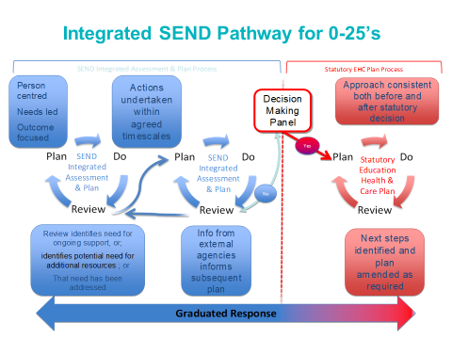

**Pupil Voice**

Listening to and acting on what has been said is a central tenet of person centred planning. This need also sit within legislation.

Convention on the Rights of the Child (UN, 1989) Article 12:

1. Parties shall assure to the child who is capable of forming his or her own views the right to express those views freely in all matters affecting the child, the view of the child being given due weight in accordance with the age and maturity of the child.
2. For this purpose, the child shall in particular be provided the opportunity to be heard in any judicial and administrative proceedings affecting the child, either directly, or through a representative or an appropriate body, in a manner consistent with the procedural rules of national law.

Legal/Government Guidelines

* 1. Children Act (DoH, 1989)
  2. SEN CoP (DfES, 2001)
  3. SEN Toolkit (DfES, 2001)
  4. Supporting the Target Setting Process (DfEE & QCA, 2001)
  5. Evaluating Educational Inclusion (Ofsted, 2001)
  6. Every Child Matters (HM Treasury, 2003)
  7. Your Voice (DfES, 2003)
  8. Real Decision Making (DCSF, 2007)
  9. Working Together: Listening to the Voices of Children and Young People (DCSF, 2008)
  10. Listening to and involving children and young people (DfE, 2014)
  11. Children and Families Act (2014)
  12. SEND Code of Practice 0-25 years (DfE, 2014)

Code of Practice

When carrying out an EHC needs assessment the local authority should seek views and information from the child using appropriate methods, which might include observation for a very young child, or the use of different methods of communication such as the Picture Exchange Communication System (SEND CoP, 2014)

Research data also suggests that there are clear advantages to involving children with SEN in assessment, planning and review processes (Roller 1998)

These include:

* Increased motivation
* Independence
* Perception of personal control
* The development of meta learning skills such as reflection, planning and monitoring
* Knowledge of learning styles and individual strengths and difficulties
* personal responsibility for progress
* A greater responsibility for change and progress.

**Authenticity**

It is essential when we are exploring views that they are recorded with authenticity. This means that:

* When view, wishes and aspirations are detailed it must be clear who is speaking, the child or young person, or their parent(s), teacher or other professional.
* Views and statements must never be represented as from the child or young person if contributed by another.

It is also important to consider has the child's voice been accurately represented or overly interpreted/distorted by others. It should also be noted that listening better includes hearing silence and that silence is not neutral or empty and that we need to be reflexive and reflective in decoding the encounter. (Lewis, p20)

**Presence to Participation**

Children and Young people’s involvement in decision that involve them will be at different points and will develop over time where we see participation as a continuum from ‘passive recipient’ to where CYP perspectives are actively involved with, and contribute to activities and practices at different levels on matters that affect them.

* Engagement – the processes and method of empowering CYP to recognise their right to and the benefits of getting involved in decision-making; and supporting them with the skills and tools to do so.
* Involvement – the inclusion of children at one of 4 levels in decision making:
* Being informed
* Expressing an informed view
* Having that view taken into account
* Being the main or joint decision maker

It is important to consider where children are on this continuum and how they are supported to continually move towards more active involvement.

**Appendix 1 - SEN Support Plan Pro-forma**

|  |
| --- |
| **SEN Support Plan** |

|  |
| --- |
| **Plan**  Insert photograph or picture chosen by the pupil    He likes to be called |
| 1. **What we know about ’s strengths and areas of need**   (based on profiles/assessments provided) |

|  |
| --- |
| **2. Summary of ’s needs; Health, Social Care and Educational** |

|  |
| --- |
| **Outcomes and Aspirations including those identified by the pupil**  **1 Aspirations for ’s future** |
|  |
| **2 Long Term Outcomes** (Achievable within a year) |
| **3 Medium Term Outcomes** (achievable within next 6 months) |
| **Specific Teaching Programmes** (achievable within 6 – 8 weeks) See STP for details.  1)  2)  3)  4) |
| **HQT and differentiation. These should also be on the one page profile as needed.**  **It may be helpful to think of these under the following headings.**   * Curriculum and teaching methods * Behaviour policies and practices * Interval and lunchtime practices * Managing all key transition points |
| This plan and actions will be reviewed by:  Within months  The meeting will be coordinated by: |

|  |  |  |  |  |  |
| --- | --- | --- | --- | --- | --- |
| **The following have been involved in ’s support plan by attending the meeting and/or providing written report.** | | | | | |
| Name | Role | Contact | | Attended meeting | Report and date |
|  |  |  | | / / |  |
|  |  |  | | / / |  |
|  |  |  | | / / |  |
|  |  |  | | / / |  |
|  |  |  | | / / |  |
|  |  |  | | / / |  |
|  |  |  | | / / |  |
|  |  |  | | / / |  |
| ’s views have been gathered from |  | | Who Facilitated: | | Date: |

|  |  |  |  |  |  |
| --- | --- | --- | --- | --- | --- |
| Full Name: | | | Preferred name: | | |
| Address: | | | Telephone: | | |
| Email: | | |
| Parent carers  Mother:  Father: | | Parental Responsibility: | | Address (if different from above) | |
| Telephone/email if different from above: | |
| Other important information about the child or their family, including barriers, or times that make it difficult to attend appointments or meetings: | | | | | |
| Placement: | | | | | |
| Key contacts: | School/Setting | | | | Education |
|  | Health Professionals:  School health advisor: | | | | Social care |

|  |  |  |  |  |  |  |  |  |
| --- | --- | --- | --- | --- | --- | --- | --- | --- |
| **Resources agreed:**  This should be completed in order to make an application for High Needs Funding or EHC Needs Assessment | | | | | | | | |
| Intervention | Resources | Indicative Costs  Support  Equipment  External service | Funding Source | Personal Budget? | Outcome | Date Achieved | Review Date | Comments |
|  |  |  |  |  |  |  |  |  |
|  |  |  |  |  |  |  |  |  |
|  |  |  |  |  |  |  |  |  |
|  |  |  |  |  |  |  |  |  |
|  |  |  |  |  |  |  |  |  |
|  |  |  |  |  |  |  |  |  |

**Appendix 2**

What’s important to…..

This is a bullet list of what really matters to the young person from their perspective (even if others do not agree). It is detailed and specific. It could include:

• Who the important people are in the young person’s life, and when and how they spend time together, for example ‘Sitting next to my best friend Lucy in class, and going to her house after school on Tuesdays’

• Important activities and hobbies, and when, where and how often these take place, for example, ‘Playing on my Xbox as soon as I get home from school every day’

• Any routines that are important to the young person, for example ‘Getting to school early so that I have time to play football with James and Lucas in the playground before the bell goes’

• Important and favourite lessons and school activities, for example ‘Singing and playing the guitar at school, and being in the school band’

* Things to be avoided that are particularly important to the young person, for example “That people do not take things from my pencil case without asking’

How to support Name at school

This is a list of how to support somebody at school, and what is helpful and what is not. It can include any specific ‘buttons’ that get pushed, and how to avoid or handle them.

The information in this section includes what people need to know, and what people need to do.

Examples

* Laura can perceive a negative comment as a ‘big telling off’.
* Anna is naturally quiet and can seem like she is ‘no trouble’, she needs gentle questions to draw her out.
* James struggles to ask people to work in pairs with him. It helps him if you suggest people for him to work with and use other ways to pair children up.
* Joe finds circle time very difficult. It is easier for him if he is sitting near the front and has an opportunity to say something early on.



**Like and Admire**

**This section lists the positive qualities, strengths and talents of the young person**

**Name’s One Page Profile**