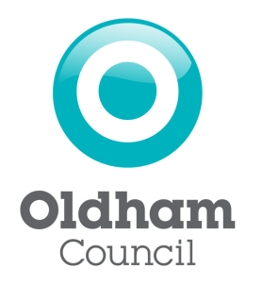
Approved List of Licensed Driver Driven
Assessment Providers

Mitchells Driving School

Call: 0161 367 8929
Mob: 07989 443 556
Email: info@mitchellsds.co.uk
Or to request a call back text ‘DRIVE’ 07989 443 556

Full details and prices at www.taxidrivingtest.co.uk/

Defensive Driver Training
Call: 01384 442233
Full details and prices at www.mytaxitest.co.uk

