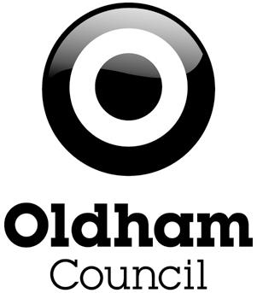

30 Hours free childcare: Information for Parents

What is the extended free entitlement?
From September 2017 many working parents of three and four year olds in Oldham will be eligible for 30 hours of free childcare per week. The extended entitlement is intended to support working parents with the cost of childcare and enable parents, where they wish, to return to work or to work additional hours.

How can the free hours be taken?
The entitlement amounts to 1140 hours over a year. It can be used up to 30 hours a week during term time (38 weeks) or for fewer hours per week spread over more weeks of the year.

Where can the extended hours be taken?
In the same variety of settings as the existing 15 hours free entitlement for three and four year-olds: day nurseries, nursery classes in schools, childminders, playgroups and pre-schools. Settings must be listed in Oldham Council’s Directory of Approved Providers.

Who is eligible?
The national eligibility criteria are as follows:
- both parents must be working (or the sole parent is working in a lone parent family), and each parent earns a weekly minimum equivalent to 16 hours at national minimum wage or living wage, and less than £100,000 per year
- working will include employed and self-employed persons
- in general families where one parent does not work (or neither parent works) will not be eligible for these additional hours
- both parents are employed but one or both parents is temporarily away from the workplace on parental, maternity or paternity leave
- both parents are employed but one or both parents is temporarily away from the workplace on adoption leave
- both parents are employed but one or both parents is temporarily away from the workplace on statutory sick pay
- one parent is employed and one parent has substantial caring responsibilities based on specific benefits received for caring or one parent is employed and one parent is disabled or incapacitated based on receipt of specific benefits

It is important to stress that everyone will continue to receive the 15 hours free childcare that is currently available to all three and four year olds.

How much is the equivalent of 16 hours at National Minimum Wage?
It depends on your age. The minimum amount will always reflect the lowest hourly rate that a person of your age can legally be paid. Therefore, currently for a parent aged 21-24, you'd need to earn a weekly average of at least £111.20. For a parent aged 25+, you'd need to earn a weekly average of at least £115.20.

What if you are self-employed or on a zero hours contract?
You will be eligible if you (or both of you in a couple) earn at least the equivalent of 16 hours at the National Minimum Wage.

How will you be able to apply for the 30 hours free childcare?
- Parents will be able to submit an application on Gov.uk or apply by phone to HMRC. (Note – This system is not yet live).
- parents will be able to apply for both Tax-Free Childcare (and 30 hour free childcare through a joint application system – currently being developed by HMRC
- it will provide a simple journey for all parents and because the criteria are similar, it will avoid the need to provide the same information twice
- parents will be expected to inform HMRC of any change in circumstance that may affect their eligibility
- If eligibility changes there is a proposed grace period – this is intended to enable children to keep their place if parents become ineligible. Further detail about how this will work is currently awaited from the Department for Education.

You can check what help you could get with childcare costs and get an indication as to your eligibility for 30 hours free childcare via the GOV UK website. https://www.gov.uk/childcare-calculator.

February 2017

