
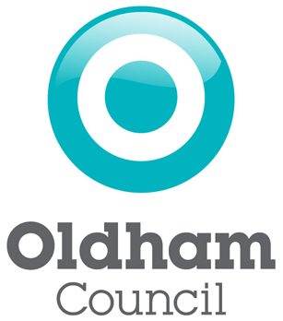
Annual Equality Data Report

Oldham Council

31 January 2016
Contents

Please click on the links below to take you to the relevant section in the document.

- Introduction
- Oldham Council
- Our demographic data
- Our service data
- Our workforce data
- Our budget
- Impact of Welfare Reform in Oldham

1 Introduction
Oldham Council is committed to delivering excellent services to the borough’s diverse range of individuals, groups and communities, whilst continuously improving the way we promote equality and celebrate diversity.

As part of our on-going commitment, we are seeking to collect relevant equality information about our service users and our communities. This information helps us to understand if we are meeting service user needs and how we can improve the services we offer.

The Equality Act 2010 replaced previous anti-discriminatory laws with a single Act. It simplified the law, removed inconsistencies and made it easier for people to understand and comply with. It also strengthened the law in important ways, in order to help tackle discrimination and inequality. (Source: “Equality Act 2010: Specific duties to support the equality duty….” Government Equalities Office)

The specific duties of the Equality Act 2010 require the council, as a Local Authority, to publish information showing compliance with the Equality Duty, at least annually; and to set and publish equality objectives, at least every four years.

This document publishes information which demonstrates that the council has due regard to the need to:-
- eliminate unlawful discrimination, harassment and victimisation and any other conduct prohibited by the Act;
- advance equality of opportunity between people who share a protected characteristic and people who do not share it; and
- foster good relations between people who share a protected characteristic and people who do not share it.

This year’s publication includes updated and information from the services we focussed on last year and presents the equality data for 15 service areas as well as key areas of significant public sector transformation or policy change, in line with the commitment made under our equality objectives.

For more information, please contact: Morgan Marshall, Business Intelligence Officer, Oldham Council at: morgan.marshall@oldham.gov.uk .

2 Oldham Council

Ambition and Corporate Objectives
Our ambition is to deliver a co-operative future where everyone does their bit to create a confident and ambitious borough.

There are three corporate objectives that underpin the delivery of the ambition. They are:

- A productive place to invest where business and enterprise thrive
- Confident communities where everyone does their bit
- A Co-operative Council delivering good value services to support a
co-operative borough

The objectives have been developed to reflect the key priorities of the council including economic growth and regeneration, strong civic leadership and delivering value for money services.

The corporate ambition and objectives form the basis of the council’s Corporate Plan. The Corporate Plan is the council’s main strategy document.
Its primary purpose is to set out our story of place and our priorities for
Oldham - what we are doing and why we are doing it. It can be accessed at:
http://www.oldham.gov.uk/downloads/file/3736/corporate_plan_2015

Our Approach to Equality
Our organisational approach to equality is to ensure that it is mainstreamed into key business drivers, such as the budget setting process and our approach to customer services. Equality related considerations and actions are being mainstreamed into the relevant strategies and plans, which shape our organisational approach in each of these areas, thus ensuring equality is integral to our approach and is owned across our organisation.

As a council, we are committed to providing high quality services that are customer focused. These services will be accessible, sensitive and responsive to the diverse needs of Oldham’s individuals, families and communities.

To this end we are continuing to publish equality related data for some of the services we deliver. We have increased the number of services for which we publish to 15. Over time, we intend to collect even more service information and to strengthen the collection of equality related data across the council. We will use this data to inform service planning and development, seeking to continually improve our performance over time.

For more information about how we endeavour to continuously improve our customer services and meet customer needs, please go to:
http://www.oldham.gov.uk/info/200609/contact/1015/customer_charter

3 Our demographic data

Census Summary
On 23rd November 2012 the Office for National Statistics (ONS) released population and household estimates and short-term migrant estimates from the 2011 Census.

The Census Second Data Release was issued by ONS on the 11th December 2012. This information contains key statistics including population (sex, age, ethnic group), housing, economic activity, qualifications, health and disability for small geographic areas (Census output areas).

The Census Third Data Release was issued by ONS on the 16th May 2013. This information contains detailed characteristics on population, ethnicity, identity, language, religion, unpaid care and health.

The Census Fourth Data Release was issued by ONS on the 31st July 2013. This information contains local multivariate statistics on ethnicity, identity, language, religion, unpaid care and health.

The Census Firth Data Release was issues by ONS on the 31st October 2013 and published in stages up until September 2014. This information contains alternative population bases, such as work day and workplace population characteristics.

2011 Census briefings for Oldham have been produced are available on Oldham Info, www.oldhaminfo.org

ACORN Profiles

ACORN data shows what a particular community or customer group is like based on the behaviours of similar people nationally. It can be a useful tool in helping the council to understand our communities. ACORN data gives each household one of five categories (for example Affluent Achievers or Comfortable Communities), which subdivide into 59 types.

The council has used the ACORN profiles to inform decision making and service delivery and design, for example fuel poverty initiatives, environmental projects such as the Green Streets programme, and research into digital inclusion.

ACORN data has recently been used to carry out analysis on the potential impact in Oldham of the Individual Electoral Registration (IER). This is the national voter registration system which took effect from the 10th June 2014 and replaced the old ‘household registration’ system. Using ACORN data to profile individuals whose identities could not be confirmed automatically by reference to local and national IT systems, demonstrated that some groups of residents are more likely to face extra barriers to registration.

ACORN profile briefings for Oldham are available on Oldham Info, www.oldhaminfo.org

Oldham Census Profile

Population, Age, and Gender
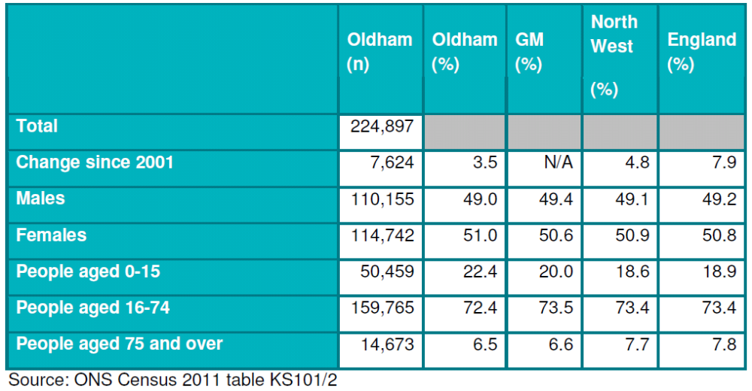

Ethnic Group
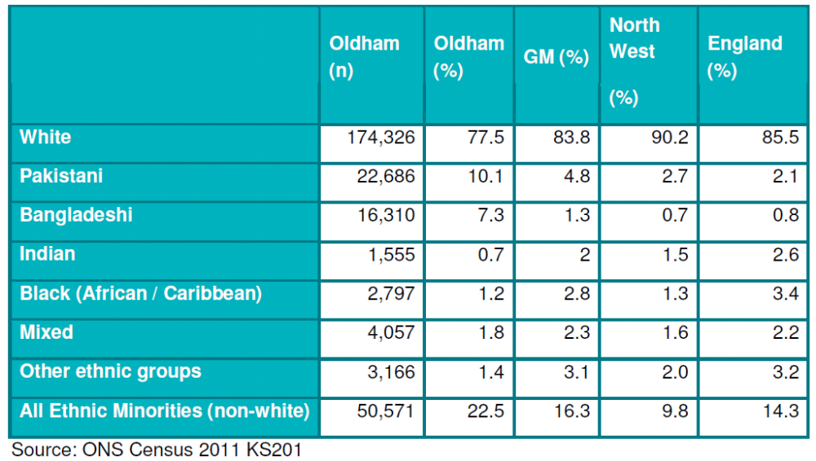

Place of Birth
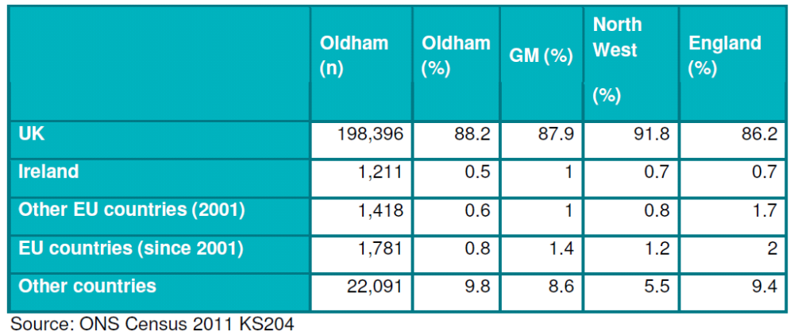

Religious Belief
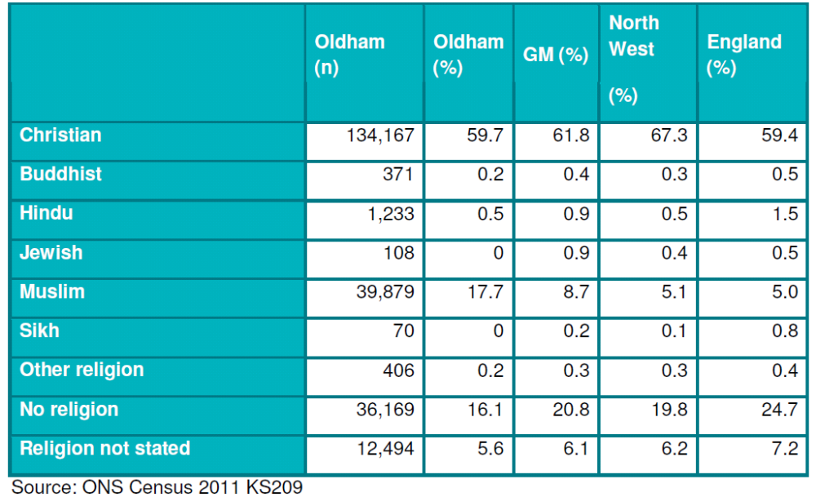

Health and Limiting Long Term Illness
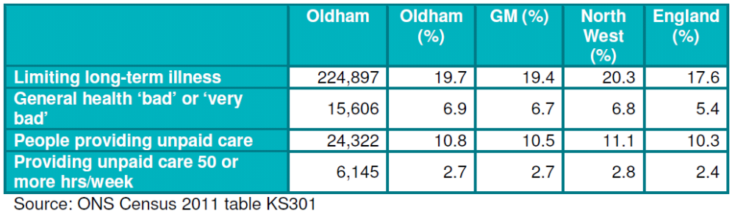

4 Our service data

Please click on the links below to take you to the relevant section in the document.

Contact Centre

Customer Complaints

Legal and Advice

Welfare Rights

Libraries

Licensing (Taxi Licensing)

Lifelong Learning

Local Council Tax Reduction

School Census

Social Fund Reform

Waste Services – Assisted Collections

Elected Member Profile

Employee Volunteering

Discretionary Housing Payments

Contact Centre

The contact centre deals with enquiries across 17 separate service lines on behalf of Oldham Council and the council’s switchboard service, providing easy access to a wide range of services over the phone and also via email.

From April 2014 to March 2015, 518,952 calls were handled and 4,856 surveys were completed. During this period, for callers enquiring about council tax, housing and council tax benefits, environmental health, environmental services and other Contact Centre Services the ethnicity and disability breakdown was as follows:

Table 1a: Enquiries to the Contact Centre by Ethnicity, 2014-2015
Ethnicity | Rather not say | White | Asian or British Asian | Mixed / Dual Heritage | Black or Black British | Other
Number of Customers | 221 | 2314 | 287 | 28 | 41 | 11
% of Customers | 7.62% | 79.74% | 9.89% | 0.96% | 1.41% | 0.38%
*2902 of people surveyed provided ethnicity information

Table 1b: Enquiries to the Contact Centre by Disability, 2014-2015
Disability | Rather not say | Yes | No
Number of Customers | 328 | 538 | 2055
% of Customers | 11.23% | 18.42% | 70.35%
*2921 people surveyed provided disability information

The software employed for customer satisfaction surveys collects ethnicity and disability data which are the core equality statistics agreed contractually when the system was purchased.

The current target is to complete 400 surveys a month.

Source: Opinion 8 system used for customer satisfaction surveys - Oldham Council Customer Services

Customer Complaints

Contact to the Complaints Team is broken down into the following areas: Corporate Complaints; Adult Social Care complaints; Children’s Social Care and Education complaints; Compliments; Comments; Suggestions; Enquiries; Service Requests and Local Government Ombudsman complaints.

The data used to provide the following ethnicity, disability, gender and age-group analysis is derived from web form contact, which constitutes 18.3% of all contact types. This method of contact is likely to be the most appropriate and reliable way of obtaining this information because it is self reported.

The following information relates to customer contacts received by the complaints team between April 2014 and March 2015. It provides information on ethnicity, disability, gender and age group.

Figure 2a: Customer Complaints Contacts by Ethnicity, 2014-2015
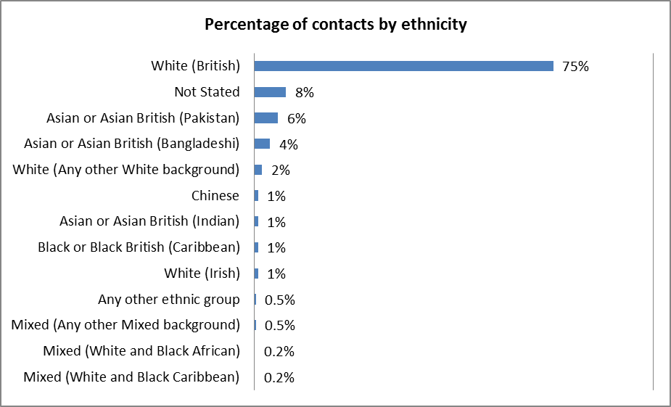
Figure 2b: Customer Complaints Contacts by Gender, 2014-2015
percentage split for gender of persons contacting the customer liaison team during April 2014- March 2015 | Male  49.6% | Female  50.4%

Figure 2c: Customer Complaints Contacts by Disability, 2014-2015
percentage of disabled persons contacting the customer liaison team during April 2014- March 2015 | Disabled  14.9% | Not Disabled  85.1%

Figure 2d: Customer Complaints Contacts by Age Group, 2014-2015
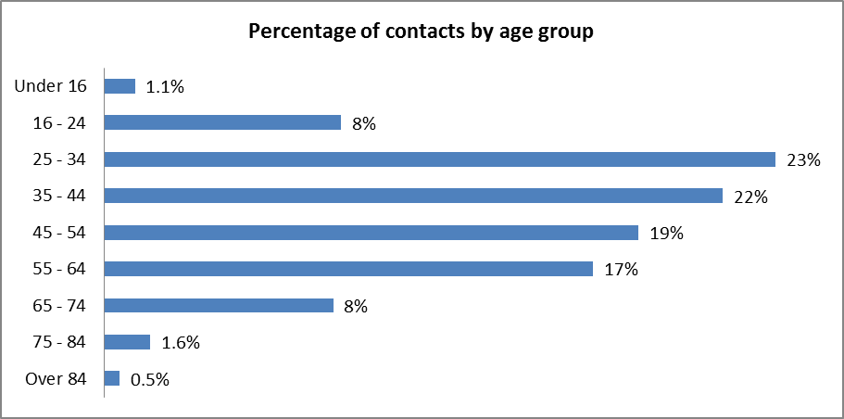

How are we using this information to improve services?

The complaints team began to collect equality data because previous research suggested that customers from some ethnic backgrounds were not accessing the complaints process as readily as some others. We have used, and continue to use, web form data from customers to monitor if complaint contacts are proportionate to the borough’s wider population in terms of ethnicity. By comparing our data with official statistics, we can conclude that our data broadly aligns with these statistics. However, the complaints team continues to monitor contacts by ethnic background on an annual basis. Going forward the team may look into the relatively high proportion of ‘not-stated’ responses regarding ethnicity to determine how we can extract ethnicity information from this group to ensure that the sub-group broadly reflects a representative sample of customers.

We currently only take ethnicity data from complaints made via the council website. Previously problems were experienced when we trialled taking equalities data over the phone; there was no good time to ask for it that did not break the rapport building processes. Having kept this under review, we are satisfied that the cohort using the online complaint form leaves us with an adequate sample size for the purpose with which we use the data for service planning and design.

Legal and Advice

On behalf of the Council, Oldham Citizens Advice Bureau (CAB) provides free, independent and confidential advice to residents on their rights and responsibilities, including welfare benefits, debt, housing, immigration and asylum, and employment. The information below represents the age, gender, disability and ethnicity of CAB clients.

Age

Table 3a: CAB Service Users by Age Group, 2013-2014
Age group | 2013/14 | Age group | 2012/13 | 2011/12
0-14 | 19 | 0-16 | 16 | 9
15-24 | 850 | 0-16 | 16 | 9
15-24 | 850 | 17-24 | 616 | 365
25-34 | 2,547 | 25-34 | 1,344 | 840
35-49 | 3,934 | 35-49 | 2,461 | 1,431
50-64 | 3,323 | 50-64 | 2,193 | 1,202
65-79 | 1,008 | 65 or over | 863 | 490
80 and over | 192 | 65 or over | 863 | 490
Not recorded/  not applicable | 1,596 | Not recorded/  not applicable | 416 | 279
Total | 13,469 | Total | 7,909 | 4,616

Figure 3a: CAB Service Users by Age Group, 2013-2014
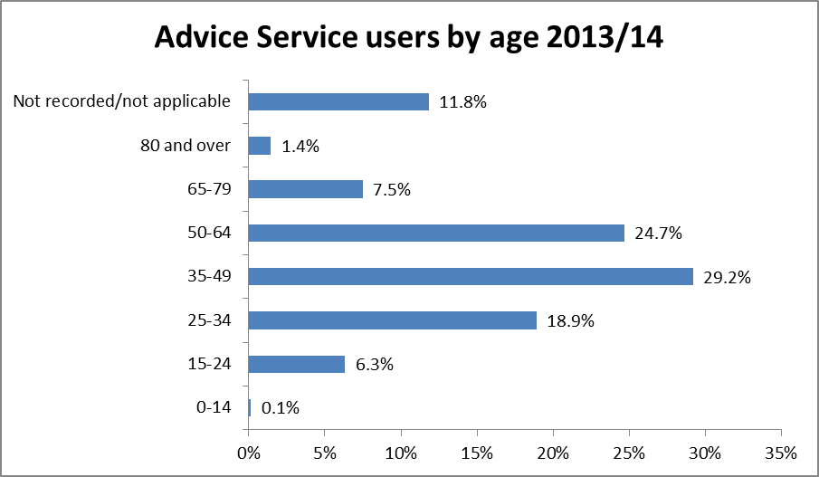

Gender

Table 3b: CAB Service Users by Gender, 2013-2014
Gender | 2013/14 | 2012/13 | 2011/12
Male | 6,007 | 3,758 | 2,160
Female | 7,323 | 4,125 | 2,444
Not recorded | 139 | 26 | 12
Total | 13,469 | 7,909 | 4,616

Figure 3b: CAB Service Users by Gender, 2013-2014
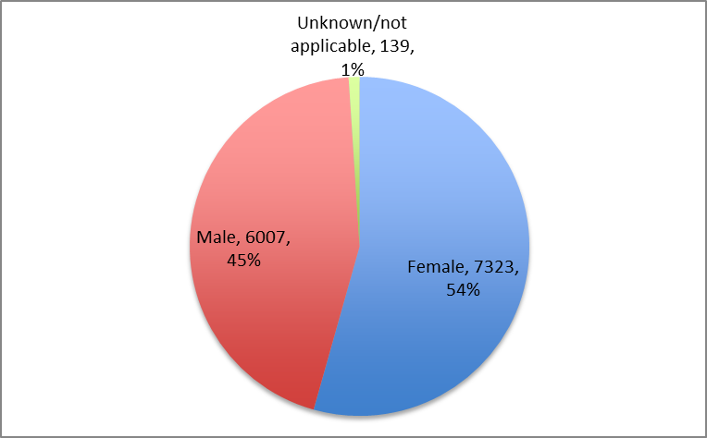

Self-reported disability

Table 3c: CAB Service Users by Disability, 2013-2014
Disability | 2013/14 | 2012/13 | 2011/12
Disabled | 1,342 | 1,851 | 981
Long-term health condition | 3,507 | 1,177 | 601
Not disabled | 5,867 | 3,774 | 2,254
Not stated | 2,753 | 1,107 | 780
Total | 13,469 | 7,909 | 4,616

Figure 3c: CAB Service Users by Disability, 2013-2014
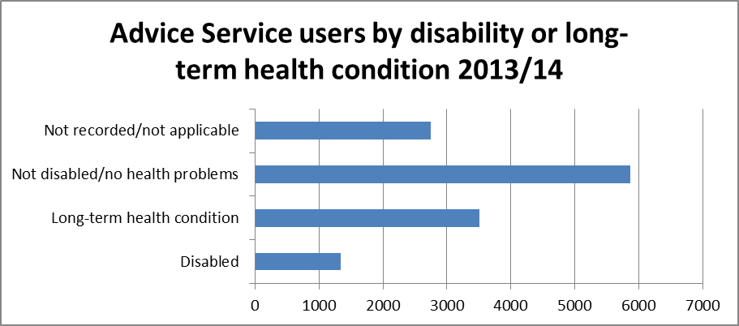

Ethnicity

Table 3d: CAB Service Users by Ethnicity, 2013-2014
Ethnicity | 2013/14 | 2012/13 | 2011/12
Asian or Asian British – Bangladeshi | 625 | 584 | 330
Asian or Asian British – Indian | 63 | 72 | 32
Asian or Asian British – Other | 238 | 114 | 50
Asian or Asian British – Pakistani | 1,323 | 888 | 490
Black or Black British – African | 334 | 164 | 100
Black or Black British – Caribbean | 73 | 65 | 43
Black or Black British – Other | 95 | 56 | 26
Chinese | 12 | 11 | 4
Mixed – Other | 42 | 19 | 13
Mixed - White & Asian | 14 | 23 | 14
Mixed - White & Black African | 29 | 38 | 19
Mixed - White & Black Caribbean | 51 | 35 | 18
White – British | 9,115 | 5,142 | 3,062
White – Irish | 74 | 44 | 20
White – Other | 307 | 146 | 96
White - Roma/Gypsy/Traveller | 3 | 1 | 1
Other | 184 | 149 | 100
Unknown or Declined to reply | 887 | 358 | 198
Total | 13,469 | 7,909 | 4,616

Figure 3d: CAB Service Users by Ethnicity, 2013-2014
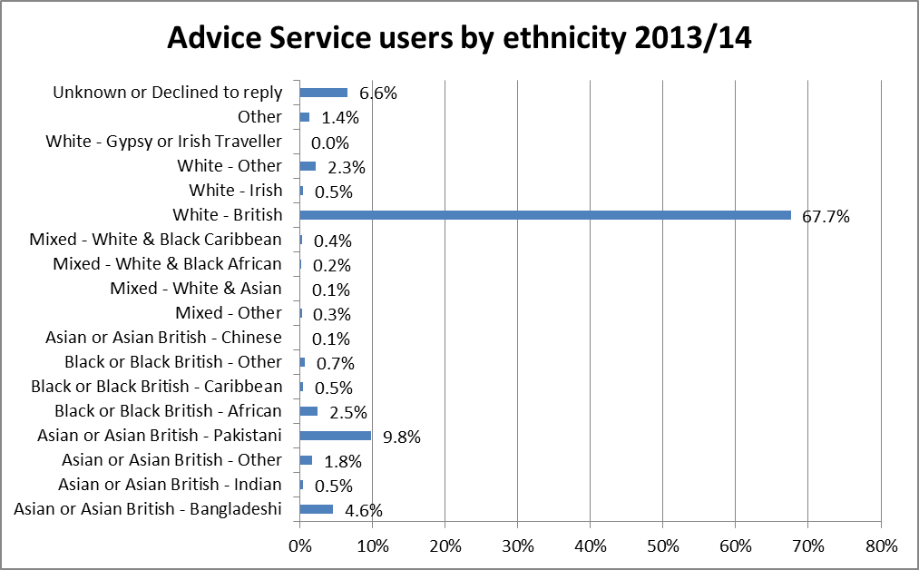

How are we using this information to improve services?

The Citizen’s Advice Bureau (CAB) collects equalities data to tailor and monitor their services. The CAB compares their clients to census data ensuring they reach the right communities and their services are demographically representative. The CAB also uses equalities data to make sure their volunteers, trustees and staff are also representative of the local population.

The CAB works closely with the Council’s Welfare Rights Service, which was set up in March 2012 to provide an additional advice service for residents. Working with CAB we have continued looking to review and align our performance reports. CAB is looking to implement Webtalk demonstrations in the summer of 2015, and this report will help to inform equality issues. The Welfare Rights Service is working to develop webchat to help extend their outreach support through the digital channel.

Oldham’s Contact Centre, Access Oldham, offers basic advice on benefit issues and (where necessary) makes referrals to Welfare Rights Officers who work with individuals on a range of welfare issues. The CAB makes referrals to the Welfare Rights service when additional welfare support is required. The equality data for customers of the Welfare Rights Service is provided in section four of this document.

Source: Data from Oldham CAB monitoring systems

Welfare Rights

The Welfare Rights Service provides clear, concise, free advice to residents, which includes:

• Support with appeals
• Tribunal preparation
• Benefit entitlement

Access Oldham, offers basic advice on benefit issues and (where necessary) make a referral to a Welfare Rights Officer who will work with individuals on a range of welfare issues.

The advice given by the service is completely independent, impartial and free. The service recognises that individuals must make their own decisions and that the role of the service is to give people information to be able to exercise their rights. The service actively promotes the take-up of benefits so that the residents of Oldham are aware of their rights and do not miss out on their entitlements.

The following information provides an equality breakdown of customers using the Welfare Rights Service from the 1st April 2015 to 3rd December 2016. It provides a breakdown according to age, ethnicity, housing status, geographic location, and sexual orientation.

Figure 4a: Customers Using the Welfare Rights Service by Age Group, 2015
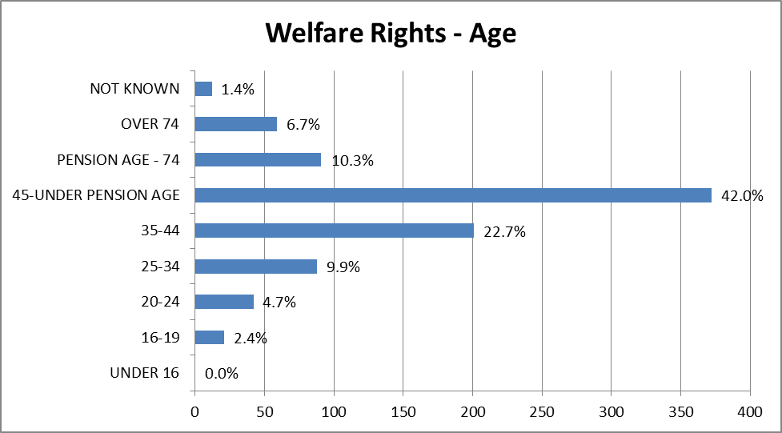

Figure 4b: Customers Using the Welfare Rights Service by Ethnicity, 2015
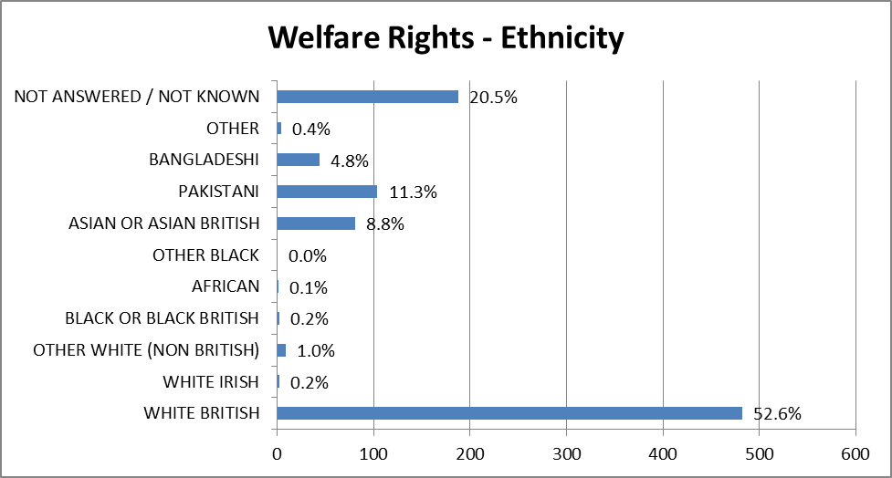

Figure 4c: Customers Using the Welfare Rights Service by Housing Status, 2015
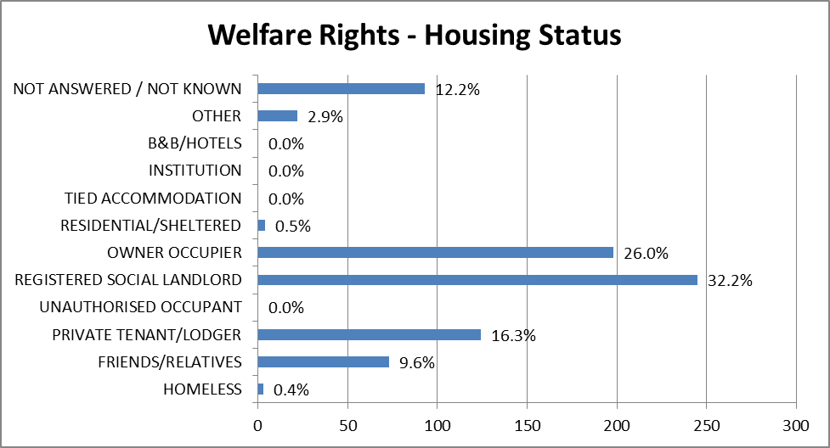

Figure 4d: Customers Using the Welfare Rights Service by Geographic Location, 2015
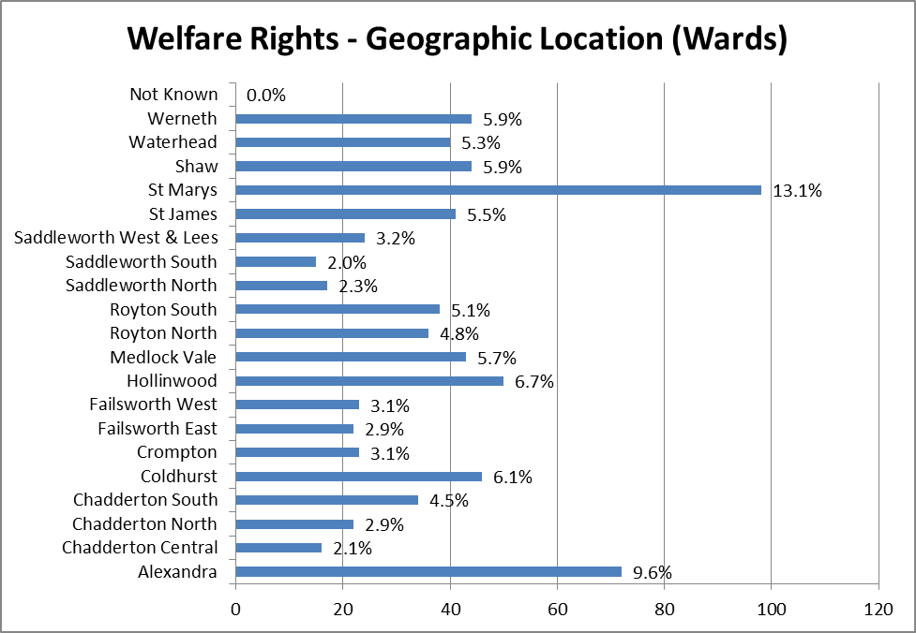

Figure 4e: Customers Using the Welfare Rights Service by Sexual Orientation, 2015
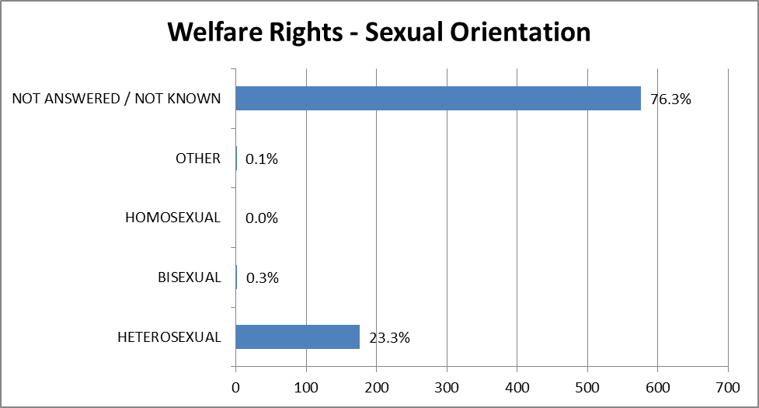

How we are using this information to improve services:

The equality information collected from customers will help to inform the planning and delivery of the Welfare Rights Service. For example it will help the service identify which areas contacts are coming from, that will help to inform where and how future surgeries and appointment sessions with customers are delivered.
Analysis on key pressure points demographically and by groups most impacted will help advise the service on where future support is required. We developed a communications plan and campaign for 2015/16 to target affected groups to help maximise income.
The Welfare Rights Service also works closely with the Citizen’s Advice Bureau (CAB), which provides free, independent and confidential advice to residents on their rights and responsibilities, including welfare benefits, debt, housing, immigration and asylum, and employment. The CAB makes referrals to the Welfare Rights service when additional welfare support is required. The equality data for customers of the CAB Legal and Advice service is provided in section three of this document.

Source: Oldham Council Welfare Rights Service

Libraries

Oldham Library Service’s mission is to be a continually improving, modern contemporary library service that engages all of the local community, forging important partnerships and links with community services, voluntary organisations and local businesses, having at its heart the promotion of reading and lifelong learning. We provide access to digital services, teach in the use of digital amenities and supply provision of facilities which are open, accessible & inclusive and play a significant part in establishing the local community identity.

All New Library Members
The following provides information on the disability breakdown all new members who have joined in the period 1st January 2014 – 31st December 2014.

Figure 5a: New Library Registrations by Gender, 2014
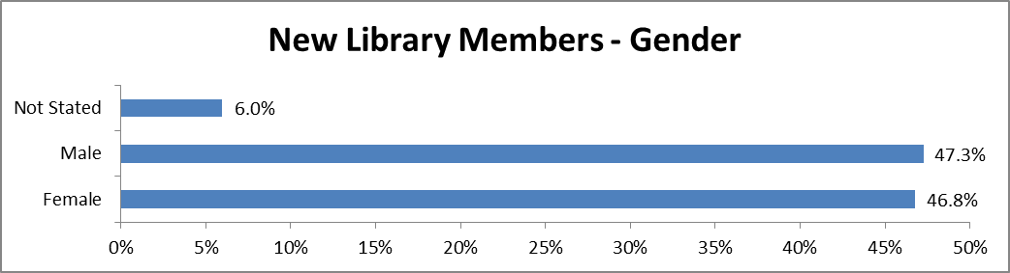

Figure 5b: New Library Registrations by Disability, 2014
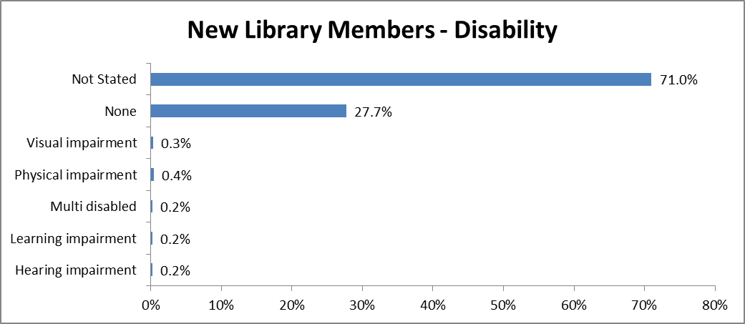

Figure 5c: New Library Registrations by Ethnicity, 2014
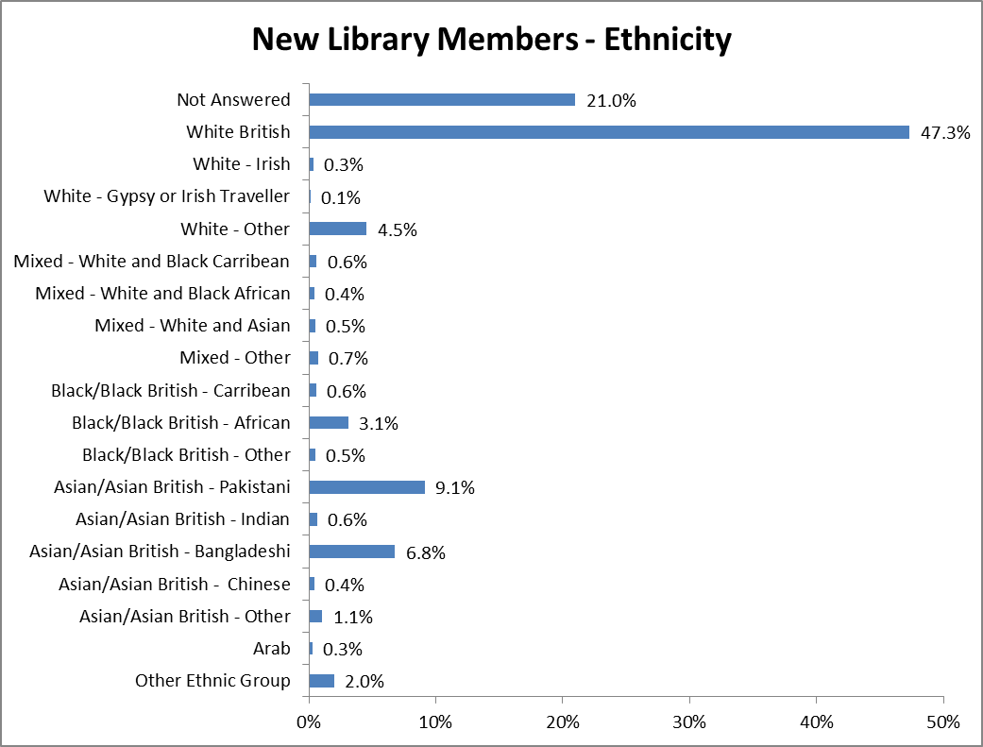

All Active Borrowers
The following provides information on the gender, disability and ethnicity breakdown of anyone who’s borrowed, renewed or returned a book in the time period between 1 January 2014 and 31 December 2014.

Figure 5d: Library Borrowers Actively Borrowing by Gender, 2014
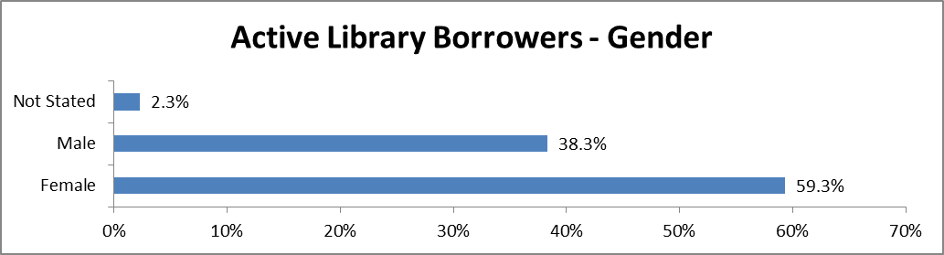

Figure 5e: Library Borrowers Actively Borrowing by Disability, 2014
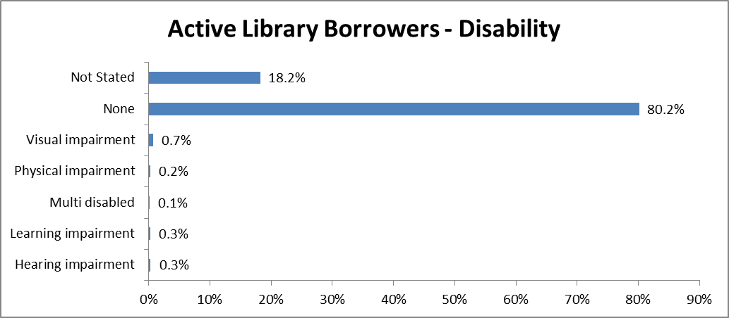

Figure 5f: Library Borrowers Actively Borrowing by Ethnicity, 2014
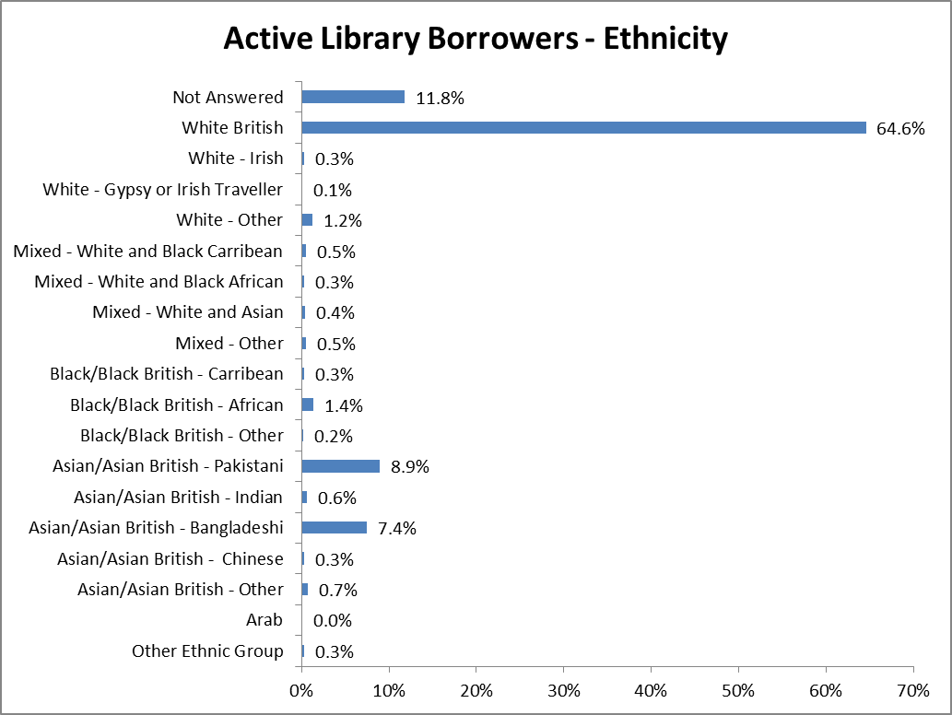

Source: Oldham Council Libraries Service

Licensing (Taxi Licensing)

In order for a person to become a licensed taxi driver in Oldham, they must meet the following criteria:-

- hold a valid GB or EU Driving License for at least two years, or 1 year GB/EU and 1 year foreign;
- have passed the prescribed tests (see below);
- be at least 21 years of age;
- be entitled to work in the UK;

If a person meets this criteria, they can submit an application to the Council’s licensing service. The procedure for submitting an application involves:-

- completing the relevant application form;
- carrying out a ‘Enhanced’ Criminal Records Check with the ‘Disclosure Barring Service’;
- paying the appropriate fee;
- submitting a pass certificate for the private hire / hackney carriage DSA test;
- having your doctor complete and sign a medical form;
- passing the Councils written knowledge test;

New drivers must complete the National Vocational Qualification (NVQ) in Road Passenger Transport within twelve months of their licence being granted. As part of the NVQ the driver will undergo an assessment which looks at, amongst other things, the driver’s basic skills in literacy, numeracy and spoken English.

As of January 2015 the Council has 1139 licensed taxi drivers, the following chart represents the age profile of those licensed drivers, with a comparison to 2013/14.

Figure 6a: Age Profile of Current Licensed Drivers, 2013/14 and 2014/15
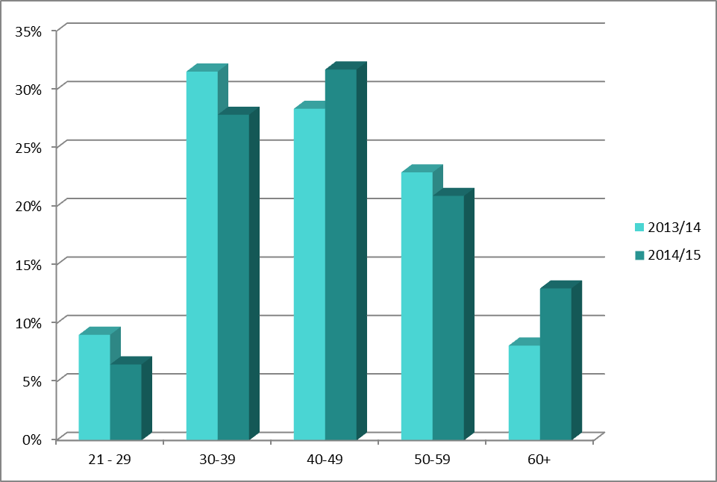

How are we using this information to improve services?

The Council's Licensing Service uses this information to monitor trends in applications, particularly where specific equality groups are not applying.

Source: Oldham Council Licensing Service

Lifelong Learning

Oldham Lifelong Learning Service is committed to delivering excellent service to learners, whilst continuously improving the way we promote equality and celebrate diversity.

As part of our on going commitment, we collect relevant equality information about our learners. This information helps us to understand if we are meeting learner needs and how we can improve the services we offer.

The Equality Act 2010 replaced previous anti-discriminatory laws with a single Act. It simplified the law, removing inconsistencies and making it easier for people to understand and comply with. It also strengthened the law in important ways, in order to help tackle discrimination and inequality. (Source: “Equality Act 2010: Specific duties to support the equality duty….” Government Equalities Office)

The specific duties of the Equality Act 2010 require the Service, as an Educational Provider, to publish information showing compliance with the Equality Duty, at least annually; and to set and publish equality objectives, at least every four years.

This document publishes information which demonstrates that the Service has due regard to the need to:-
- eliminate unlawful discrimination, harassment and victimisation and any other conduct prohibited by the Act;
- advance equality of opportunity between people who share a protected characteristic and people who do not share it;
and
- foster good relations between people who share a protected characteristic and people who do not share it.

The information the Service currently collects will help inform the Service’s equality objectives as part of the Equality Act 2010. The Service currently collects information on some of the protected characteristics, namely Race, Gender, Age and Disability.

This summary provides information on participation of learners from some of the protected characteristics as well as their attainment.

If you have any questions or comments about Oldham Lifelong Learning Service and equality and diversity please contact:

Chiaka Ebizie – Senior Manager, Lifelong Learning
0161 770 8056 or chiaka.ebizie@oldham.gov.uk

The Service

Oldham Lifelong Learning Service is a direct deliverer of post-19 learning opportunities. The Local Authority is committed to providing learning in the most appropriate and convenient locations for learners.

Mission
To deliver high quality, accessible local learning opportunities which enable adults to realise their potential and gain employment by developing their confidence, creativity, knowledge and skills.

Objectives

Objective 1
To provide a relevant and flexibly delivered curriculum as a foundation for lifelong learning to meet the needs of the target groups and to encourage non participating adults to return to learning and gain employment.

Objective 2
To maintain the Service’s commitment to quality assurance and continuous improvement in order to deliver a high quality service to learners.

Objective 3
To develop further collaborative partnerships with the statutory sector, voluntary agencies and local communities to ensure coherent provision and progression for users of the service.

Objective 4
To consult learners, partners and local communities to ensure provision is responsive and meets identified needs.

Objective 5
To ensure that staff deliver high quality teaching and learning and provide stimulating and challenging opportunities for all learners.

Objective 6
To promote the Lifelong Learning Service ensuring that information, advice and guidance, marketing and publicity are relevant and accessible to all learners.

Objective 7
To ensure the delivery of a high quality, responsive and accessible service by the provision of appropriate resources.

Policies and Procedures
The Service operates a comprehensive range of policies and procedures including Equal Opportunity & Diversity, Harassment & Bullying, Safeguarding and Complaints. In addition, the Service assesses the equality impact of all decisions and policies regarding the services they offer.

Equality Data

Who uses our Service? Learners and groups who are protected by the Equality Act 2010

Learners attend one or more of the following types of courses: Adult Skills (AS) and Community Learning (CL).

Ethnicity

In 2014/15 academic year;

- 41% of learners across all provision were from a black and minority ethnic (BME) background
- 45% of learners in AS were from a BME background
- 42% of learners in CL were from a BME background.

The Oldham 2001 Census figures show that 9.8% of Oldham’s population aged 19 and over were from a BME background. However, the 2012 population forecast for Oldham indicate that the ethnic composition of Oldham’s population aged 19 and over is as follows: 85% of Oldham’s population aged 19 and over are from white backgrounds; 15% are from Black and Minority Ethnic backgrounds.

The Service provides courses across Oldham and targets learners in the disadvantaged areas of Oldham which have high representation of BME heritage residents. The Service also works in areas of deprivation where the population is largely White-British heritage, for example in the Fitton Hill and Medlock Vale areas.

The Service offers its provision in venues in communities with high levels of deprivation. 35% of learners across the Service’s courses (from all ethnic backgrounds) came from the top five most deprived wards in Oldham as defined by the index of multiple deprivation; 53% of our learners came from the top 10 most deprived wards in Oldham.

Gender

In 2014/15 academic year;

- 31% of learners across all provision were male
- 69% of learners across all provision were female
- 35% of learners in AS were male; 65% were female
- 30% of learners in CL were male; 70% were female

The 2011 Census Population Estimates indicate that as of March 31 2011, Oldham had a total population of 165,260 residents aged 19 or over. Of this population, 48% of Oldham’s population were male and 52% were female.

However, men have traditionally been under-represented in Adult and Community Learning across the country. The percentage of male learners accessing the Service is in line with other Providers nationally. According to the Department for Business Innovation and Skills (BIS) Review of Informal Adult and Community Learning (IACL): Equality Impact Assessment, Revised Screening Document published in September 2011 25% of participants in IACL nationally are male. Following an exercise undertaken by Adult and Community Learning Providers in 2013-14, it was established that the SFA National Average for providers similar to the Service is 28%.

Age

The Service statistics show that people of all ages accessed the service. The age profile of our learners continues to compare well with the age range of the total population.

- 8.4% of learners were aged 19 – 24 (Oldham – 10%)
- 28% were aged 25 – 34 (Oldham – 18%)
- 23% were aged 35 – 44 (Oldham – 19%)
- 18% were aged 45 – 54 (Oldham – 18%)
- 13% were aged 55 – 64 (Oldham – 15%)
- 9.3% were aged 65+ (Oldham – 20%)

The overall Service percentages are in line with the BIS Review of Informal Adult and Community Learning (IACL): Equality Impact Assessment, Revised Screening Document published in September 2011, which states that 92% of learners funded by Adult Safeguarded learning are aged 25 and over¹.

Disability

- 17% of learners across all provision declared a disability
- 20% of learners in AS declared a disability
- 16% of learners in CL declared a disability

In addition;
- 9% of learners across all provision declared a learning difficulty
- 11% of learners in AS declared a learning difficulty
- 8% of learners in CL declared a learning difficulty

According to the BIS Review of Informal Adult and Community Learning (IACL): Equality Impact Assessment, Revised Screening Document published in September 2011 2% of England’s population have a learning disability and 12% of IACL learners declared that they have a learning disability¹.

Supported Learners

These are learners who are assisted by either the Learning Support Team or external support. Supported learners receive a wide range of support. A supported learner may have a Learning Support Worker in the classroom or they may have one session with their tutor and the Worker to plan how course materials can be adapted to suit their requirements. Support is also provided through specialist resources and assistive technology.

- 9% of learners across all provision were supported.
- 11 % of learners in AS courses were supported
- 6% of learners in CL were supported

The balance of supported learners in vocational courses shows that supported learners are being fully integrated into qualification courses, which is a key aim of the Learning Support function.

Deprivation

The Service offers its provision in venues in communities with high levels of deprivation. 35% of learners across the Service’s courses (from all ethnic backgrounds) came from the top five most deprived wards in Oldham as defined by the index of multiple deprivation; 54% of our learners came from the top 10 deprived wards in Oldham. This reflects the Service’s efforts to work in the areas of most need.

- 76% of learners across all provision received a concession.

How well do learners from different backgrounds achieve?

Oldham Lifelong Learning Service monitors whether learners complete their course, if they pass their exam or achieve their learning outcome at the end of the course. This statistic is called the success rate.

The Service continues to monitor success rates by equality groups. It looks at how successful different equality groups are, for example how successful are men compared to women. It also looks at learners grouped together by ethnicity, gender, disability, age, concessionary status, and supported learners. The overall Service data for 2014/15 shows that all learners are achieving as well as their peers. There were no trends by equality groups that caused concern.

If significant variances are identified as part of the Service’s Monitoring process, an action plan is put in place. This is to ensure that the reason for the variance is identified and that relevant actions are taken to ensure that the gap is narrowed.

Learner satisfaction

The Service’s Learner Satisfaction Survey gives more detail about how satisfied learners are with the Service. The proportion of learners by equality group who completed the Survey compares well to the proportion of learners by equality group who learn with us.

The Service has in place a range of mechanisms where learners can make suggestions for improvements to the Service. All matters of concern and complaints were dealt with to the satisfaction of the service user and improvements were put in place as appropriate.

Complaints are analysed against the protected characteristics and there were no trends by equality groups that caused concern. The complaints system is accessible to all groups of learners.

The Service operates a harassment and bullying policy and procedure and a hate incident reporting system.

Equality planning, consultation and involvement

Learners and staff are involved in the annual self-assessment on equality and diversity every year. Equality Impact Assessments have been completed where appropriate.

Other forms of consultation in 2014/15 have included consultation events for learners and partners to help to decide what courses we put on and where we put them on and also course feedback sheets, learner voice processes and surveys. The Service also undertook consultation with learners during the development of the Service’s equality objectives. The outcome of the consultation events has informed service planning and objective setting.

Staffing / Employment

As the Service sits within Oldham Council, information on employment is collated and monitored corporately. The Service, in line with corporate policy, continues to operate a Positive Action Strategy for Staff Recruitment and Development.

Local Council Tax Reduction

From the 1st April 2013 the Council introduced a localised Council Tax Reduction Scheme to replace Council Tax Benefit for those of working age. The scheme was revised from the 1st April 2014 to increase the level of support provided.

The source of all data contained within this appendix is the live benefit database.

What we know about those currently claiming Council Tax Reduction?

Current Council Tax Reduction claimants

The breakdown of claims by council tax band is as follows:

Table 8a: Council Tax Reduction Claims by Council Tax Band, Nov 2015
 | A | B | C | D | E | F | G | H | T | U
Claimants | 20,273 | 3,315 | 1,985 | 466 | 183 | 45 | 37 | 14 | - | 18
Occupied properties | 47,766 | 16,178 | 15,263 | 6,451 | 3,167 | 1,447 | 829 | 71 | 24 | 202
Claimants % | 42.4 | 20.5 | 13.0 | 7.2 | 5.8 | 3.1 | 4.5 | 19.7 | 0.0 | 8.9

This data shows that the overwhelming majority of CTR claimants live in Band A properties.

Potential impact on people of a particular age

The breakdown of claims by claimant type is as follows:

Table 8b: Council Tax Reduction Claims by Claimant Type, Sept 2014
Type of Recipient | Number | %
Elderly | 9,805 | 38%
Working age - passported benefits | 10,286 | 40%
Working age – other | 5,611 | 22%
TOTAL | 25,702

This shows that those people of working age (62% of the entire claimant group) are adversely affected, particularly since there is a mandatory requirement to protect those on pension credit i.e. those claimants in the elderly bracket. Therefore the number of claimants of working age is 15,897

Potential impact on men or women (including maternity or pregnancy considerations)

The breakdown of claims by gender of the claimant is as follows:

Table 8c: Council Tax Reductions Claims by Gender of the Claimant, Nov 2015
Gender | Working Age | % | % of Working age population
Male | 7,360 | 43 | 10.5
Female | 9,782 | 57 | 14.4
Total | 17,142 |  | 12.4

The demographic information shows a 43/57 split in terms of men and women in the population, so this would indicate that slightly more women than men are affected by the scheme. It is likely that this is down to the number of lone parents with dependent children included in this group, 90% of which are women.

Impact on those on low incomes

In a borough that has 3 areas within the top 1% most deprived in the country, there is a real risk that maintaining or reducing the levels of support could drive people over the financial edge and have a major impact on their quality of life. An increased level of support will have a positive effect for such people. Analysis shows that claimants living in (Lower Super Output) Areas in the wards of Coldhurst and St. Mary’s, particularly the Barker Street and St. Mary’s Estates, will be most likely to be cumulatively impacted by welfare reforms (i.e. those neighbourhoods with the highest volumes of claimants of all benefit types). Other wards and neighbourhoods where there are high volumes of individual benefits likely to be affected by the changes include Werneth, Hollinwood (particularly Limeside Village), Alexandra (particularly Alt and Holts), St. James’ (particularly Sholver), Medlock Vale and Waterhead. However, impacts will be felt in all but a few areas of Oldham.

The table below shows claimant types by ward and those wards mentioned above are highlighted. There is clear read across between those wards mentioned in the extract above and those with the largest number of claimants of working age. Therefore it is reasonable to suggest that those people with low incomes would potentially be disproportionately adversely affected by the scheme.

Table 8d: Council Tax Reductions Claims by Geographical Location (Ward) of the Claimant, Nov 2015
Ward | Working Age | Elderly | Total
Alexandra | 1853 | 585 | 2438
Chadderton Central | 602 | 348 | 950
Chadderton North | 615 | 446 | 1061
Chadderton South | 760 | 494 | 1254
Coldhurst | 1913 | 699 | 2612
Crompton | 375 | 442 | 817
Failsworth East | 541 | 460 | 1001
Failsworth West | 674 | 515 | 1189
Hollinwood | 1278 | 658 | 1936
Medlock Vale | 1184 | 504 | 1688
Royton North | 391 | 433 | 824
Royton South | 446 | 404 | 850
Saddleworth North | 173 | 246 | 419
Saddleworth South | 143 | 275 | 418
Saddleworth West and Lees | 376 | 379 | 755
Shaw | 633 | 465 | 1098
St. James' | 1022 | 413 | 1435
St. Mary's | 1556 | 508 | 2064
Waterhead | 1167 | 574 | 1741
Werneth | 1326 | 460 | 1786
Total | 17028 | 9308 | 26336

Impact on those people from particular ethnic groups
We do not currently collect ethnicity data in relation to CTR claimants; however, the demographic data shows the following information about ethnicity in the wards highlighted above. This shows that three of the wards (Coldhurst, St. Mary’s and Werneth) identified as being most impacted have a high proportion of people from a BME background (over 50% of residents). It also shows that another three (Alexandra, Medlock Vale, and Waterhead) have significant numbers of people from BME backgrounds (over 15% of residents), whilst Hollinwood and St. James are primarily made up of residents from non-BME backgrounds.

Whilst we cannot confirm that people from particular ethnic backgrounds would be disproportionately adversely affected by maintaining or reducing the levels of support under the scheme, the demographic data suggests that this might be the case.

Table 8e: Ethnicity by Ward
 | % White | % Pakistani | % Bangladeshi | % Other non-white
Alexandra | 63.4 | 22.8 | 3.8 | 10.0
Chadderton Central | 88.3 | 2.2 | 5.1 | 4.4
Chadderton North | 78.4 | 2.1 | 15.7 | 3.8
Chadderton South | 91.1 | 2.2 | 1.7 | 5.0
Coldhurst | 27.1 | 3.7 | 60.2 | 9.0
Crompton | 96.0 | 0.5 | 1.0 | 2.5
Failsworth East | 95.9 | 0.8 | 0.2 | 3.1
Failsworth West | 95.1 | 0.6 | 0.2 | 4.1
Hollinwood | 86.9 | 5.6 | 2.4 | 5.1
Medlock Vale | 61.5 | 22.8 | 6.9 | 8.8
Royton North | 97.4 | 0.3 | 0.4 | 1.9
Royton South | 93.5 | 0.8 | 2.1 | 3.5
Saddleworth North | 97.3 | 0.4 | 0.2 | 2.0
Saddleworth South | 97.5 | 0.4 | 0.2 | 1.9
Saddleworth West and Lees | 97.0 | 0.6 | 0.1 | 2.3
Shaw | 94.0 | 1.0 | 2.8 | 2.2
St. James' | 94.4 | 0.5 | 0.3 | 4.7
St. Mary's | 34.0 | 49.1 | 8.6 | 8.2
Waterhead | 76.8 | 16.1 | 1.3 | 5.7
Werneth | 23.4 | 48.6 | 17.8 | 10.3
Oldham | 77.5 | 10.1 | 7.3 | 5.1
England | 85.4 | 2.1 | 0.8 | 11.7

Impact on people of a particular faith / belief
Whilst we cannot confirm that people with particular faiths / beliefs would be disproportionately adversely affected by maintaining or reducing the levels of support under the scheme, the demographic data suggests that this might be the case because of the link to the evidence displayed relating to ethnicity.

Impact on those with a disability
Of the 15,897 working age claimants, 3,274 (23%) have a disability premium within their benefit calculation. Whilst this indicates that the individual is considered to have some form of disability, it does not tell us the nature or extent of the disability.

For 2013/14 council tax of the 4,283 claimants currently under the recovery process due to non-payment, 863 are in receipt of a disability premium, this is 20% of those on recovery.

For 2014/15 council tax of the 3,298 claimants currently under the recovery process due to non-payment, 694 are in receipt of a disability premium, this is 21% of those on recovery.

Of the claimants under recovery action in both 2013/14 and 2014/15, 585 are in receipt of a disability premium.

The evidence shows that whilst the majority of claimants who are in receipt of a disability premium are managing to make their payments, however there is a core number of claimants who are not. Additionally, there are still some changes to Disability Living Allowance to be made in terms of changing onto Personal Independence Payments. This impact is unknown so the potential impact on those in receipt of disability premiums is something we are keen to keep under review.

Collection rates
As of 29th September 2014, the collection rate for council tax in relation to 2014/15 CTR accounts is 39%. In comparison the collection in September 2013 was 42%.

There is a possibility in a decline in the collection rate due to ongoing recovery for those claimants who have council tax arrears for 2013/14 and 2014/15.

For council tax reduction arrears remaining from 2013/14, 2027 deductions from benefit are in place, of those 3279 are also undergoing recovery in 2014/15.

Recovery Activity
Of those claimants who received Council Tax Reduction in 2013/14 4304 accounts are now on recovery action. As of 10th September 2014 of those claimants who receive council tax reduction in 2014/15 3279 accounts are on recovery action.

The breakdown below shows those accounts broken down by property band.

Table 8f: Council Tax Recovery Action by Council Tax Property Band, 2013/14
Band | A | B | C | D | E | F | G | Total
Number | 3,686 | 370 | 178 | 53 | 12 | 3 | 2 | 4,304

Table 8g: Council Tax Recovery Action by Council Tax Property Band, 2014/15
Band | A | B | C | D | E | F | G | Total
Number | 2,803 | 288 | 126 | 51 | 8 | 1 | 2 | 3,279

These figures are proportionately in-line with the overall number of claimants in each band, which indicate that since the local council tax reduction scheme was introduced people in higher bands are not finding it more difficult to pay than those in lower bands.

Other financial impacts
It is notable that Oldham was ranked 26th worst affected out of the 379 local authorities in Great Britain with the overall annual impact of welfare reform changes being estimated at £90.1m, once the changes are fully implemented. This equates to a loss of £637 a year per working-age adult. This is a key finding for Oldham from the Centre for Regional Economic and Social Research (CRESR, Sheffield Hallam University) recently published report: “Hitting the poorest hardest – The local and regional impact of welfare reform”. This one-off, large-scale study was completed in 2013. Whilst no comparable research has been conducted since at this scale, we are not aware of any evidence to suggest Oldham’s position has significantly changed.

How are we using this information to improve services?

Our data about ethnicity collected through the application process is currently optional therefore our information about impact on people of particular ethnic backgrounds has been taken from demographic data. A Data collection review included: the collection of gender, Age, Ward and Ethnicity information, we therefore cannot confirm that people with particular faiths or beliefs, would be disproportionately adversely affected by maintaining the levels of support under the CTR scheme.

A number of actions identified in developing the 2014/15 scheme were intended to mitigate the impact of CTR and the wider welfare reform.

Source: Academy Database, Unity

School Census Data

The council gathers school census information on a termly basis. The following information provides a breakdown of the gender and ethnic group of all school pupils for both primary and secondary education.

How do we use this data to inform services?

The council collects school census information on a termly basis. This data provides demographic statistics for Oldham, including information on BME (Black Minority Ethnic), First Language, SEN (Special Educational Needs) and FSM (Free School Meals) populations. The data is also used to calculate pupil population forecasts and projections. This data feeds into monitoring attainment by vulnerable groups, which the council uses to inform the finance, planning and delivery of school services.

Table 9a: School Pupils by Gender, Jan 2015
School Census – January 2015
Gender
 | Boys | Girls
Primary Schools | 12894 | 12738
Secondary Schools | 7906 | 7602

Table 9b: School Pupils by Ethnicity, Jan 2015

School Census – January 2015
Ethnicity – Percentage
Ethnicity | Primary | Secondary | Total
Bangladeshi | 14.2 | 13.5 | 13.9
Indian | 0.5 | 0.4 | 0.5
Other Asian | 0.8 | 0.6 | 0.7
Pakistani | 18.4 | 14.8 | 17.0
Black African | 1.8 | 0.9 | 1.4
Black Caribbean | 0.2 | 0.3 | 0.2
Black Other | 0.3 | 0.3 | 0.3
Chinese | 0.3 | 0.2 | 0.3
Other Mixed | 0.9 | 0.8 | 0.9
Mixed Asian | 1.3 | 0.9 | 1.2
Mixed African | 0.5 | 0.3 | 0.5
Mixed Caribbean | 1.4 | 1.5 | 1.4
Not Obtained | 0.6 | 2.0 | 1.1
Other | 0.9 | 0.4 | 0.8
Refused | 0.5 | 0.5 | 0.5
White British | 54.9 | 60.4 | 57.1
Irish | 0.2 | 0.1 | 0.1
Traveller/Irish | 0.0 | 0.0 | 0.0
Other White | 2.0 | 1.6 | 1.8
Gypsy/Roma | 0.2 | 0.6 | 0.4

BME pupils are defined as those pupils with an ethnic group that is Non-White British and does not include those pupils whose ethnicity was refused or were not obtained. The BME population is 41.4% for the total pupils in primary, secondary and special schools.
Figures may not total 100% due to rounding

Table 9c: School Pupils by Year Group & Ethnicity, Jan 2015
School Census – January 2015
Ethnicity Numbers by Age
(First or only registration)
Year Group | Age | % BME
Reception | 4 | 43.1
Y1 | 5 | 46.2
Y2 | 6 | 43.6
Y3 | 7 | 44.3
Y4 | 8 | 45.0
Y5 | 9 | 43.0
Y6 | 10 | 42.5
Y7 | 11 | 39.4
Y8 | 12 | 38.1
Y9 | 13 | 37.3
Y10 | 14 | 35.0
Y11 | 15 | 34.8

Figure 9a:

The percentage of pupils in Oldham primary and secondary schools who are BME (Black Minority Ethnic) pupils
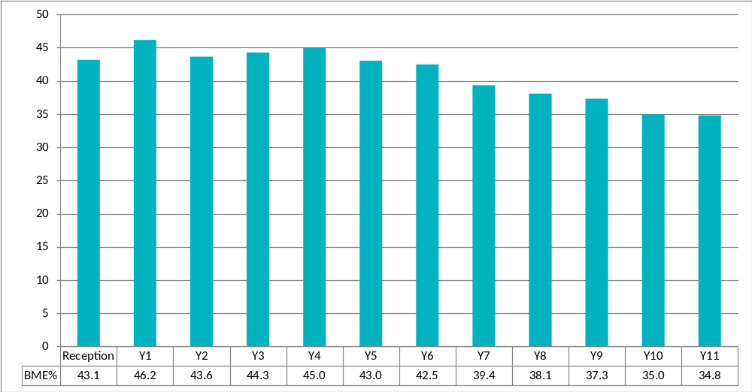
Key Stage 4 Attainment (GCSE and equivalents)

The data on the following pages provides information on the equality breakdown of KS4 attainment in Oldham for the reporting period up to the academic year 2013-14.
For consistency, the 2013-14 results are based on the best results of pupils rather than the new First Results introduced by the DfE in 2014.

This information includes:

- Population (numbers) of boys and girls and the percentage change from 2010 to 2014.
- Numbers of pupils achieving 5 or more A*-C grades including English and Maths from 2010 to 2014.
- Pupils by ethnicity from 2010 to 2014.
- Numbers of pupils achieving 5 or more A*-C grades including English and Maths by ethnicity from 2010 to 2014.
- Pupils who receive Free School Meals (FSM) from 2010 to 2014.
- Numbers of pupils achieving 5 or more A*-C grades including English and Maths who receive Free School Meals (FSM) from 2010 to 2014.
- Pupils with Special Educational Needs (SEN) from 2010 to 2014.
- Numbers of pupils achieving 5 or more A*-C grades including English and Maths with Special Educational Needs (SEN) from 2010 to 2014.

In Oldham, we monitor the following ethnic group, Black / Mixed Black. This group consists of the following groups of pupils who belong to the following ethnicities:

- Black African
- Black Caribbean
- Other Black Background
- White and Black African
- White and Black Caribbean

The Mixed / Dual group consist of pupils’ ethnicity if they are White and Asian or of any other mixed heritage.

How do we use this data to inform services?

The council collects information on attainment and achievement on an annual basis. This contains information on attainment by Gender, BME (Black Minority Ethnic), SEN (Special Educational Needs) and FSM (Free School Meals) populations. The attainment of these vulnerable groups is regularly monitored to ensure any areas for improvement can be identified and is fed back to schools. This information is also used to set local targets for Oldham Council in monitoring and improving the attainment and achievements of these vulnerable groups.

Oldham Council also monitors smaller ethnicity groups within the main groups. For example, White pupils will be White British, Other White, Gypsy/Roma, and White European pupils.
Figure 9b:
Population percentage change from the 2010 baseline by gender for pupils at the end of Key Stage 4

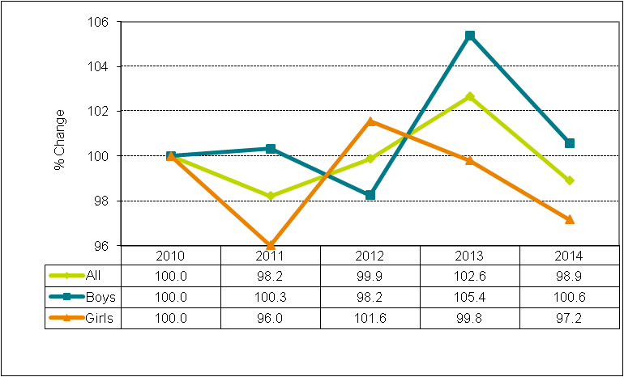

Table 9d: Pupil Population by Gender, 2010-2014
 | Actual population
 | 2010 | 2011 | 2012 | 2013 | 2014
All | 3,021 | 2,967 | 3,017 | 3,101 | 2,988
Boys | 1,540 | 1,545 | 1,513 | 1,623 | 1,549
Girls | 1,481 | 1,422 | 1,504 | 1,478 | 1,439
Boys% | 51.0% | 52.1% | 50.1% | 52.3% | 51.8%
Girls% | 49.0% | 47.9% | 49.9% | 47.7% | 48.2%

Figure 9c:
Percentage of pupils achieving 5 or more A*-C GCSEs including English and Maths by gender
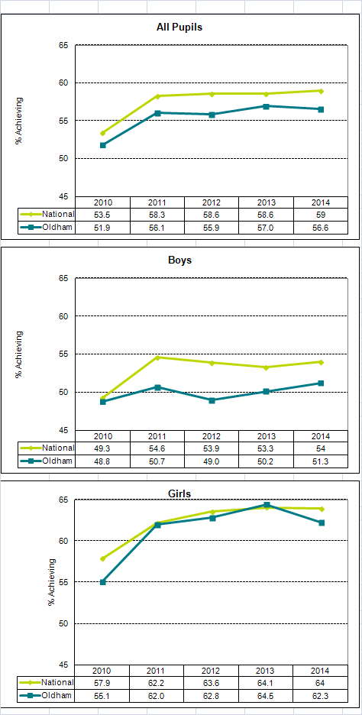
Population percentage change from the 2010 baseline of pupils by Ethnicity at the end of Key Stage 4
Table 9e:
 | Actual population
 | 2010 | 2011 | 2012 | 2013 | 2014
All Pupils | 3,021 | 2,967 | 3,017 | 3,101 | 2,988
White | 2,220 | 2,152 | 2,215 | 2,199 | 2,023
Pakistani | 328 | 335 | 336 | 360 | 371
Bangladeshi | 297 | 322 | 312 | 359 | 376
Black / Mixed Black | 82 | 76 | 73 | 89 | 90
Mixed / Dual | 35 | 26 | 29 | 37 | 60
All others | 59 | 56 | 52 | 57 | 68
White% | 73.5% | 72.5% | 73.4% | 70.9% | 67.7%
Pakistani% | 10.9% | 11.3% | 11.1% | 11.6% | 12.4%
Bangladeshi% | 9.8% | 10.9% | 10.3% | 11.6% | 12.6%
Black / Mixed Black% | 2.7% | 2.6% | 2.4% | 2.9% | 3.0%
Mixed / Dual% | 1.2% | 0.9% | 1.0% | 1.2% | 2.0%
All others% | 2.0% | 1.9% | 1.7% | 1.8% | 2.3%

Figure 9d:
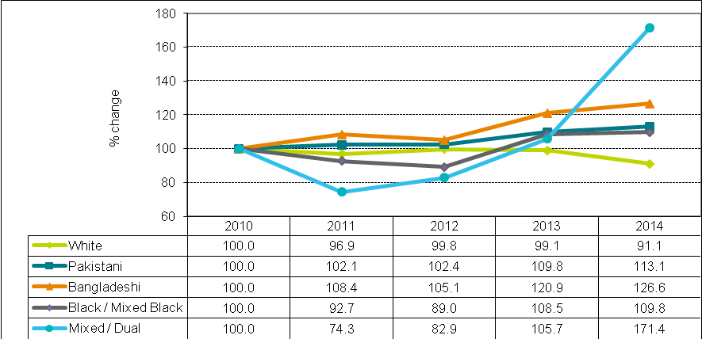

Figure 9e:
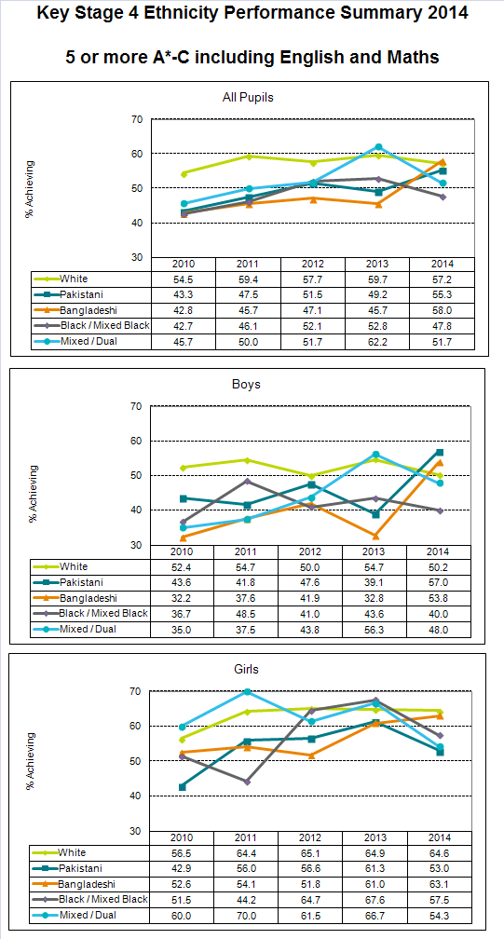
Figure 9f:
Population percentage change from the 2010 baseline of pupils claiming eligibility for Free School Meal (FSM) at the end of Key Stage 4

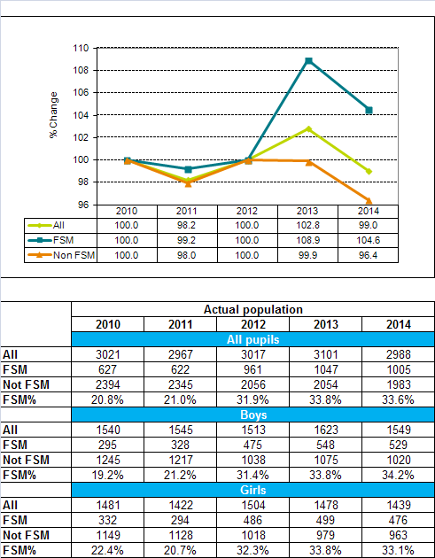

Figure 9g:
Percentage of pupils achieving 5 or more A*-C GCSEs including English and Maths by FSM and Gender
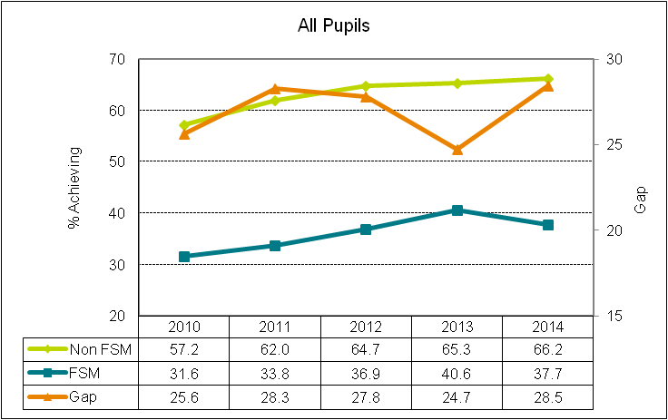
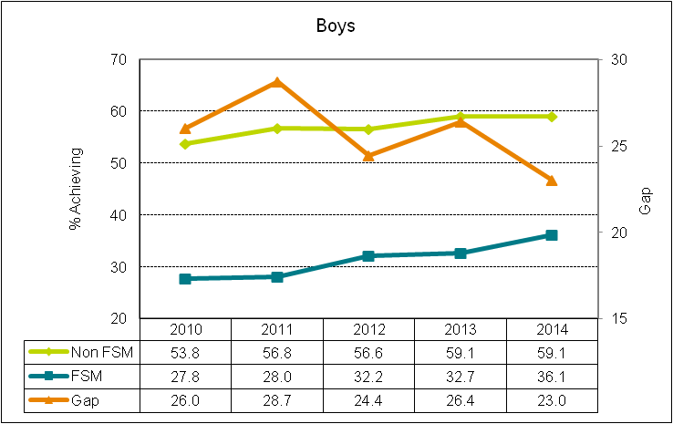
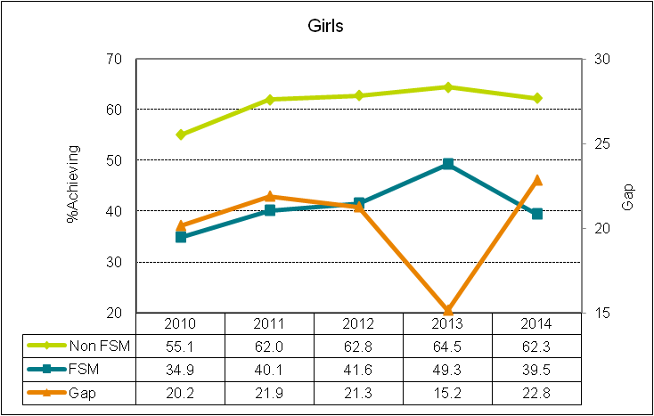

Population percentage change from the 2010 baseline of SEN and non SEN pupils at the end of Key Stage 4

Figure 9h:
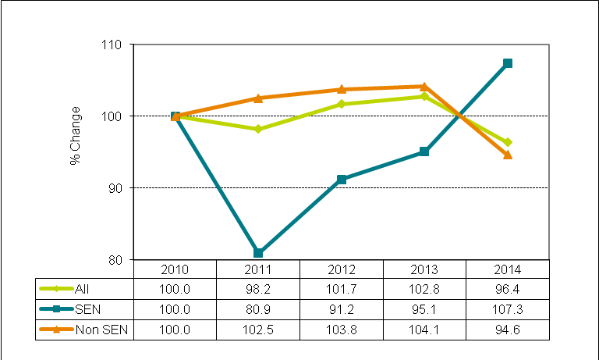

Table 9f:
 |  |  | Actual population
 |  |  | 2010 |  | 2011 |  | 2012 |  |  | 2013 | 2014
 |  |  | All pupils
 | All |  | 3,021 |  | 2,967 |  | 3,017 |  |  | 3,101 | 2,988
 | SEN |  | 603 |  | 488 |  | 445 |  |  | 423 | 454
 | Non SEN |  | 2,418 |  | 2,479 |  | 2,572 |  |  | 2,678 | 2,534
 | SEN % |  | 20.0% |  | 16.4% |  | 14.7% |  |  | 13.6% | 15.2%
 |  |  | Boys
 | All |  | 1,540 |  | 1,545 |  | 1,513 |  |  | 1,623 | 1,549
 | SEN |  | 387 |  | 319 |  | 289 |  |  | 281 | 302
 | Non SEN |  | 1,153 |  | 1,226 |  | 1,224 |  |  | 1,342 | 1,247
 | SEN % |  | 25.1% |  | 20.6% |  | 19.1% |  |  | 17.3% | 19.5%
 |  |  | Girls
 | All |  | 1,481 |  | 1,422 |  | 1,504 |  |  | 1,478 | 1,439
 | SEN |  | 216 |  | 169 |  | 156 |  |  | 142 | 152
 | Non SEN |  | 1,265 |  | 1,253 |  | 1,348 |  |  | 1,336 | 1,287
 | SEN % |  | 14.6% |  | 11.9% |  | 10.4% |  |  | 9.6% | 10.6%
Figure 9i:
Percentage of pupils achieving 5 or more A*-C GCSEs including English and Maths by SEN and Gender

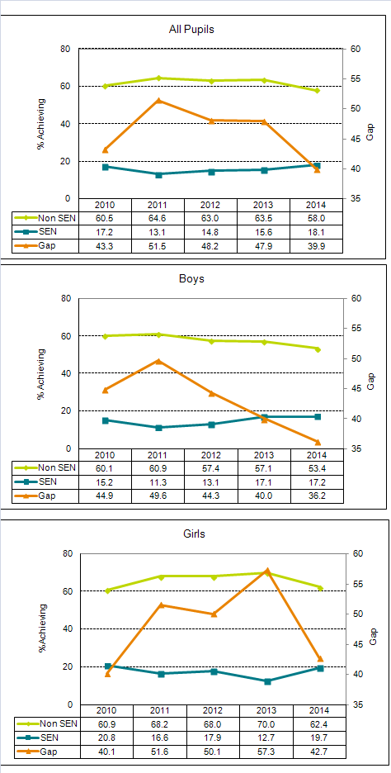
Persistent Absence

The data on the following pages provides information on the equality breakdown of persistent absence from schools in Oldham for the reporting period.

Pupils are classed as being persistently absent if they miss 46 or more sessions (half days) during the year. This works out at 15% of sessions missed. For each term, the thresholds are cumulative and are shown in the table.

Table 9g: Persistent Absence Thresholds
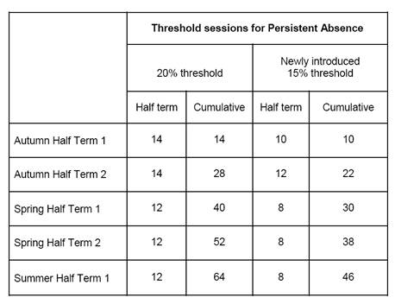

The data provides information broken down by half term periods in the school year;

- HT1-2 refers to the data collected during the first term of school.
- HT1-4 refers to the data collected during the first and second term of school.
- HT1-5 refers to the data collected during the first and second terms and the first half term period of the summer term (up until the end of May) .

The Government currently only provides the council with persistent absence data until May. Going forward, the Government will provide councils with data for the complete school year.

This information includes;

Primary

- Overall primary persistent absence from 2009-10 to 2012-13.
- Primary persistent absence by ethnicity with BME (Black Minority Ethnic) split from 2009-10 to 2012-13.
- Primary persistent absence by ethnicity and Free School Meals (FSM) from 2009-10 to 2012-13.
- Primary persistent absence by ethnicity and Special Educational Needs (SEN) from 2009-10 to 2012-13.

This data only covers pupils from Year 1 to Year 6 for trend purposes.

Secondary

- Overall secondary persistent absence from 2009-10 to 2013-14.
- Secondary persistent absence by ethnicity with BME (Black Minority Ethnic) split from 2009-10 to 2012-13.
- Secondary persistent absence by ethnicity and Free School Meals (FSM) from 2008-9 to 2009-10 to 2012-13.
- Secondary persistent absence by ethnicity and Special Educational Needs (SEN) from 2009-10 to 2012-13.

How do we use this data to inform services?
The council collects information on pupils who are persistently absent from school. This information is broken down by Gender, BME (Black Minority Ethnic), SEN (Special Educational Needs) and those claiming eligibility for FSM (Free School Meals). Persistent absence is regularly monitored to ensure any areas for improvement can be identified and is fed back to schools.

Figure 9j:
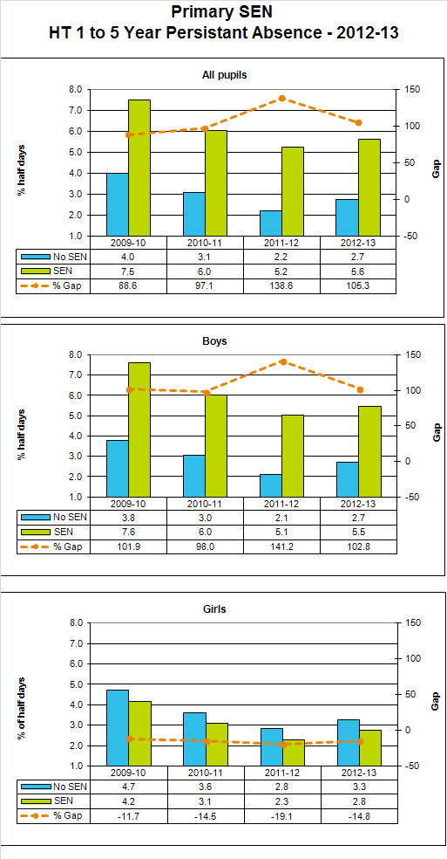
Figure 9k:

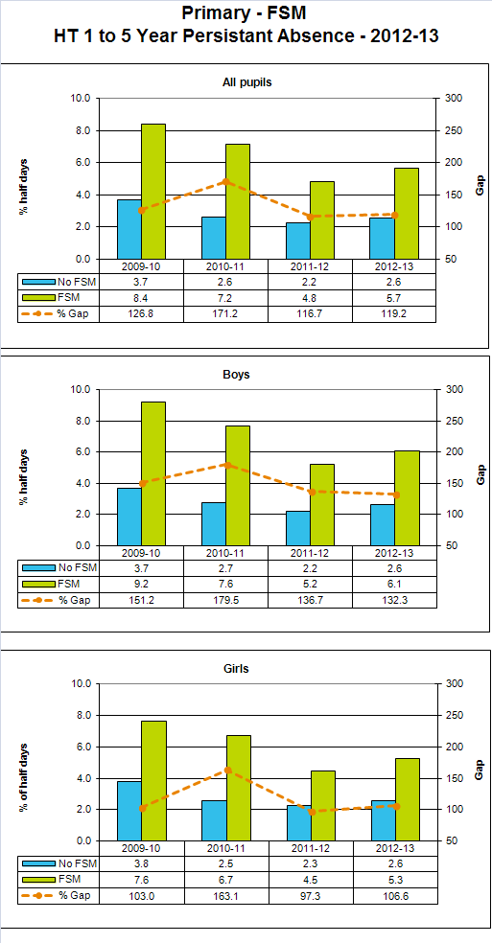
Figure 9l:

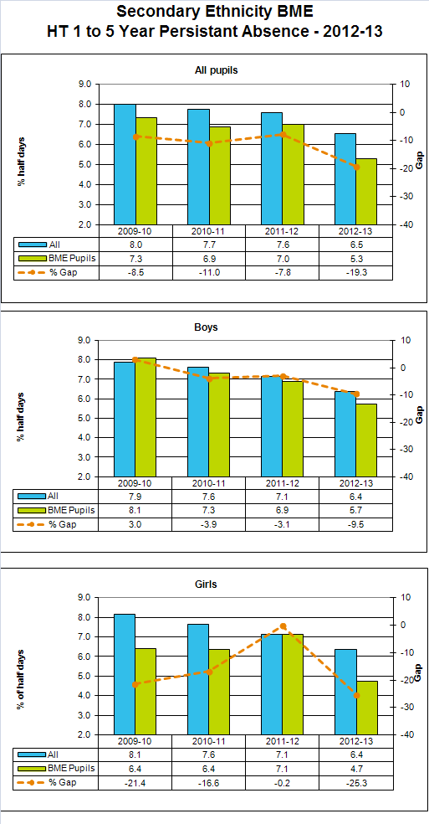

Figure 9m:
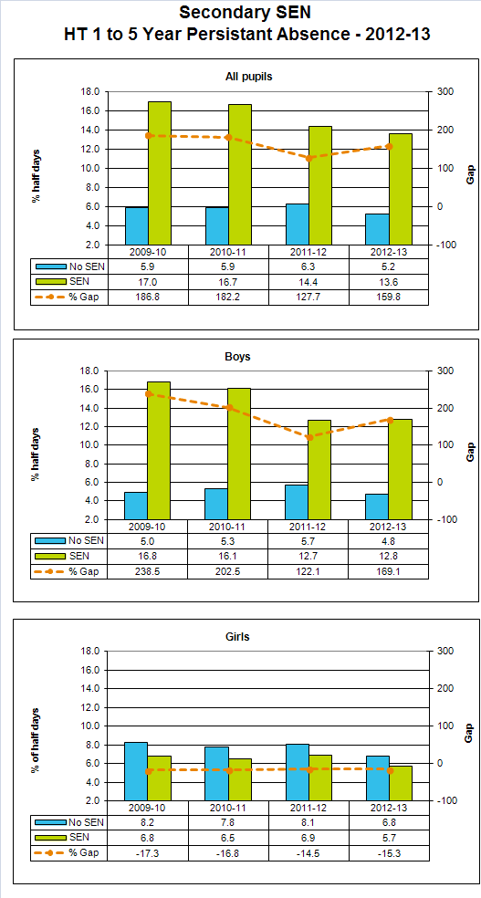

Figure 9n:
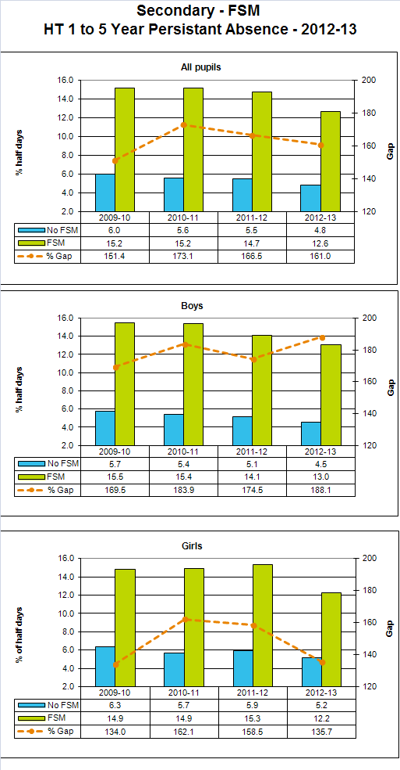

Social Fund Reform (Local Welfare Provision)

The Welfare Reform Act 2012 set out the Government’s reform plans for the
Social Fund. The act established a combination of new locally based provisions that replaced Community Care Grants and Crisis Loans for general living expenses. In addition there is a new nationally administered advance of benefit facility that will replace alignment Crisis Loans and Budgeting Loans.

The provision of Community Care Grants and Crisis Loans for living expenses ended on 31 March 2013. The local scheme called Local Welfare Provision (LWP) is now in place.

Local Welfare Provision will:

- Meet short term emergency/immediate support needs of vulnerable people
- Assist vulnerable people to establish or maintain a home in the community

The data is recorded via the Local Welfare Provision computer database and is taken from 100% of users. Please note that not every customer answered each question fully.

The following tables provide information on claims to the social fund in Oldham.

Table 10a: Claims for Local Welfare Provision by Age
Age Group | Number of customers  2013/14 | % of customers | Number of customers 2014/15 | % of customers
16-24 | 359 | 20.93% | 316 | 23.55%
25-34 | 478 | 27.87% | 390 | 29.06%
35-44 | 339 | 19.77% | 246 | 18.32%
45-54 | 258 | 15.04% | 196 | 14.61%
55-64 | 107 | 6.24% | 90 | 6.71%
65-74 | 8 | 0.47% | 18 | 1.34%
75-84 | 8 | 0.47% | 11 | 0.82%
85+ | 0 | 0.00% | 0 | 0.00%
Not Provided | 158 | 9.21% | 75 | 5.59%
Total | 1,715 | 100.00% | 1,342 | 100%

Table 10b: Claims for Local Welfare Provision by Gender
Gender | Number of customers 2013/14 | % of customers | 2014/15 | % of customers
Male | 866 | 50.50% | 636 | 47.39%
Female | 849 | 49.50% | 706 | 52.61%
Total | 1,715 | 100.00% | 1,342 | 100.00%

Table 10c: Claims for Local Welfare Provision by Ethnicity

Ethnicity | Number of customers 2013/14 | %  of customers
Asian or Asian British – Bangladeshi | 40 | 2.33%
Asian or Asian British – Indian | 1 | 0.06%
Asian or Asian British – Pakistani | 73 | 4.26%
Asian or Asian British – any other Asian background | 14 | 0.82%
Black or Black British – African | 28 | 1.63%
Black or Black British – Caribbean | 12 | 0.70%
Black or Black British – any other Black background | 13 | 0.76%
Chinese | 1 | 0.06%
Mixed – White and Asian | 6 | 0.35%
Mixed – White and Black African | 11 | 0.64%
Mixed – White and Black Caribbean | 28 | 1.63%
Mixed – any other mixed background | 10 | 0.58%
White – British | 1,102 | 64.26%
White – Irish | 7 | 0.41%
White – any other White background | 39 | 2.27%
Gypsies / travellers | 2 | 0.12%
Arab | 4 | 0.23%
Any other Ethnic background | 57 | 3.32%
Not known/not provided | 267 | 15.57%
Total | 1,715 | 100.00%
- Detailed ethnicity Breakdown is not available for 2014/15

Table 10d: Claims for Local Welfare Provision by Religious Belief
Religion / Belief | Number of  Customers 2013/14 | %  of customers | Number of  Customers 2014/15 | %  of customers
Buddhist | 6 | 0.35% | 6 | 0.45%
Catholic | 199 | 11.60% | 160 | 11.92%
Christian | 449 | 26.18% | 315 | 23.47%
Hindu | 1 | 0.06% | 2 | 0.15%
Jewish | 1 | 0.06% | 0 | 0.0%
Muslim | 157 | 9.15% | 134 | 9.99%
Sikh | - | 0.00% | 0 | 0.00%
Other | 34 | 1.98% | 26 | 1.94%
No religious belief | 647 | 37.73% | 547 | 40.76%
Not provided | 221 | 12.89% | 152 | 11.33%
Total | 1,715 | 100.00% | 1342 | 100%

Table 10e: Claims for Local Welfare Provision by Sexual Orientation
Sexual Orientation | Number  of customers  2013/14 | %  of customers | Number  of customers 2014/15 | %  of customers
Bisexual | 17 | 0.99% | 15 | 1.12%
Heterosexual | 1,438 | 83.85% | 1,157 | 86.21%
Gay | 17 | 0.99% | 21 | 1.56%
Lesbian | 18 | 1.05% | 13 | 0.97%
Not provided | 225 | 13.12% | 136 | 10.13%
Total | 1,715 | 100% | 1,342 | 100%

Table 10f: Claims for Local Welfare Provision by Relationship Status
Relationship | Number  of customers  2013/14 | %  of customers | Number  of customers 2014/15 | %  of customers
Never married / civil partner | 719 | 41.92% | 589 | 43.89%
Married | 104 | 6.06% | 69 | 5.14%
Same sex partnership | 8 | 0.47% | 3 | 0.22%
Divorced | 153 | 8.92% | 116 | 8.64%
Legally dissolved same sex partnership | - | 0.00% | 1 | 0.07%
Separated | 326 | 19.01% | 233 | 17.36%
Widowed | 27 | 1.57% | 28 | 2.09%
Surviving partner from same sex partnership | 5 | 0.29% | 3 | 0.22%
Not provided | 373 | 21.75% | 300 | 22.35%
Total | 1,715 | 100% | 1,342 | 100%

How are we using this information to inform services?

The service was only introduced on the 1st April 2013 and is continuously developing. The new service allows us to analyse the information to identify trends and gaps and set objectives for the next year. The system used, provided by Capita, provides limited scope to improve the equality data however, equality integration will be considered at any future review.

The uncertainty of the future of Local Welfare Provision has prevented the service from using the data to target areas and promote the scheme which could lead to reputational issues for the Council as we may not be able to meet residents’ expectations should funding no longer exist. Prior to the scheme being launched it was widely publicised through our ‘Make the Most of your Money Campaign’ to a range of stakeholders and residents. In addition, to ensure the scheme was being accessed by the intended service users, we targeted groups that provide support to the most vulnerable residents of Oldham and delivered awareness sessions

Data Source: Local Welfare Provision database

Waste Services – Assisted Collections

Our waste service provides assisted collections to residents who are physically unable to put their bins out for collection.

We collect information about the number of collections we carry out for the protected characteristics below. As at January 2015, approximately 2,720* assisted collections are provided every week for reasons of:

- Disability
- Age (infirmity)
- Pregnancy/maternity

*We can only ever approximate the number of assisted collections carried out because of the challenge in keeping the database up to date.

This is because these are the only protected characteristics which we would consider to prevent residents from physically being able to put their container out for collection.

This information is collected from Waste Management’s assisted collection database which is held on our collection system (Mayrise). The data is originally derived from individual resident requests for assisted collections which are approved by the Waste Management service.

The assisted collections represent approximately 2.8% of the overall number of collections which currently stands at approximately 94,470 households.

How are we using this information to inform services?

We now include a ‘tick box’ section on all assisted collection application forms whereby applicants are asked if they require an assisted collection for reasons of:

- physical disability
- infirmity due to old age
- pregnancy/maternity
- Other (Please give details)

Going forward into 2015, we will carry out a comprehensive review of our assisted collection database, processes, policies and procedures to ensure all those who are eligible have fair and equal access to the service.

Source: Oldham Council Waste Services

Elected Member Profile

The council gathers equality information on its Councillors. The following information provides a breakdown of the gender and age composition of the Members of the Council.

Figure 12a: Elected Members – by Age and Gender, 2014
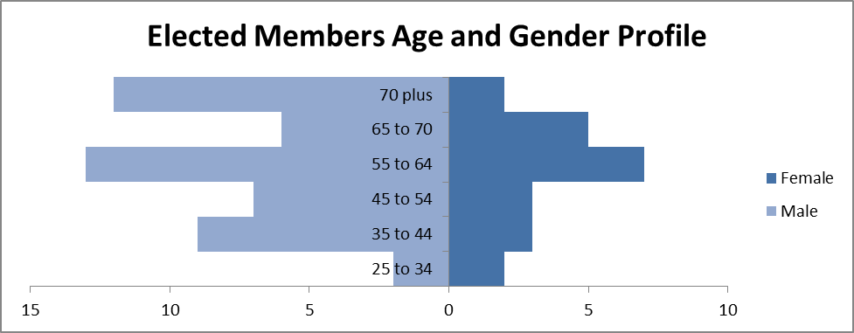

Figure12b: Oldham Elected Members – by Age Groups, 2014 Compared to LGA National Census 2013
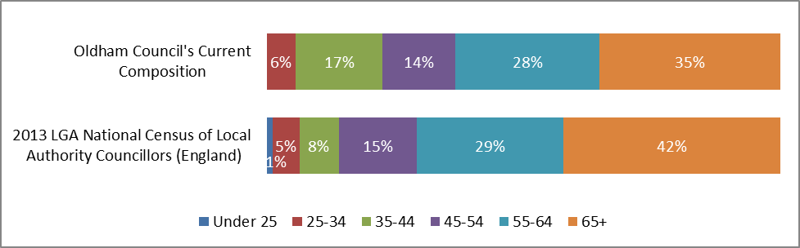

How are we using this information to inform services?

The council is currently working to strengthen the role of councillors and to improve democratic engagement in the Borough. This has meant providing more support and devolving more powers to local ward members, as well as increasing the range of opportunities for residents to get involved in local democracy, for example by opening up live council to public questions via Twitter.

As part of this work, we have strengthened the role of councillors in Oldham. From a new programme of leadership development to enhanced powers and responsibilities for ward members, we are creating opportunities for members to become stronger community leaders.

The Councillors’ Survey is an online survey of all Oldham councillors. This survey of our local elected members is one element of this important work. The survey aimed to find out more about their experiences of being a councillor in Oldham, with questions ranging from what had motivated members to stand for election (the main reason being a desire to serve the local community), to their involvement in other types of community work (the significant majority are involved in things like school governors’ boards and charities). Using the information collected as part of the survey, we have been able to provide better opportunities and support for Oldham’s councillors to become more effective leaders in their communities.

Source: Oldham Council Business Intelligence Team

Employee Volunteering

Employee Volunteering
The Employer Support Volunteering (ESV) scheme was launched in 2012 and offers council employees the opportunity to volunteer within the communities of Oldham for up to 3 days in any one year period. The scheme is now in its third year with participation levels increasing. The council has set ambitious targets of 75% of employees to have volunteered during the financial year 2014/15. Every employee has to record their volunteering activity via our HR self-service system which captures equality characteristics. The following information provides a breakdown of those who have recorded their volunteering activity during the financial year 2013/14 according to gender, disability, age and ethnicity.

Employee Volunteering

The below tables identify the diversity of employees volunteering under the Council’s Employer Supported Volunteering Scheme.

Table 13a: Employees Volunteering by Gender
Gender | 2014/15 | 2013/14
Male | 40% | 38%
Female | 60% | 62%

Table 13b: Employees Volunteering by Ethnicity
Ethnicity | 2014/15 | 2013/14
BME | 14% | 8%
Non BME | 80% | 84%
Undeclared | 5% | 8%

Table 13c: Employees Volunteering by Disability
Disability | 2014/15 | 2013/14
Disabled | 2% | 2%
Not Disabled | 64% | 44%
Undeclared | 33% | 54%

Table 13d: Employees Volunteering by Age Groups
Age Band | 2014/15 | 2013/14
16 to 24 | 11% | 0%
25 to 34 | 14% | 9%
35 to 44 | 32% | 28%
45 to 54 | 31% | 42%
55 to 64 | 11% | 22%
65+ | 0% | 0%
Table 15e: Employee Volunteering by Categories
Volunteering - Categories
Volunteering - External to the Council |  |  | 22
Volunteering - Get Oldham Working |  |  | 16
Volunteering - Internal to the Council |  |  | 63
Volunteering - Self-Organised |  |  | 76
Volunteering - Team Placement |  |  | 79

How are we using this information to inform services?

The overall evaluation of the first year of the scheme has helped to make changes and improvements going forward. For example, those employees within front line services with customer facing roles may need extra support to ensure that they are able to participate and fit volunteering around their working patterns. We have also identified where they have been gaps in our information records and moved to recording our volunteering activity via our HR system to ensure that we have an accurate and up to date record of equality information. Capturing our equality data has also allowed us to identify where we need to concentrate our efforts on increasing participation, for example with employees who may have disabilities.

We are also now capturing data about the community and voluntary organisations that provide volunteering placements. This will help inform us in the future if there are any gaps in provision on the basis of equality so that we can provide a targeted approach to future engagement.

Over thirty voluntary, community and faith groups have offered and benefitted from volunteering placements. These placements cover a variety of equality themes, including;
- Young people
- Older people
- Poverty
- Drug and alcohol
- Adults with learning disabilities
- Mental health
- Vulnerable adults
- BME residents
- Women’s rights
- Carers

Original Source of data: People Services

- Discretionary Housing Payments

Discretionary Housing Payments (DHP) are awarded to claimants who have a shortfall in their Housing Benefit award and prove that there is a need to assist them financially in this way.

Equality data is only recorded where DHP has been awarded and only ethnicity details are collected at this stage as contractually agreed. The recording of this data is manual and is only for those claimants that are willing and choose to provide this information.

DHP is a small part of the benefits service so the data provided does not entirely reflect customers of the whole service. Data collection is captured through the Academy IT system with ethnicity being recorded as a specific equality characteristic. Other information can be extracted from the system such as age, but some information is reliant on a household receiving appropriate benefits, e.g. maternity, disability. This is because surveys are not currently carried out specifically on DHP claimants.

The table below outlines the ethnicity data.

Figure 14a: Customers receiving Discretionary Housing Payments by Ethnicity
Ethnicity | Number of Customers  2013/14 | % of customers | Number of Customers 2014/15 | % of customers
Asian or Asian British – Bangladeshi | 54 | 3.38% | 21 | 1.38%
Asian or Asian British – Indian | 8 | 0.50% | 1 | 0.07%
Asian or Asian British – Pakistani | 60 | 3.75% | 12 | 0.79%
Asian or Asian British – any other Asian background | 7 | 0.44% | 5 | 0.33%
Black or Black British – African | 19 | 1.19% | 12 | 0.79%
Black or Black British – Caribbean | 5 | 0.31% | 5 | 0.33%
Black or Black British – any other Black background | 7 | 0.44% | 1 | 0.07%
Chinese | 0 | 0.00% | 0 | 0.00%
Mixed – White and Asian | 6 | 0.38% | 1 | 0.07%
Mixed – White and Black African | 3 | 0.19% | 4 | 0.26%
Mixed – White and Black Caribbean | 13 | 0.81% | 3 | 0.20%
Mixed – any other mixed background | 6 | 0.38% | 2 | 0.13%
White – British | 1,034 | 64.67% | 632 | 41.58%
White – Irish | 10 | 0.63% | 10 | 0.66%
White – any other White background | 30 | 1.88% | 16 | 1.05%
Gypsies / travellers | 14 | 0.88% | 2 | 0.13%
Arab | 0 | 0.00% | 0 | 0.00%
Any other Ethnic background | 12 | 0.75% | 4 | 0.26%
Not known/not provided | 311 | 19.45% | 789 | 51.91%
Total | 1,599 | 100.00% | 1,520 | 100.00%

How are we using this information to inform services?

Currently, the data collected is very limited and it is difficult to ascertain the direct service improvements which can be drawn from this information. The Council is currently undergoing a customer service transformation; as part of the Customer Transformation work, the council is currently testing a DHP online application form which will help customers claim support and improve financial, demographic, and customer data capture for continued support provision monitoring.

Original Source of data: Customer Services

5. Our workforce data

All of the information outlined below, relates to the Council’s centrally employed workforce, i.e. those not including those working within schools. The data has been taken at the end of Quarter 2 2015/16

This report includes detailed workforce profiles in the following areas:

- Overall and directorate employee numbers
- Gender and full time/part time mix
- Age and length of service
- Ethnicity
- Disability
- Pay information
- Dismissals and grievances
- An indication of likely representation on sexual orientation and religion and belief (where the data is such that no-one can be identified as a result)
- Gender pay gap information
- Job vacancy advertisement responses

Table 15a:
High level indicators:

Reference | Description | September  2014
HR P1 | Number of current employees | 2718
PI 4 | Leavers in the last year as a % of the average total staff | 17.83%
SI 7 | Percentage of people still in post after 12 months service | 63.91%
SI 10  BVPI 11a | Top 5% earners that are women | 61.94%
BVPI 11b | Top 5% of earners from black & ethnic minority communities | 5.88%
BVPI 11c | Top 5% earners who have declared a disability | 3.30%
SI 11  BVPI 16a | Percentage of LA employees who meet DDA definition as % of workforce | 4.37%
SI 12 | Percentage of staff over 50 | 39.74%
SI 13  BVPI 17a | Percentage of LA employees from BME as % of workforce | 10.45%

Figures are for directorates only i.e. exclude schools.

Workforce profile – gender, full and part time employees

Table 15b: Overall employee numbers by portfolio gender and full time/part time indicator
 | Full Time Staff |  | Full Time Total | Part Time |  | Part Time Total | Grand Total | Full Time Equivalent | % FTE
 |  |  | Full Time Total | Staff
Portfolio | Female | Male |  | Female | Male
Cooperatives and Neighbourhoods | 167 | 433 | 600 | 119 | 40 | 159 | 759 | 688.46 | 32.37
Corporate and Commercial Services | 203 | 93 | 296 | 94 | 18 | 112 | 408 | 370.28 | 17.41
Economy and Skills | 111 | 44 | 155 | 748 | 82 | 830 | 985 | 538.88 | 25.34
Health and Wellbeing | 284 | 101 | 385 | 82 | 12 | 94 | 479 | 444.21 | 20.89
Policy and Governance (including Chief Executive) | 41 | 36 | 77 | 8 | 2 | 10 | 87 | 84.88 | 3.99
Total | 806 | 707 | 1513 | 1051 | 154 | 1205 | 2718 | 2126.71 | 100.00

Workforce Profile – age and length of service

Table 15c: Job count age by portfolio
Portfolio | Total | 16to24 | %age 16-24 | 25to34 | 35to44 | 45to54 | 55to64 | 65to70 | 70+
Cooperatives and Neighbourhoods | 759 | 38 | 5.01 | 154 | 192 | 238 | 128 | 8 | 1
Corporate and Commercial Services | 408 | 21 | 5.15 | 76 | 105 | 135 | 67 | 3 | 1
Economy and Skills | 985 | 26 | 2.64 | 109 | 188 | 346 | 272 | 33 | 11
Health and Wellbeing | 479 | 14 | 2.92 | 81 | 131 | 167 | 83 | 3
Policy and Governance (including Chief Executive) | 87 | 11 | 12.64 | 20 | 31 | 21 | 4
Total | 2718 | 110 | 4.05 | 440 | 647 | 907 | 554 | 47 | 13

Table 15d: Count of employees aged 50 or over
Age 50+
Portfolio | Employee Count
Cooperatives and Neighbourhoods | 254
Corporate and Commercial Services | 149
Economy and Skills | 504
Health and Wellbeing | 162
Policy and Governance (including Chief Executive) | 11
Total | 1080

Total job count in portfolios = 2718
Percentage over 50 = 1080 / 2718 *100 = 39.74
Secondary Indicators
- Number of people who commenced their employment in the 12 month period from 1 October 2013 to 30 September 2014 = 338
- Percentage of people that are still in post after 12 months service = 63.91 %

Workforce profile – ethnicity

Table 15e: Job count ethnicity by portfolio
Portfolio | Asian | Black | Dual | Chinese and Other | Sub Total BME | White | Sub Total Declared | Sub Total Undeclared | Total
Cooperatives and Neighbourhoods | 33 | 8 | 6 | 1 | 48 | 639 | 687 | 72 | 759
Corporate and Commercial Services | 40 | 6 | 2 | 2 | 50 | 335 | 385 | 23 | 408
Economy and Skills | 55 | 12 | 10 | 3 | 80 | 793 | 873 | 112 | 985
Health and Wellbeing | 38 | 19 | 7 | 2 | 66 | 372 | 438 | 41 | 479
Policy and Governance (including Chief Executive) | 5 | 3 | 4 | 1 | 13 | 64 | 77 | 10 | 87
Total | 171 | 48 | 29 | 9 | 257 | 2203 | 2460 | 258 | 2718

There are 257 people in portfolios from Black and Minority Ethnic communities. This equates to 10.45% of directorate staff who have recorded their ethnicity.

Table 15f: Ethnicity – new starters’ year to date
Portfolio | Total Starters | BME | Declared Ethnicity | % age
Cooperatives and Neighbourhoods | 55 | 7 | 50 | 14.00
Corporate and Commercial Services | 35 | 8 | 34 | 23.53
Economy and Skills | 62 | 5 | 52 | 9.62
Health and Wellbeing | 32 | 3 | 26 | 11.54
Policy and Governance (including Chief Executive) | 14 | 4 | 11 | 36.36
Total | 198 | 27 | 173 | 15.61

Table 15g: Ethnicity – leavers’ year to date
Portfolio | Total Leavers | BME | Declared Ethnicity | %age
Cooperatives and Neighbourhoods | 61 | 7 | 49 | 14.29
Corporate and Commercial Services | 29 | 7 | 26 | 26.92
Economy and Skills | 71 | 8 | 63 | 12.70
Health and Wellbeing | 37 | 5 | 34 | 14.71
Policy and Governance (including Chief Executive) | 8 | 3 | 7 | 42.86
Total | 206 | 30 | 179 | 16.76

Workforce profile – disability

Table 15h: Disability by portfolio
Portfolio | Current Employee  Records | Provided Information | %age | Declared Disability | %age
Cooperatives and Neighbourhoods | 759 | 468 | 61.66 | 18 | 3.85
Corporate and Commercial Services | 408 | 297 | 72.79 | 13 | 4.38
Economy and Skills | 985 | 562 | 57.06 | 12 | 2.14
Health and Wellbeing | 479 | 262 | 54.70 | 25 | 9.54
Policy and Governance (including Chief Executive) | 87 | 60 | 68.97 | 4 | 6.67
Total | 2718 | 1649 | 58.50 | 72 | 4.37

Table 15i: Disability – new starters’ year to date
Portfolio | Total | Provided Information | %age Declared | Declared Disability | %age Disabled
Cooperatives and Neighbourhoods | 55 | 51 | 92.73 | 1 | 1.96
Corporate and Commercial Services | 35 | 32 | 91.43 | 0 | -
Economy and Skills | 62 | 54 | 87.10 | 0 | -
Health and Wellbeing | 32 | 27 | 84.37 | 1 | 3.70
Policy and Governance (including Chief Executive) | 14 | 12 | 85.71 | 1 | 8.33
Total | 198 | 176 | 88.89 | 3 | 1.70

Table 15j: Disability – leavers’ year to date
Portfolio | Total | Provided Information | %age Declared | Declared Disability | %age Disabled
Cooperatives and Neighbourhoods | 61 | 41 | 67.21 | 1 | 2.44
Corporate and Commercial Services | 29 | 23 | 79.31 | 1 | 4.35
Economy and Skills | 71 | 41 | 57.75 | 1 | 2.44
Health and Wellbeing | 37 | 23 | 62.16 | 1 | 4.35
Policy and Governance (including Chief Executive) | 8 | 8 | 100.00 | - | -
Total | 206 | 136 | 66.02 | 4 | 2.94

Workforce profile – Sexual Orientation

Table 15K: Top 5% earners (secondary indicator 10)
Bisexual | Gay man | Heterosexual | Lesbian/Gay woman | Prefer not to say | Not known | Total
5 | 7 | 1011 | 9 | 46 | 1640 | 2718

Workforce profile – employee pay related information

Table 15l: Top 5% earners (secondary indicator 10)
Portfolio | Female FTE | % age | Male FTE | % age | Grand Total
Cooperatives and Neighbourhoods | 15 | 51.72 | 14 | 48.28 | 29
Corporate and Commercial Services | 24.40 | 61.93 | 15 | 38.07 | 39.40
Economy and Skills | 26.50 | 70.67 | 11 | 29.33 | 37.50
Health and Wellbeing | 12.43 | 67.52 | 5.98 | 32.48 | 18.41
Policy and Governance (including Chief Executive) | 3 | 37.50 | 5 | 62.50 | 8
Grand Total | 81.33 | 61.47 | 50.98 | 38.53 | 132.31

Table 15m: Gender pay gap information
Grade | Number of Females | Number of Males | Average Female Pay | Average Male Pay | Females Pay as a % of Males
Grade 1 | 483 | 73 | £15,207 | £15,207 | 100.00
Grade 2 | 231 | 124 | £16,764 | £16,522 | 101.47
Grade 3 | 136 | 71 | £18,326 | £18,354 | 99.84
Grade 4 | 220 | 144 | £21,041 | £20,729 | 101.51
Grade 5 | 145 | 72 | £24,318 | £24,030 | 101.20
Grade 6 | 163 | 110 | £26,555 | £26,887 | 98.77
Grade 7 | 93 | 49 | £30,880 | £31,580 | 97.78
Grade 8 | 72 | 36 | £34,879 | £34,469 | 101.19
Grade 9 | 60 | 29 | £38,317 | £39,011 | 98.22
Grade 10 | 20 | 10 | £42,137 | £42,320 | 99.57
SM3 | 29 | 20 | £45,511 | £45,080 | 100.96
SM2 | 16 | 9 | £48,998 | £49,180 | 99.63
SM1 | 9 | 17 | £59,420 | £59,857 | 99.27
Grand Total | 1677 | 764 | £22,276 | £24,659 | 90.34

Workforce profile – dismissals

Table 15n: Dismissals by gender
Female | Male | Total
59 | 48 | 107

Table 15o: Dismissals by age
16-24 | 25-34 | 35-44 | 45-54 | 55-64 | 65-70 | 70+ | Total
3 | 23 | 22 | 30 | 27 | 2 | 0 | 107

Table 15p: Dismissals by sexual orientation
Bisexual | Gay man | Heterosexual | Lesbian/Gay woman | Not known | Total
0 | 1 | 21 | 1 | 84 | 107

Table 15q: Dismissals by disability
Declared Disabled | Declared Not Disabled | Undeclared or blank | Total
6 | 65 | 36 | 107

Table 15r: Dismissals by ethnicity
Asian | Black | Chinese and Other | Dual | Undeclared | White | Total
15 | 2 | 0 | 0 | 16 | 74 | 107

Table 15s: Dismissals by religious belief
Buddhist | Christian | Muslim | None | Undeclared or blank | Total
2 | 40 | 2 | 11 | 10 | 4

Workforce profile – Grievances

Table 15t: Grievances by Ethnicity, Gender, and Disability
Number | White British | BME | Female | Male | Disabled | Non-Disabled
20 | 18 | 2 | 15 | 5 | 4 | 16

Response to recruitment adverts

A total of 249 jobs were advertised during the period 1 October 2013 to 30 September 2014.

Table 15u: Responses by gender
Female | Male | Prefer not to say | Total
3352 | 1642 | 14 | 5008

Table 15v: Responses by ethnicity
Asian | Black | Chinese and Other | Dual | Undeclared | White | Total
1058 | 401 | 22 | 146 | 46 | 3335 | 5008

Table 15w: Responses by sexual orientation
Bisexual | Gay man | Heterosexual | Lesbian/Gay woman | Prefer not to say | Total
42 | 63 | 4678 | 35 | 190 | 5008

Table 15x: Responses by disability
Declared Disabled | None or blank | Total
335 | 4673 | 5008

Table 15y: Response by religious belief
Buddhist | Christian | Hindu | Muslim | None | Other | Undeclared | Total
10 | 2196 | 39 | 1012 | 1456 | 132 | 163 | 5008

Table 15z: Response by age
16-24 | 25-34 | 35-44 | 45-54 | 55-64 | 65-74 | Not given | Total
1328 | 1606 | 990 | 815 | 250 | 5 | 10 | 4

How are we using this information to inform services?

The workforce equalities data is monitored regularly at the level included within this report. However, to ensure the Council’s obligations under the Equality Act remain satisfied and equality is given the full emphasis required a full and detailed equalities analysis is currently being undertaken. This will include all equality strands where the data is sufficiently robust and will span a number of people focussed activities, for example; recruitment, performance management and employee relations. The outcomes of the analysis will then appropriately feed into relevant workstreams to ensure equality of opportunity within the workplace.

6. Our Budget

In taking financial decisions the Council must demonstrate that it has given “due regard” to the need to eliminate discrimination, promote equality of opportunity and promote good relations between different groups.

Oldham’s Equality Impact Assessment (EIA) form helps us to adhere to this regard as well as;
- Strengthen the process through improved accountability;
- Stimulate a more rigorous and overt analysis of the impact and possible mitigations;
- Implement a stronger equality monitoring and management process to ensure that we follow through on what we said we would do – this includes identifying risks to implementation and how these will be managed.

The equality impact assessment process undertaken for the Council’s budget process involves:
- An initial equality impact screening on budget proposals to identify whether any have the potential for significant disproportionate adverse impact in respect of any protected characteristic.
- The initial screenings are then independently reviewed by a small group with knowledge of the equality legislation, comprising the Cabinet Member for Adult Social Care and Public Health, the Assistant Executive Director for Adults and Commissioning, a senior officer from the Neighborhoods directorate, and a lawyer from the Legal Services team.

The key aims of this review process are to:
- Assess the potential equality impact of each proposal using the information provided
- Provide challenge to those where the Group feel the initial screening does not accurately identify those equality groups potentially affected and that a further screening process needs to be completed

A key element to assessing the equality impact has been the involvement of elected members such as through membership of the Equality Challenge Group, through briefings with Executive Directors and Cabinet Members during the development of proposals, working together to consider the equality impacts and identify any mitigating actions and making EIAs available to Members alongside the budget proposals.

The link provided below provides access to budget papers which will have an EIA behind each specific budget proposal where an EIA is needed. http://committees.oldham.gov.uk/ieListMeetings.aspx?CommitteeId=132
(EIAs for specific budget proposals will be in the report pack of the agenda for each of the budget meetings)
7. Impact of Welfare Reform in Oldham

The Welfare Reform Act 2012 introduced wide-ranging changes to the country’s welfare regime. These included phased reforms to out of work benefits e.g. Jobseeker’s Allowance, Incapacity Benefit, Disability Living Allowance as well as other benefits such as Housing and Council Tax Benefit.

The Act also introduced a range of new regulations (e.g. Benefit Cap, Universal Credit and Personal Independence Payments) as well as stronger sanctions.

Since 2012, the Council has worked proactively with partners to prepare for and support residents through those reforms and mitigate any adverse impact. These have included:

- Developing a Council Tax reduction scheme replacing Council Tax Benefit, with a maximum reduction of 80% for Band A properties (in 2014/15, up from 75% in 2013/14).

- Reviewing the local Discretionary Housing Payment scheme, allowing support to be provided to those affected by the ‘size criteria’ and benefit cap.

- Introducing a Local Welfare Provision (LWP) scheme to replace community care grants and crisis loans, which includes a more rigorous assessment of need than the previous DWP scheme.

- Recruitment of two additional Welfare Rights officers from April 2013 (using LWP monies) to support residents affected by changes.

- A high-profile ‘make the most of your money’ campaign was delivered in preparation for the welfare changes, with information and materials widely distributed across the Borough.

Impact of welfare reform in Oldham
- The proportion of residents in receipt of out-of-work benefits is reducing.
- This is likely to be a result of more local job opportunities and the impact of tougher benefit sanctions.
- Taking into account Universal Credit claimants, unemployment in Oldham remains an ongoing challenge.
- The local Council Tax Reduction scheme helps with collection rates for those previously on Council Tax Benefit – they are higher than predicted but still significantly below the overall rate.
- Numbers affected by ‘size criteria’ (‘bedroom tax’) and rent arrears are reducing, but there is evidence of voids for larger homes, as tenants are downsizing.

Mitigating action taken
- The Discretionary Housing Payment scheme is mitigating some of the impact of the size criteria
- Local Welfare Provision has provided more than 1000 items (e.g. food, furniture, white goods, clothes, utilities and bedding) to residents in crisis during 2014.
- The Welfare Rights team supported residents to claim an additional £3m benefit payments which they were not previously accessing.
- The Council and its partners have been supporting residents with the transition to Universal Credit.
- Housing and voluntary partners are supporting residents in key areas, including money management, digital inclusion, provision of food and tackling illegal money lending.
- Oldham’s ‘Make the Most of Your Money’ campaign was successful and plans are being developed to repeat the campaign this autumn.
- Get Oldham Working is creating significant numbers of opportunities – jobs, apprenticeships, traineeships and work experience.

Further findings and more information is presented in the Impact of Welfare Reform report that went to Full Council on 22 October 2014, these documents are available at:

http://committees.oldham.gov.uk/documents/s51547/Update%20on%20Welfare%20Reform%20in%20Oldham.pdf

http://committees.oldham.gov.uk/documents/s51548/Update%20on%20Welfare%20Reform%20in%20Oldham%20-%20Appendix%20-%20Welfare%20Reform%20Dashboard.pdf

How are we using this information to inform services?
The Council is utilising information to determine if more could be done to better understand those residents ‘not engaging’ with our support to enable us to further tailor and target activity. We are also keen to do more to support self-reliance and tackle the underlying causes of crises.

Our welfare reform activity supports our corporate objectives, through:
- Reducing dependency on public services – ‘Confident communities where everyone does their bit’.
- Tackling worklessness – ‘A productive place to invest where business and enterprise thrive’.
- Local welfare provision – ‘a co-operative council creating responsive and high quality services’.

The Council’s Leadership and Members monitor the impacts of Welfare Reform and receive various reports tracking the impacts of Welfare Reform including.
- Annual welfare reform impact reports.
- Quarterly thematic ‘deep dives’, with evidence-based recommendations for improved practice:

‘Deep dive’ research timetable | When
Impact on vulnerable people | Apr 15
Food Poverty | May 15
Cost of the Cuts | Aug 15
Young people | Jan 16
Debt and finances | Mar 16

- Quarterly welfare reform dashboards to keep track of key trends

The latest ‘deep dive’ report provides a high-level analysis of the impact of welfare reform on vulnerable groups in Oldham. It identifies common demographic characteristics of people and groups disproportionately affected by the key provisions of welfare reform and of those residents using local services to mitigate its impact.

To identify patterns of vulnerability, we look at a wide range of local and national data available on Oldham residents affected by welfare reform. It also draws on national research where appropriate. The analysis includes client information from DWP (Benefit Sanctions, Personal Independence Payments, Benefit Cap, Bedroom Tax, Universal Credit) and local services (Discretionary Housing Payment, Local Welfare Provision, Council Tax Reduction, Welfare Rights and Oldham Foodbank).

Information and reporting is focused on evidence-based practice and interventions, with recommendations to help achieve the Council’s corporate objectives and improve services.

Statistical First Release DS/SFR12

